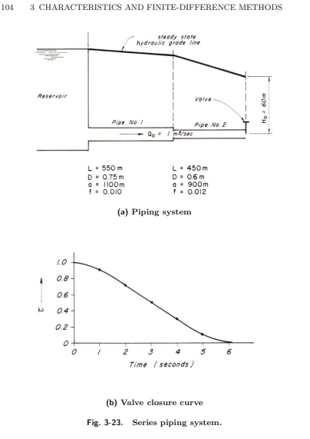

1. Hydraulic Transient Problem

*#Error: Level small.*

clc;

clear all;

L=[550 450];

D=[0.75 0.6];

a=[1100 900];

f=[0.01 0.012];

g=9.81;

Qo=1; % steady state discharge

Num_pipe=2; % number of pipes

Num_reach=2; %number of reach at which each pipe is divided into

Num_node=Num_pipe*(Num_reach+1);

H_ds=60; % reservior head, m

T_last=10; % time upto which computations should be done in sec

delta_t=L(1)/(a(1)*Num_reach); % in sec

Num_timestep=T_last/delta_t;

Num_timenode=Num_timestep+1;

%%

% pipe cs area

CS_area=zeros(1,2);

CS_area(1)=(pi/4)*D(1)^2;

CS_area(2)=(pi/4)*D(2)^2;

% x coordinate vector

x_pipe1=linspace(0,L(1),3);

x_pipe2=linspace(L(1),L(1)+L(2),3);

x_vector=[x_pipe1 x_pipe2];

%pipe coff Ca

Ca=zeros(1,2);

Ca(1)=(g*CS_area(1))/a(1);

Ca(2)=(g*CS_area(2))/a(2);

% coff R

R=zeros(1,2);

R(1)=f(1)/(2*D(1)*CS_area(1));

R(2)=f(2)/(2*D(2)*CS_area(2));

% Valve opening condition

Tau=zeros(1,Num_timenode);

Tau(1)=1;Tau(5)=0.9;Tau(9)=0.7;Tau(13)=0.5;Tau(17)=0.3;

Tau(21)=0.1;Tau(25)=0;

for i=0:1:5

Tau(4*i+2)=Tau(4*i+1)+(Tau(4*i+5)-Tau(4*i+1))*(1/4);

Tau(4*i+3)=Tau(4*i+1)+(Tau(4*i+5)-Tau(4*i+1))*(2/4);

Tau(4*i+4)=Tau(4*i+1)+(Tau(4*i+5)-Tau(4*i+1))*(3/4);

end

%% Calculation for steady state conditions

H=zeros(Num_timenode,Num_node);

Q=zeros(Num_timenode,Num_node);

Q(1,:)=Qo;

H(1,6)=H_ds;

H(1,5)=H_ds+(f(2)*(x_vector(6)-x_vector(5))*Qo^2)/(2*D(2)*g*CS_area(2)^2);

H(1,4)=H(1,5)+(f(2)*(x_vector(5)-x_vector(4))*Qo^2)/(2*D(2)*g*CS_area(2)^2);

H(1,3)=H(1,4);

H(1,2)=H(1,3)+(f(1)*(x_vector(3)-x_vector(2))*Qo^2)/(2*D(1)*g*CS_area(1)^2);

H(1,1)=H(1,2)+(f(1)*(x_vector(2)-x_vector(1))*Qo^2)/(2*D(1)*g*CS_area(1)^2);

%junction loss and other minor losses are neglected

%% Boundary conditions

Cn=zeros(Num_timenode,Num_node);

Cp=zeros(Num_timenode,Num_node);

Cv=zeros(Num_timenode,Num_node);

while i<Num_timenode

i=i+1;

for i=2:Num_timenode

% FOR UPSTREAM RESERVOIR***

Cn(i,1)=Q(i-1,2)-(g*CS_area(1))/a(1)*H(i-1,2)-R(1)*delta_t*Q(i-1,2)*abs(Q(i-1,2));

Q(i,1)=Ca(1)*H(1,1)+Cn(1);

H(i,1)=H(1,1);

% Interior nodes

Cp(i,2)=Q(i-1,1)+((g*CS_area(1))/a(1))*H(i-1,1)-R(1)*delta_t*Q(i-1,1)*abs(Q(i-1,1));

Cn(i,2)=Q(i-1,3)-((g*CS_area(1))/a(1))*H(i-1,3)-R(1)*delta_t*Q(i-1,3)*abs(Q(i-1,3));

Q(i,2)=0.5*(Cp(i,2)+Cn(i,2));

H(i,2)=(Q(i,2)-Cn(i,2))/Ca(1);

Cp(i,5)=Q(i-1,4)+((g*CS_area(2))/a(2))*H(i-1,4)-R(2)*delta_t*Q(i-1,4)*abs(Q(i-1,4));

Cn(i,5)=Q(i-1,6)-((g*CS_area(2))/a(2))*H(i-1,6)-R(2)*delta_t*Q(i-1,6)*abs(Q(i-1,6));

Q(i,5)=0.5*(Cp(i,5)+Cn(i,5));

H(i,5)=(Q(i,5)-Cn(i,5))/Ca(2);

% Junction condition

Cp(i,3)=Q(i-1,2)+((g*CS_area(1))/a(1))*H(i-1,2)-R(1)*delta_t*Q(i-1,2)*abs(Q(i-1,2));

Cn(i,4)=Q(i-1,5)-((g*CS_area(2))/a(2))*H(i-1,5)-R(2)*delta_t*Q(i-1,5)*abs(Q(i-1,5));

H(i,3)=(Cp(i,3)-Cn(i,4))/(Ca(1)+Ca(2));

H(i,4)=H(i,3);

Q(i,3)=Cp(i,3)-Ca(1)*H(i,3);

Q(i,4)=Q(i,3);

% Valve BC

Cp(i,6)=Q(i-1,5)+((g*CS_area(2))/a(2))*H(i-1,5)-R(2)*delta_t*Q(i-1,5)*abs(Q(i-1,5));

Cv(i,6)=((Tau(i)*Qo)^2)/(Ca(2)*H(1,6));

Q(i,6)=0.5*(-Cv(i,6)+sqrt(Cv(i,6)^2+4*Cp(i,6)*Cv(i,6)));

H(i,6)=(Cp(i,6)-Q(i,6))/Ca(2);

end

end

Q

H

time=0:delta_t:T_last;

H_valve=transpose(H(:,6));

plot(time,H_valve);

title("Head values at downstream valve");

xlabel('time in s');

ylabel('Head in m');

Output

Q =

1.0000 1.0000 1.0000 1.0000 1.0000 1.0000

0.2665 1.0000 1.0000 1.0000 1.0000 0.9931

0.2665 0.6350 1.0000 1.0000 0.9931 0.9858

0.2665 0.6350 0.6730 0.6730 0.9859 0.9782

0.2665 0.6729 0.6650 0.6650 0.6606 0.9703

0.2665 0.6649 0.6590 0.6590 0.6518 0.4923

0.2665 0.6591 0.6502 0.6502 0.4916 0.4848

0.2665 0.6502 0.4722 0.4722 0.4841 0.4779

0.2665 0.4726 0.4648 0.4648 0.4586 0.4685

0.2665 0.4652 0.4573 0.4573 0.4493 0.4326

0.2665 0.4574 0.4478 0.4478 0.4315 0.4217

0.2665 0.4478 0.4284 0.4284 0.4203 0.4097

0.2665 0.4285 0.4171 0.4171 0.4067 0.3950

0.2665 0.4172 0.4042 0.4042 0.3919 0.3768

0.2665 0.4042 0.3889 0.3889 0.3744 0.3569

0.2665 0.3889 0.3709 0.3709 0.3541 0.3336

0.2665 0.3709 0.3500 0.3500 0.3302 0.3061

0.2665 0.3501 0.3255 0.3255 0.3021 0.2735

0.2665 0.3255 0.2965 0.2965 0.2689 0.2351

0.2665 0.2965 0.2622 0.2622 0.2296 0.1898

0.2665 0.2623 0.2217 0.2217 0.1832 0.1363

0.2665 0.2218 0.1738 0.1738 0.1285 0.1057

0.2665 0.1739 0.1174 0.1174 0.0964 0.0728

0.2665 0.1174 0.0871 0.0871 0.0617 0.0375

0.2665 0.0871 0.0550 0.0550 0.0283 0

0.2665 0.0550 0.0212 0.0212 -0.0067 0

0.2665 0.0212 -0.0142 -0.0142 -0.0071 0

0.2665 -0.0142 -0.0105 -0.0105 -0.0075 0

0.2665 -0.0105 -0.0067 -0.0067 -0.0034 0

0.2665 -0.0067 -0.0026 -0.0026 0.0008 0

0.2665 -0.0026 0.0017 0.0017 0.0009 0

0.2665 0.0017 0.0013 0.0013 0.0009 0

0.2665 0.0013 0.0008 0.0008 0.0004 0

0.2665 0.0008 0.0003 0.0003 -0.0001 0

0.2665 0.0003 -0.0002 -0.0002 -0.0001 0

0.2665 -0.0002 -0.0002 -0.0002 -0.0001 0

0.2665 -0.0002 -0.0001 -0.0001 -0.0001 0

0.2665 -0.0001 -0.0000 -0.0000 0.0000 0

0.2665 -0.0000 0.0000 0.0000 0.0000 0

0.2665 0.0000 0.0000 0.0000 0.0000 0

0.2665 0.0000 0.0000 0.0000 0.0000 0

H =

67.6530 66.6955 65.7380 65.7380 62.8690 60.0000

67.6530 66.6955 65.7380 65.7380 62.8690 62.2457

67.6530 -25.9390 65.7380 65.7380 65.0949 64.6074

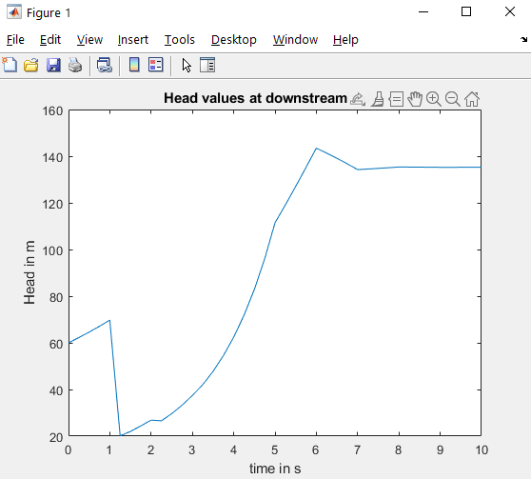

67.6530 -25.9390 -35.9586 -35.9586 67.4359 67.1039

67.6530 -35.5487 -33.9217 -33.9217 -33.2267 69.7326

67.6530 -33.5169 -32.4674 -32.4674 -30.9089 20.1247

67.6530 -32.0426 -30.2062 -30.2062 20.6086 22.0370

67.6530 -29.7922 14.9842 14.9842 22.4705 24.3631

67.6530 15.2989 16.8715 16.8715 18.7465 26.8713

67.6530 17.1773 18.9457 18.9457 21.2772 26.5761

67.6530 19.1527 21.3759 21.3759 26.7438 29.6404

67.6530 21.5755 26.2962 26.2962 29.7066 33.2856

67.6530 26.4843 29.1721 29.1721 32.8155 37.4377

67.6530 29.3514 32.4720 32.4720 36.8774 42.0600

67.6530 32.6382 36.3626 36.3626 41.6859 47.7715

67.6530 36.5183 40.9530 40.9530 47.2224 54.5087

67.6530 41.0971 46.2560 46.2560 53.7383 62.4495

67.6530 46.3870 52.5004 52.5004 61.4417 71.8264

67.6530 52.6169 59.8707 59.8707 70.5439 82.9223

67.6530 59.9715 68.5805 68.5805 81.3045 96.0215

67.6530 68.6641 78.8811 78.8811 94.0111 111.4456

67.6530 78.9467 91.0524 91.0524 108.9783 119.0880

67.6530 91.0998 105.4041 105.4041 116.1020 127.0262

67.6530 105.4343 113.1116 113.1116 123.4399 135.1668

67.6530 113.1297 121.2771 121.2771 132.1675 143.4334

67.6530 121.2852 129.8617 129.8617 141.2663 141.3371

67.6530 129.8655 138.8333 138.8333 139.0307 139.0994

67.6530 138.8347 137.9146 137.9146 136.6667 136.7244

67.6530 137.9148 136.9328 136.9328 135.6085 134.2341

67.6530 136.9327 135.8904 135.8904 134.5003 134.4926

67.6530 135.8904 134.7974 134.7974 134.7746 134.7665

67.6530 134.7974 134.9109 134.9109 135.0636 135.0565

67.6530 134.9108 135.0311 135.0311 135.1928 135.3607

67.6530 135.0311 135.1583 135.1583 135.3282 135.3291

67.6530 135.1583 135.2919 135.2919 135.2946 135.2956

67.6530 135.2919 135.2780 135.2780 135.2593 135.2602

67.6530 135.2780 135.2633 135.2633 135.2435 135.2230

67.6530 135.2633 135.2477 135.2477 135.2270 135.2269

67.6530 135.2477 135.2314 135.2314 135.2311 135.2310

67.6530 135.2314 135.2331 135.2331 135.2354 135.2353

67.6530 135.2331 135.2349 135.2349 135.2373 135.2398

2.Finite Element Problems

**2.1 Truss 1:**

clear all;

clc;

E=200e9*ones(13,1);

A=(1/1000)*[4.5;4.5;4.5;4.5;11.25;7.2;5.625;1.8;5.625;7.2;11.25;9;9];

% area of each element

Node=[0 0;4.8 0;9.6 0;14.4 0;19.2 0;14.4 6.4;9.6 6.4;4.8 6.4];

%coordinates of nodes

elcon=[1 2 E(1) A(1);2 3 E(2) A(2); 3 4 E(3) A(3); 4 5 E(4) A(4);1 8 E(5) A(5);2 8 E(6) A(6); 3 8 E(7) A(7);3 7 E(8) A(8); 3 6 E(9) A(9); 4 6 E(10) A(10);5 6 E(11) A(11);8 7 E(12) A(12); 7 6 E(13) A(13)];

%element connectivity matrix. nodes connected to each element.

UBC=[1 1 0;1 2 0;5 2 0];

% displacement boundary conditions.[node no x or y displacement value]

FBC=[2 2 -180; 3 2 -270; 4 2 -360; 5 1 0];

%force boundary condition

numnode=size(Node,1);

%returns the number of rows in the array or matrix.

% Numnode means total number of nodes=8 . if size(Node,2) was there

% it may give number of columns i.e 2

numel=size(elcon,1) ;

%number of elements

Kg=zeros(2*numnode);

%global stiffness matrix is 2 times number of nodes square matrix.

Fg=zeros(2*numnode,1);

%global force vector.

Ug=zeros(2*numnode,1);

%global displacement vector

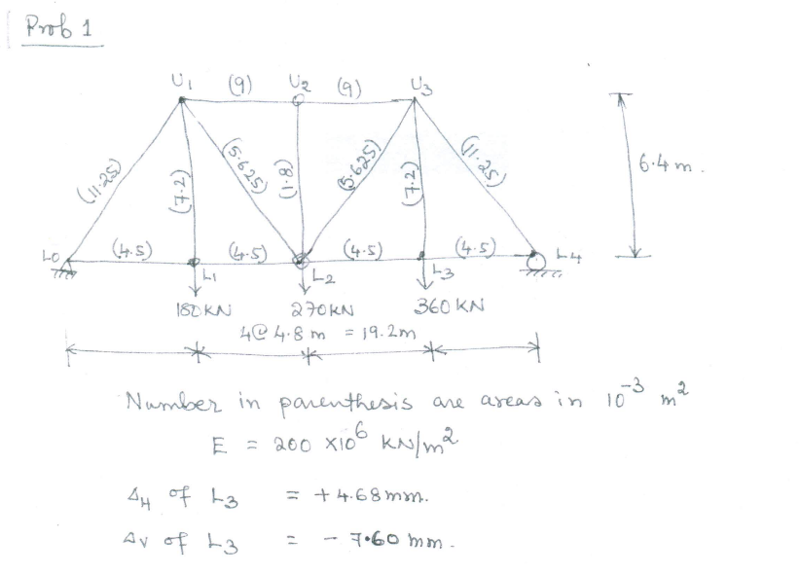

for el=1:numel

n1=elcon(el,1);

n2=elcon(el,2);

%from elcon matrix, two node numbers are being stored from each element number.

x1=Node(n1,1);

y1=Node(n1,2);

% coordinates of node 1 of an element

x2=Node(n2,1);

y2=Node(n2,2);

% coordinates of node 2 of an element

theta=atan2(y2-y1,x2-x1);

%atan2 represents 4 quadrant inverse tangent.

L=sqrt((x2-x1)^2+(y2-y1)^2);

C=cos(theta);

S=sin(theta);

kel=(A(el,1)*E(el,1)/L)*[C^2 C*S -C^2 -C*S;C*S S^2 -C*S -S^2;-C^2 -C*S C^2 C*S;-C*S -S^2 C*S S^2];

k1=2*n1-1;

k2=2*n1;

k3=2*n2-1;

k4=2*n2;

%k1, k2,k3,k4 represents the positions of displacement terms of elemental

%stiffness matrix in global stiffness matrix

Kg(k1:k2,k1:k2)=Kg(k1:k2,k1:k2)+kel(1:2,1:2);

Kg(k1:k2,k3:k4)=Kg(k1:k2,k3:k4)+kel(1:2,3:4);

Kg(k3:k4,k1:k2)=Kg(k3:k4,k1:k2)+kel(3:4,1:2);

Kg(k3:k4,k3:k4)=Kg(k3:k4,k3:k4)+kel(3:4,3:4);

end

Kg([1 2 10],:)=[];

Kg(:,[1 2 10])=[];

K=Kg;

%applying boundary conditions

K;

f=[0;-180000;0;-270000;0;-360000;0;0;0;0;0;0;0];

u=K\f;

displacement=[u(5,1) u(6,1)] %in m

Output:

displacement =

0.0047 -0.0076

**2.2 Trusss-2**

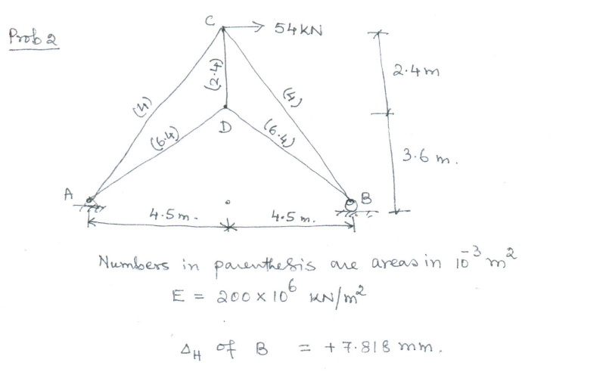

clear all;

clc;

E=10^9*[200; 200; 200;200;200];

A=(1/1000)*[6.4; 6.4; 4; 2.4;4];

% area of each element

Node=[0,0;4.5,3.6;9,0;4.5,6];

%coordinates of nodes

elcon=[1,2;2,3;3 4;2 4;1 4];

%element connectivity matrix. nodes connected to each element.

UBC=[1 1 0;1 2 0; 3 2 0];

% displacement boundary conditions.[node no x or y displacement value]

FBC=[4 1 54000];

%force boundary condition

numnode=size(Node,1);

%returns the number of rows in the array or matrix.

% Numnode means total number of nodes=8 . if size(Node,2) was there

% it may give number of columns i.e 2

numel=size(elcon,1);

%number of elements

Kg=zeros(2*numnode);

%global stiffness matrix is 2 times number of nodes square matrix.

Fg=zeros(2*numnode,1);

%global force vector.

Ug=zeros(2*numnode,1);

%global displacement vector

for el=1:numel

n1=elcon(el,1);

n2=elcon(el,2) ;

%from elcon matrix, two node numbers are being stored from each element number.

x1=Node(n1,1);

y1=Node(n1,2);

% coordinates of node 1 of an element

x2=Node(n2,1);

y2=Node(n2,2);

% coordinates of node 2 of an element

theta=atan2d(y2-y1,x2-x1);

%atan2 represents 4 quadrant inverse tangent.

L=sqrt((x2-x1)^2+(y2-y1)^2);

C=cosd(theta);

S=sind(theta);

kel=(A(el,1)*E(el,1)/L)*[C^2 C*S -C^2 -C*S;C*S S^2 -C*S -S^2;-C^2 -C*S C^2 C*S;-C*S -S^2 C*S S^2];

k1=2*n1-1;

k2=2*n1;

k3=2*n2-1;

k4=2*n2;

%k1, k2,k3,k4 represents the positions of displacement terms of elemental

%stiffness matrix in global stiffness matrix

Kg(k1:k2,k1:k2)=Kg(k1:k2,k1:k2)+kel(1:2,1:2);

Kg(k1:k2,k3:k4)=Kg(k1:k2,k3:k4)+kel(1:2,3:4);

Kg(k3:k4,k1:k2)=Kg(k3:k4,k1:k2)+kel(3:4,1:2);

Kg(k3:k4,k3:k4)=Kg(k3:k4,k3:k4)+kel(3:4,3:4);

end

Kg([1 2 6],:)=[];

Kg(:,[1 2 6])=[];

K=Kg;

%applying boundary conditions

K;

f=[0;0;0;54000;0];

u=K\f;

ux_B=u(3) % Horizontal displacement at B in m

Output:

ux_B =

0.0078

**2.3. Frame**

clc

clear all

E=200e9;

A=0.09;

Ic=6.75*10^(-4);

I_VEC=[Ic; Ic; 2*Ic; 2*Ic; Ic];% Area moment of inertia

node=[0 0;0 4.5;0,7.5;3,7.5;6,7.5;6,2.5]; % node coordinates

elcon=[1 2;2 3;3 4;4,5; 5,6]; % element connectivity matrix

numel=size(elcon,1); %number of elements

numnode=size(node,1); %number of nodes

k_global=zeros(3*numnode);

for el=1:numel

n1=elcon(el,1);

n2=elcon(el,2);

% n1,n2 represent node numbers for 'el'th element.

x1=node(n1,1);

y1=node(n1,2);

% (x1,y1) coordinates of node 1 of an element

x2=node(n2,1);

y2=node(n2,2);

% coordinates of node 2 of an element

theta=atan2d(y2-y1,x2-x1);

%atan2 represents 4 quadrant inverse tangent.

L=sqrt((x2-x1)^2+(y2-y1)^2); % LENGTH OF THE ELEMENT

C=cosd(theta);

S=sind(theta);

I=I_VEC(el,1); % area moment of inertia for 'el'th element

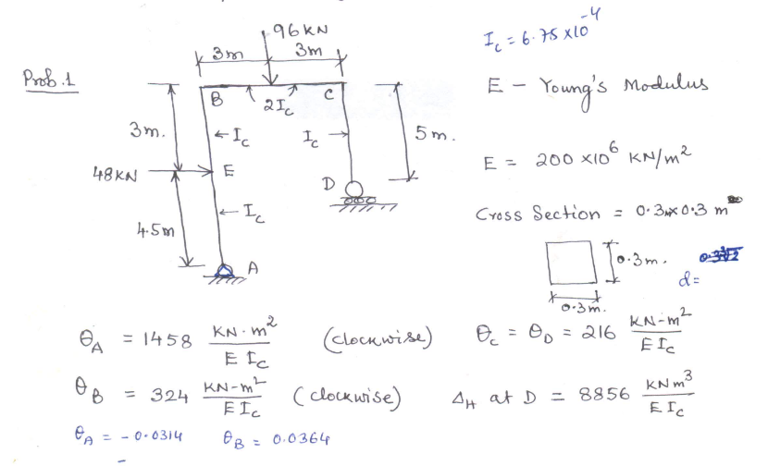

T1=(A*E)/L;

T2=(12*E*I)/L^3;

T3=(4*E*I)/L;

T4=(6*E*I)/L^2;

T5=(2*E*I)/L;

k_el_lcs=[T1 0 0 -T1 0 0;

0 T2 T4 0 -T2 T4;

0 T4 T3 0 -T4 T5;

-T1 0 0 T1 0 0;

0 -T2 -T4 0 T2 -T4;

0 T4 T5 0 -T4 T3]; %elemental stiffness matrix in local

% co ordinate system

TRANSFORMATION_MAT=zeros(6);

TRANSFORMATION_MAT(1:2,1:2)=[C S;-S C];

TRANSFORMATION_MAT(4:5,4:5)=[C S;-S C];

TRANSFORMATION_MAT(3,3)=1;

TRANSFORMATION_MAT(6,6)=1;

k_el_gcs=TRANSFORMATION_MAT.'*k_el_lcs*TRANSFORMATION_MAT

k1=3*n1-2;

k2=3*n1-1;

k3=3*n1;

k4=3*n2-2;

k5=3*n2-1;

k6=3*n2;

k_global(k1:k6,k1:k6)=k_global(k1:k6,k1:k6)+k_el_gcs

%Kg(k1:k2,k3:k4)=Kg(k1:k2,k3:k4)+kel(1:2,3:4)

%Kg(k3:k4,k1:k2)=Kg(k3:k4,k1:k2)+kel(3:4,1:2)

%Kg(k3:k4,k3:k4)=Kg(k3:k4,k3:k4)+kel(3:4,3:4)

end

f_global=[0; 0; 0; 48000; 0; 0; 0; 0; 0; 0; -96000; 0; 0; 0; 0; 0; 0; 0];

k_global([1 2 17],:)=[];

k_global(:,[1 2 17])=[];

f_global([1 2 17],:)=[];

u=k_global\f_global

Theta_ABCD=[u(1);u(7);u(13);u(15)] %in radian

ux_D=u(14) %in m

OUTPUT:

Theta_ABCD =

-0.0108

-0.0024

0.0016

0.0016

ux_D =

0.0656

u =

-0.0108

0.0432

-0.0000

-0.0072

0.0576

-0.0000

-0.0024

0.0576

-0.0034

0.0002

0.0576

-0.0000

0.0016

0.0656

0.0016

**2.4 Beam**

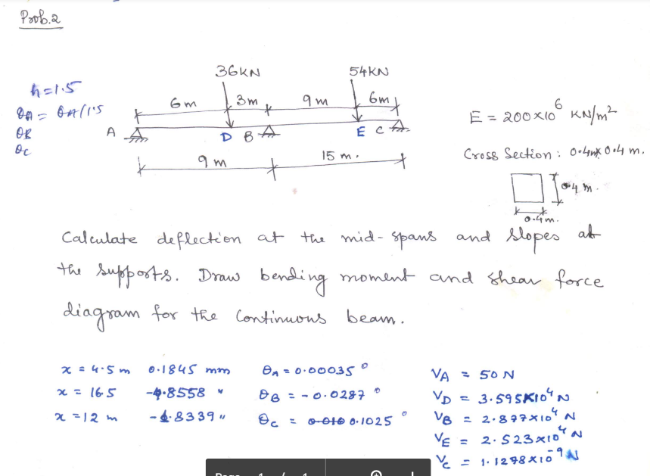

%% Informations given

L=24;

E=200e6;

I=(0.4)^4/12;

F01=36;%Forces are in KN

F02=54;

Node=(0:1.5:L)';% coordinates for nodes

% element connectivity matrix

elcon=zeros(16,2);

for i=1:16

elcon(i,1)=i;

elcon(i,2)=i+1;

end

%%

numnode=size(Node,1); %number of nodes

numel=size(elcon,1); %number of elements

Kg=zeros(2*numnode);

Fg=zeros(2*numnode,1);

Ug=zeros(2*numnode,1);

for el=1:numel

n1=elcon(el,1); %1st node for an element

n2=elcon(el,2); %2nd node for an element

le=L/numel;

kel=((E*I)/le^3)*[12 6*le -12 6*le; 6*le 4*le^2 -6*le 2*le^2; -12 -6*le 12 -6*le; 6*le 2*le^2 -6*le 4*le^2];

k1=2*n1-1;

k2=2*n1;

k3=2*n2-1;

k4=2*n2;

%k1, k2,k3,k4 represents the positions of displacement terms of elemental

%stiffness matrix in global stiffness matrix

Kg(k1:k2,k1:k2)=Kg(k1:k2,k1:k2)+kel(1:2,1:2);

Kg(k1:k2,k3:k4)=Kg(k1:k2,k3:k4)+kel(1:2,3:4);

Kg(k3:k4,k1:k2)=Kg(k3:k4,k1:k2)+kel(3:4,1:2);

Kg(k3:k4,k3:k4)=Kg(k3:k4,k3:k4)+kel(3:4,3:4);

end

Kg;

Kg([1 13 33],:)=[];

Kg(:,[1 13 33])=[];

Fg(9,1)=-36;

Fg(25,1)=-54;

Fg([1 13 33],:)=[];

u=Kg\Fg;

U_y=1000*u([6,15,21],:) %Vertical displacements at 4.5m, 12m, 16.5m.

U_theta=(180/pi)*u([1,12,31],:) %Rotation at A,B and C.

%% SFD & BMD using FEM

%Getting total displacement vector

u_total=zeros(2*numnode,1);

u_total(2:12,:)=u(1:11,:);

u_total(14:32)=u(12:30,:);

u_total(34,1)=u(31,1);

%To store SF and BM in "F_EL" for each node

F_EL=[];

for i=1:numel

u_elemental=[u_total(2*i-1);u_total(2*i);u_total(2*i+1);u_total(2*i+2)];

f_el=kel*u_elemental;

F_EL=[F_EL;f_el];

end

for i=1:numel-1 %Because, last two rows for V and M would not come twice.No need to delete.

F_EL([2*i+1 2*i+2],:)=[];

end

%To extract SF and BM vector seperately from "F_EL"

BM=[];

SF=[];

for i=1:numnode

BM=[BM;F_EL(2*i)];

SF=[SF;F_EL(2*i-1)];

end

%Plotting

subplot(2,1,1)

plot(Node,1000*SF);

xlabel('Distance in m');

ylabel('Shear Force in N');

title('SFD');

grid on;

subplot(2,1,2)

plot(Node,BM);

xlabel('Distance in m');

ylabel('Bending moment in kN.m');

title('BMD');

grid on;

Output:

U_y =

0.1845

-1.8339

-4.8558

U_theta =

0.0023

-0.0192

0.0683

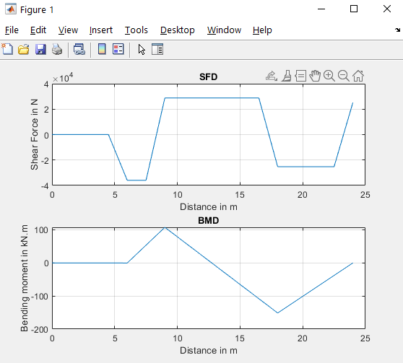

**2.4. Beam (Using Different method)**

*// Error: Level medium☹*

clear all;

clc;

E=200e9;

I=0.4^4/12;

L=24;

q=0;

xi=[-sqrt(1/3); sqrt(1/3)];

w=[1; 1];

%% element connectivity matrix

elcon=zeros(16,2);

for i=1:16

elcon(i,1)=i;

elcon(i,2)=i+1;

end

numel=size(elcon,1);

le=L/numel;

elcon;

numnode=numel+1;

%% coordinates for nodes

Node_coordinate=zeros(numnode,1);

for i=1:numnode

Node_coordinate(i,1)=Node_coordinate(i,1)+(i-1)*le;

end

Node_coordinate;

%% Initialization

Kg=zeros(2*numnode);

%Ug=zeros(2*numnode,1);

Fg=zeros(2*numnode,1);

%% Shape Functions

%N1=0.25*(2-3*xi+xi^3)

%N2=(le/8)*(1-xi-xi^2+xi^3)

%N3=0.25*(2+3*xi-xi^3)

%N4=(le/8)*(-1-xi+xi^2+xi^3)

%% 2nd derivative of shape functions for 1st gauss point

ddN1_1=1.5*xi(1);

ddN2_1=(le/8)*(-2+6*xi(1));

ddN3_1=-1.5*xi(1);

ddN4_1=(le/8)*(2+6*xi(1));

ddN_VEC_1=[ddN1_1; ddN2_1; ddN3_1; ddN4_1];

%% 2nd derivative of shape functions for 2nd gauss point

ddN1_2=1.5*xi(2);

ddN2_2=(le/8)*(-2+6*xi(2));

ddN3_2=-1.5*xi(2);

ddN4_2=(le/8)*(2+6*xi(2));

ddN_VEC_2=[ddN1_2; ddN2_2; ddN3_2; ddN4_2];

%% elemental stiffness matrix

kel=zeros(4);

for i=1:4

for j=1:4

kel(i,j)=E*I*(2/le)^3*(ddN_VEC_1(i)*ddN_VEC_1(j)*w(1)+ddN_VEC_2(i)*ddN_VEC_2(j)*w(2));

end

end

kel;

%% for 1st gauss point

N1_1=0.25*(2-3*xi(1)+xi(1)^3);

N2_1=(le/8)*(1-xi(1)-xi(1)^2+xi(1)^3);

N3_1=0.25*(2+3*xi(1)-xi(1)^3);

N4_1=(le/8)*(-1-xi(1)+xi(1)^2+xi(1)^3);

N_VEC_1=[N1_1;N2_1;N3_1;N4_1];

%% for 2nd gauss point

N1_2=0.25*(2-3*xi(2)+xi(2)^3);

N2_2=(le/8)*(1-xi(2)-xi(2)^2+xi(2)^3);

N3_2=0.25*(2+3*xi(2)-xi(2)^3);

N4_2=(le/8)*(-1-xi(2)+xi(2)^2+xi(2)^3);

N_VEC_2=[N1_2;N2_2;N3_2;N4_2];

%% elemental force vector for distributed load

fel=zeros(4,1);

for i=1:4

fel(i)=(le/2)*q*(N_VEC_1(i)*w(1)+N_VEC_2(i)*w(2));

end

for el=1:numel % el=element number, numel=total no of elements

n1=elcon(el,1);

n2=elcon(el,2);

k1=2*n1-1;

k2=2*n1;

k3=2*n2-1;

k4=2*n2;

%k1, k2,k3,k4 represents the positions of displacement terms of elemental

%stiffness matrix in global stiffness matrix

Kg(k1:k4,k1:k4)=Kg(k1:k4,k1:k4)+kel(1:4,1:4);

Fg(k1:k4,1)=Fg(k1:k4,1)+fel(1:4,1);

end

Fg(5,1)=-36000;

Fg(13,1)=-54000;

Kg([1,13,33],:)=[];

Kg(:,[1,13,33])=[];

Fg([1,13,33],:)=[];

Kg;

Fg;

Ug=Kg\Fg;

U_y=Ug([6,15,21],:) %Vertical displacements at 4.5m, 12m, 16.5m in m.

U_theta=(180/pi)*Ug([1,12,31],:) %Rotation at A,B and C IN DEGREES.

Output*: //(incorrect)!*

U_theta =

-0.0205

0.0121

-0.0060

U_y =

1.0e-03 *

-0.8780

0.4556

0.5933

3.COMPUTATIONAL HYDRAULICS

(1) Gauss Elimination

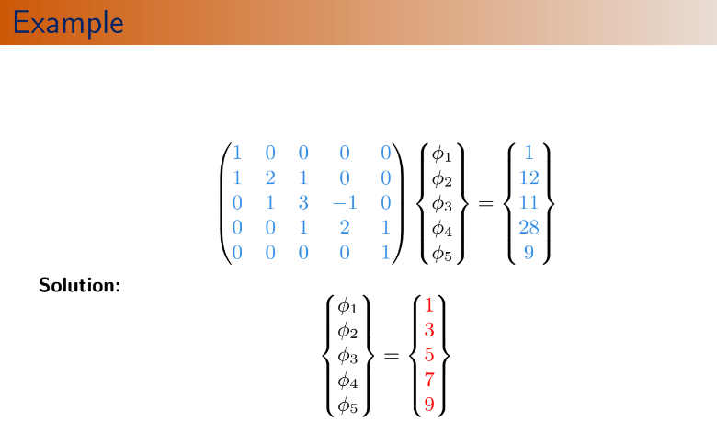

clc

clear

function **phi**=gausselim(**A**, **r**)

*//Linear Equation: A*phi=r*

[nr_A,nc_A]=size(**A**)*//size of A*

[nr_r,nc_r]=size(**r**)*//size of r*

*//" [nr_A,nc_A]=size(A) " retrieves the number of rows and columns of a matrix A and assigns them to the variables "nr_A" and "nc_A", respectively.*

if nc_A<>nr_A then

error('A is not a square matrix')

abort;

*//if nc_A is not equal to nr_A , it means that matrix A is not square*

end

if nc_A<>nr_r then

error('Not compatible matrices')

abort;

end

n=nc_A

*//Forward Elimination*

for k=1:1:n-1

for i=k+1:1:n

gam=**A**(i,k)/**A**(k,k)

for j=k+1:n

**A**(i,j)=**A**(i,j)-gam\***A**(k,j)

end

**r**(i)=**r**(i)-gam\***r**(k)

end

end

*//Backward Substitution*

phi(n)=r(n)/A(n,n)

for i=n-1:-1:1

sumj=r(i)

for j=i+1:n

sumj=sumj-A(i,j)*phi(j)

end

phi(i)=sumj/A(i,i)

end

endfunction

A=[1 0 0 0 0

1 2 1 0 0

0 1 3 -1 0

0 0 1 2 1

0 0 0 0 1];

r=[1

12

11

28

9];

phi=gausselim(A,r)

disp(phi)

Output:

1.

3.

5.

7.0000000

9.

**2. LU Decomposition**

clc

clear

function **phi**=ludcomp(**A**, **r**)

*//Linear Equation:A*phi=r*

[nr_A,nc_A]=size(**A**)*//size of A*

[nr_r,nc_r]=size (**r**)*//size of r*

if nc_A<>nr_A then

error('A is not a square matrix')

abort;

end

if nc_A<>nr_r then

error('Not compatible matrices')

abort;

end

n=nc_A



*//Decomposition*

for k=1:1:n-1

for i=k+1:1:n

gam=A(i,k)/A(k,k)

A(i,k)=gam

for j=k+1:n

A(i,j)=A(i,j)-gam*A(k,j)

end

end

end

*//Forward substitution*

psi(1)=r(1)

for i=2:1:n

sumj=r(i)

for j=1:i-1

sumj=sumj-A(i,j)*psi(j)

end

psi(i)=sumj

end

*//Backward substitution*

phi(n)=psi(n)/A(n,n)

for i=n-1:-1:1

sumj=psi(i)

for j=i+1:n

sumj=sumj-A(i,j)*phi(j)

end

phi(i)=sumj/A(i,i)

end

endfunction

A=[1 0 0 0 0;1 2 1 0 0;0 1 3 -1 0;0 0 1 2 1;0 0 0 0 1];

r=[1

12

11

28

9];

phi=ludcomp(A,r)

Output:

phi

phi =

1.

3.

5.

7.0000000

9.

**3. Tridiagonal matrix method**

Output:

1.

3.

5.

7.

9.

clc

clear

function **phi**=tdmasolv(**b**, **d**, **a**, **r**)

*//n:number of rows*

n=length(**d**);

**a**(1)=**a**(1)/**d**(1);

**r**(1)=**r**(1)/**d**(1);

*//forward elimination*

for i=2:n-1

fact=**d**(i)-**b**(i)\***a**(i-1);

**a**(i)=**a**(i)/fact;

**r**(i)=(**r**(i)-**b**(i)\***r**(i-1))/fact;

end

**r**(n)=(**r**(n)-**b**(n)\***r**(n-1))/(**d**(n)-**b**(n)\***a**(n-1));

*//Backward substitution*

**phi**(n)=**r**(n);

for i=n-1:-1:1

**phi**(i)=**r**(i)-**a**(i)\***phi**(i+1);

end

endfunction

d=[1 2 3 2 1];

b=[0 1 1 1 0];

a=[0 1 -1 1 0];

r=[1 12 11 28 9];

phi=tdmasolv(b,d,a,r)

disp(phi)



**4. Jacobi’s Method:**



clc

clear

function [**count**, **rmse**, **phi**]=jacobi(**A**, **r**, **phio**, **eps_max**)

*//Linear Equation: A*phi=r*

[nr_A,nc_A]=size(**A**)*//size of A*

[nr_r,nc_r]=size (**r**)*//size of r*

if nc_A<>nr_A then

error('A is not a square matrix')

abort;

end

if nc_A<>nr_r then

error('Not compatible matrices')

abort;

end

n=nc_A

**count**=0

**rmse**=1

Output:

1.

3.

5.

7.

9.

while rmse>eps_max

rmse=0

for i=1:n

res(i)=r(i)

for j=1:n

res(i)=res(i)-A(i,j)*phio(j)

end

phi(i)=phio(i)+res(i)/A(i,i)

rmse=rmse+(res(i)/A(i,i)).^2

end

phio=phi

rmse=sqrt(rmse/n)

count=count+1;

end

endfunction

A=[1 0 0 0 0

1 2 1 0 0

0 1 3 -1 0

0 0 1 2 1

0 0 0 0 1];

r=[1

12

11

28

9];

phio=[0

0

0

0

0];

eps_max=1e-6

[count,rmse,phi]=jacobi(A,r,phio,eps_max)

disp(phi)

*//Explanation of the loop*

*//phio = [0; 0; 0]*

*//res1 = r(1) - A(1,1)*phio(1) - A(1,2)*phio(2) - A(1,3)*phio(3)*

*// = 1 - 2*0 - 1*0 - 1*0*

*// = 1*

*//phi(1) = phio(1) + res1/A(1,1)*

*// = 0 + 1/2*

*// = 0.5*

*//*

*//res2 = r(2) - A(2,1)*phio(1) - A(2,2)*phio(2) - A(2,3)*phio(3)*

*// = 1 - 1*0 - 2*0 - 1*0*

*// = 1*

*//phi(2) = phio(2) + res2/A(2,2)*

*// = 0 + 1/2*

*// = 0.5*

*//*

*//res3 = r(3) - A(3,1)*phio(1) - A(3,2)*phio(2) - A(3,3)*phio(3)*

*// = 1 - 1*0 - 1*0 - 3*0*

*// = 1*

*//phi(3) = phio(3) + res3/A(3,3)*

*// = 0 + 1/3*

*// = 0.333*

*//*

*//RMSE = (res1/A(1,1))^2 + (res2/A(2,2))^2 + (res3/A(3,3))^2*

*// = (1/2)^2 + (1/2)^2 + (1/3)^2*

*// = 7/36*

**5. Gauss-Seidal Method**



clc

clear

function [**count**, **rmse**, **phi**]=gseidal(**A**, **r**, **phio**, **eps_max**, **omega**)

*//Linear Equation:A*phi=r*

[nr_A,nc_A]=size(**A**)*//size of A*

[nr_r,nc_r]=size (**r**)*//size of r*

if nc_A<>nr_A then

error('A is not a square matrix')

abort;

end

if nc_A<>nr_r then

error('Not compatible matrices')

abort;

end

n=nc_A

**count**=0

**rmse**=1

**phi**=**phio**

Output:

"solution="

1.

3.

5.

7.

9.

"rmse error="

0.

"count="

5.

while rmse>eps_max

rmse=0

for i=1:1:n

resi=r(i)

for j=1:n

resi=resi-A(i,j)*phi(j)

end

phi(i)=phi(i)+omega*resi/A(i,i)

rmse=rmse+(omega*resi/A(i,i)).^2

end

rmse=sqrt(rmse/n)

count=count+1;

end

endfunction

A=[1 0 0 0 0

1 2 1 0 0

0 1 3 -1 0

0 0 1 2 1

0 0 0 0 1];

r=[1

12

11

28

9];

phio=[0

0

0

0

0];

eps_max=1e-6;

omega=1

[count,rmse,phi]=gseidal(A,r,phio,eps_max,omega)

disp("solution",phi)

disp("rmse error",rmse)

disp("count",count)

**6. Newton-Raphson Method**

clc

clear

function **phi**=ludcomp(**A**, **r**)

*//Linear Equation:A*phi=r*

[nr_A,nc_A]=size(**A**)*//size of A*

[nr_r,nc_r]=size (**r**)*//size of r*

if nc_A<>nr_A then

error('A is not a square matrix')

abort;

end

if nc_A<>nr_r then

error('Not compatible matrices')

abort;

end

n=nc_A

*//Decomposition*

for k=1:1:n-1

for i=k+1:1:n

gam=**A**(i,k)/**A**(k,k)

**A**(i,k)=gam

for j=k+1:n

**A**(i,j)=**A**(i,j)-gam\***A**(k,j)

end

end

end

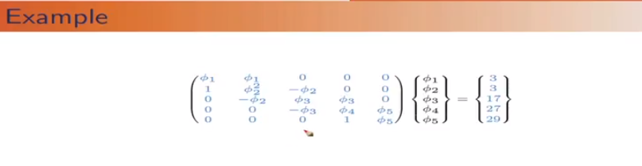

*//Forward substitution*

psi(1)=r(1)

for i=2:1:n

sumj=r(i)

for j=1:i-1

sumj=sumj-A(i,j)*psi(j)

end

psi(i)=sumj

end

*//Backward substitution*

phi(n)=psi(n)/A(n,n)

for i=n-1:-1:1

sumj=psi(i)

for j=i+1:n

sumj=sumj-A(i,j)*phi(j)

end

phi(i)=sumj/A(i,i)

end

endfunction

*//.....*

function **FV**=Fun(**phi**)

**FV**(1)=**phi**(1)^2+**phi**(1)\***phi**(2)-3

**FV**(2)=**phi**(1)+**phi**(2)^3-**phi**(2)\***phi**(3)-3

**FV**(3)=-**phi**(2)^2+**phi**(3)^2+**phi**(3)\***phi**(4)-17

**FV**(4)=-**phi**(3)^2+**phi**(4)^2+**phi**(4)\***phi**(5)-27

**FV**(5)=**phi**(4)+**phi**(5)^2-29

endfunction

function **JV**=JM(**phi**)

**JV**=zeros(length(**phi**),length(**phi**))

*//1*

**JV**(1,1)=2\***phi**(1)+**phi**(2)

**JV**(1,2)=**phi**(1)

*//2*

**JV**(2,1)=1

**JV**(2,2)=3\***phi**(2)^2-**phi**(3)

**JV**(2,3)=-**phi**(3)

*//3*

JV(3,2)=-2*phi(2)

JV(3,3)=2*phi(3)+phi(4)

JV(3,4)=phi(3)

*//4*

JV(4,3)=-2*phi(3)

JV(4,4)=2*phi(4)+phi(5)

JV(4,5)=phi(4)

*//5*

JV(5,4)=1

JV(5,5)=2*phi(5)

endfunction

function [**count**, **rmse**, **phi**]=newtonrn(**phio**, **n**, **eps_max**)

**count**=0

**rmse**=1

while **rmse**>**eps_max**

**rmse**=0

JV=JM(**phio**)

FV=Fun(**phio**)

dphi=ludcomp(JV,-FV)

for i=1:**n**

**phi**(i)=**phio**(i)+dphi(i)

**rmse**=**rmse**+(dphi(i)).^2

end

**phio**=**phi**

**rmse**=sqrt(**rmse**/**n**)

**count**=**count**+1

end

endfunction

*//*

phio1=[1

1

1

1

1];

phio2=[0

0

0

0

0];

phio3=[10

1

100

6

11];

eps_max=1e-6;

n=5

[count,rmse,phi]=newtonrn(phio3,n,eps_max)

FV=Fun(phi)

disp(phi)

Output:

1.0000000

2.0000000

3.0000000

4.0000000

5.0000000

**(7) GW_1D_GAUSS_ELIMINATION**

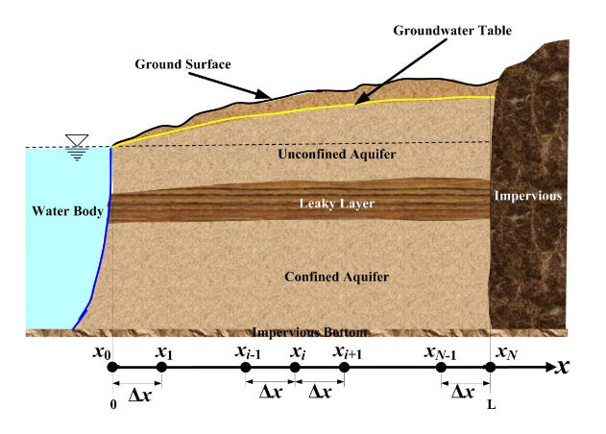

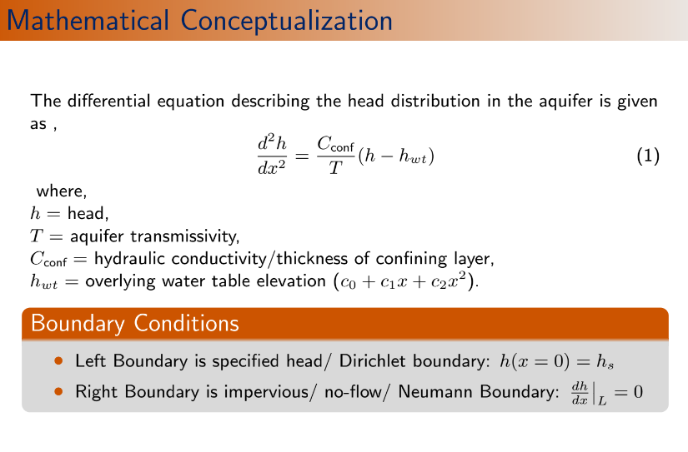

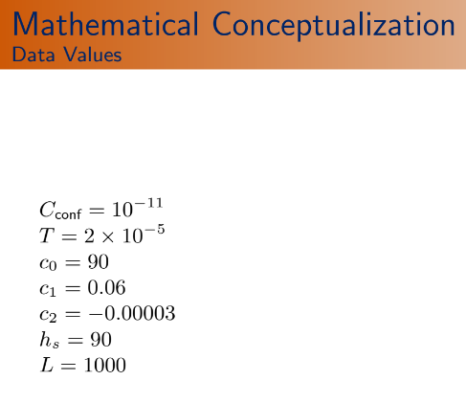

*//Groundwater 1d using Gauss elimination method*

clc

clear

function **phi**=gausselim(**A**, **r**)

*//Linear Equation: A*phi=r*

[nr_A,nc_A]=size(**A**)*//size of A*

[nr_r,nc_r]=size(**r**)*//size of r*

if nc_A<>nr_A then

error('A is not a square matrix')

abort;

end

if nc_A<>nr_r then

error('Not compatible matrices')

abort;

end

n=nc_A

*//Forward Elimination*

for k=1:1:n-1

for i=k+1:1:n

gam=**A**(i,k)/**A**(k,k)

for j=k+1:n

**A**(i,j)=**A**(i,j)-gam\***A**(k,j)

end

**r**(i)=**r**(i)-gam\***r**(k)

end

end

*//Backward Substitution*

**phi**(n)=**r**(n)/**A**(n,n)

for i=n-1:-1:1

sumj=**r**(i)

for j=i+1:n

sumj=sumj-**A**(i,j)\***phi**(j)

end

**phi**(i)=sumj/**A**(i,i)

end

endfunction

*//....Problem dependent parameters*

nnode=21; *//number of nodes*

xl=0;*//coordinate of left end boundary xL*

xr=1000;

cconf=1e-11;

T=2e-5;

hs=90;

c0=90;

c1=0.06;

c2=-0.00003;

*//....*

x=linspace(xl,xr,nnode);*//In between left and right boundary, nnode numbers of x coordinates has been generated.*

delx=x(2)-x(1);*//gird size*

*//.....Initialization of matrices...*

h=zeros(nnode,1);

A=zeros(nnode,nnode);

r=zeros(nnode,1);

*//Left boundary*

A(1,1)=1.0;

r(1)=hs;

*//Interior nodes*

for i=2:nnode-1

A(i,i-1)=1.0/(delx^2);

A(i,i)=-((cconf/T)+2.0/(delx^2));

A(i,i+1)=1.0/(delx^2);

r(i)=-(cconf/T)*(c0+c1*x(i)+c2*x(i)^2);

end

*//Right boundary*

*//Two point*

A(nnode,nnode)=1/delx;

A(nnode,nnode-1)=-1/delx;

r(nnode)=0;

disp(A)

disp(r)

h=gausselim(A,r)

plot(x,h','-r')

disp(max(h))

**Output: //A**

column 1 to 10

1. 0. 0. 0. 0. 0. 0. 0. 0. 0.

0.0004 -0.0008005 0.0004 0. 0. 0. 0. 0. 0. 0.

0. 0.0004 -0.0008005 0.0004 0. 0. 0. 0. 0. 0.

0. 0. 0.0004 -0.0008005 0.0004 0. 0. 0. 0. 0.

0. 0. 0. 0.0004 -0.0008005 0.0004 0. 0. 0. 0.

0. 0. 0. 0. 0.0004 -0.0008005 0.0004 0. 0. 0.

0. 0. 0. 0. 0. 0.0004 -0.0008005 0.0004 0. 0.

0. 0. 0. 0. 0. 0. 0.0004 -0.0008005 0.0004 0.

0. 0. 0. 0. 0. 0. 0. 0.0004 -0.0008005 0.0004

0. 0. 0. 0. 0. 0. 0. 0. 0.0004 -0.0008005

0. 0. 0. 0. 0. 0. 0. 0. 0. 0.0004

0. 0. 0. 0. 0. 0. 0. 0. 0. 0.

0. 0. 0. 0. 0. 0. 0. 0. 0. 0.

0. 0. 0. 0. 0. 0. 0. 0. 0. 0.

0. 0. 0. 0. 0. 0. 0. 0. 0. 0.

0. 0. 0. 0. 0. 0. 0. 0. 0. 0.

0. 0. 0. 0. 0. 0. 0. 0. 0. 0.

0. 0. 0. 0. 0. 0. 0. 0. 0. 0.

0. 0. 0. 0. 0. 0. 0. 0. 0. 0.

0. 0. 0. 0. 0. 0. 0. 0. 0. 0.

0. 0. 0. 0. 0. 0. 0. 0. 0. 0.

column 11 to 20

0. 0. 0. 0. 0. 0. 0. 0. 0. 0.

0. 0. 0. 0. 0. 0. 0. 0. 0. 0.

0. 0. 0. 0. 0. 0. 0. 0. 0. 0.

0. 0. 0. 0. 0. 0. 0. 0. 0. 0.

0. 0. 0. 0. 0. 0. 0. 0. 0. 0.

0. 0. 0. 0. 0. 0. 0. 0. 0. 0.

0. 0. 0. 0. 0. 0. 0. 0. 0. 0.

0. 0. 0. 0. 0. 0. 0. 0. 0. 0.

0. 0. 0. 0. 0. 0. 0. 0. 0. 0.

0.0004 0. 0. 0. 0. 0. 0. 0. 0. 0.

-0.0008005 0.0004 0. 0. 0. 0. 0. 0. 0. 0.

0.0004 -0.0008005 0.0004 0. 0. 0. 0. 0. 0. 0.

0. 0.0004 -0.0008005 0.0004 0. 0. 0. 0. 0. 0.

0. 0. 0.0004 -0.0008005 0.0004 0. 0. 0. 0. 0.

0. 0. 0. 0.0004 -0.0008005 0.0004 0. 0. 0. 0.

0. 0. 0. 0. 0.0004 -0.0008005 0.0004 0. 0. 0.

0. 0. 0. 0. 0. 0.0004 -0.0008005 0.0004 0. 0.

0. 0. 0. 0. 0. 0. 0.0004 -0.0008005 0.0004 0.

0. 0. 0. 0. 0. 0. 0. 0.0004 -0.0008005 0.0004

0. 0. 0. 0. 0. 0. 0. 0. 0.0004 -0.0008005

0. 0. 0. 0. 0. 0. 0. 0. 0. -0.02

column 21

0.

0.

0.

h

h =

90.

90.404091

90.805031

91.199852

91.585767

91.960164

92.320605

92.664822

92.990714

93.296344

93.579938

93.839882

94.074719

94.283150

94.464029

94.616363

94.739311

94.832183

94.894439

94.925688

94.925688

//r

90.

-0.0000465

-0.0000478

-0.0000492

-0.0000504

-0.0000516

-0.0000526

-0.0000537

-0.0000546

-0.0000555

-0.0000562

-0.0000570

-0.0000576

-0.0000582

-0.0000586

-0.0000591

-0.0000594

*//max(h)*

94.925688

0.

0.

0.

0.

0.

0.

0.

0.

0.

0.

0.

0.

0.

0.

0.

0.

0.0004

0.02

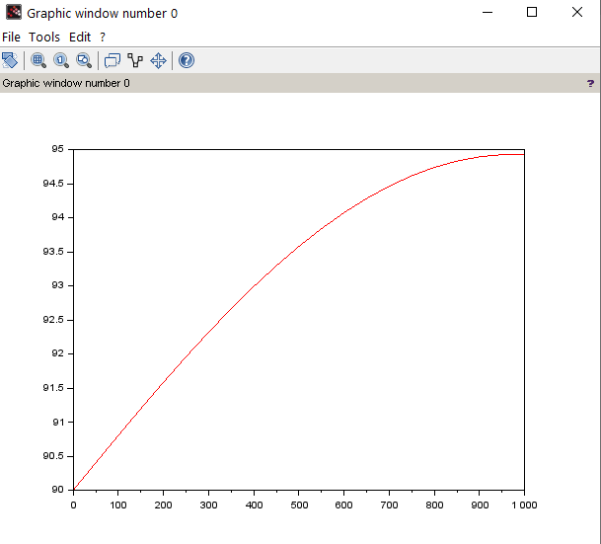

**(8) GW_1D_TDMA**







*//Groundwater 1D using Tridiagonal matrix method*

clc

clear

function **phi**=tdmasolv(**b**, **d**, **a**, **r**)

*//n:number of rows*

n=length(**d**);

**a**(1)=**a**(1)/**d**(1);

**r**(1)=**r**(1)/**d**(1);

*//forward elimination*

for i=2:n-1

fact=**d**(i)-**b**(i)\***a**(i-1);

**a**(i)=**a**(i)/fact;

**r**(i)=(**r**(i)-**b**(i)\***r**(i-1))/fact;

end

**r**(n)=(**r**(n)-**b**(n)\***r**(n-1))/(**d**(n)-**b**(n)\***a**(n-1));

*//Backward substitution*

**phi**(n)=**r**(n);

for i=n-1:-1:1

**phi**(i)=**r**(i)-**a**(i)\***phi**(i+1);

end

endfunction

*//....Problem dependent parameters*

nnode=21; *//number of nodes*

xl=0;*//coordinate of left end boundary xL*

xr=1000;

cconf=1e-11;

T=2e-5;

hs=90;

c0=90;

c1=0.06;

c2=-0.00003;

*//....*

x=linspace(xl,xr,nnode);*//In between left and right boundary, nnode numbers of x coordinates has been generated.*

delx=x(2)-x(1);*//gird size*

*//.....Initialization of matrices...*

h=zeros(nnode,1);

a=zeros(nnode,1);

d=zeros(nnode,1);

b=zeros(nnode,1);

r=zeros(nnode,1);

*//Left boundary*

d(1,1)=1.0;

r(1)=hs;

*//Interior nodes*

for i=2:nnode-1

b(i,1)=1.0/(delx^2);

d(i,1)=-((cconf/T)+2.0/(delx^2));

a(i,1)=1.0/(delx^2);

r(i)=-(cconf/T)*(c0+c1*x(i)+c2*x(i)^2);

end

*//Right boundary*

*//Two point*

d(nnode,1)=1/delx;

b(nnode,1)=-1/delx;

r(nnode)=0;

h=tdmasolv(b,d,a,r)

plot(x,h','-r')

disp("Head at nodes",h)

disp("maximum head",max(h))

Output:

"Head at nodes"

90.

90.404091

90.805031

91.199852

91.585767

91.960164

92.320605

92.664822

92.990714

93.296344

93.579938

93.839882

94.074719

94.283150

94.464029

94.616363

94.739311

94.832183

94.894439

94.925688

94.925688

"maximum head"

94.925688

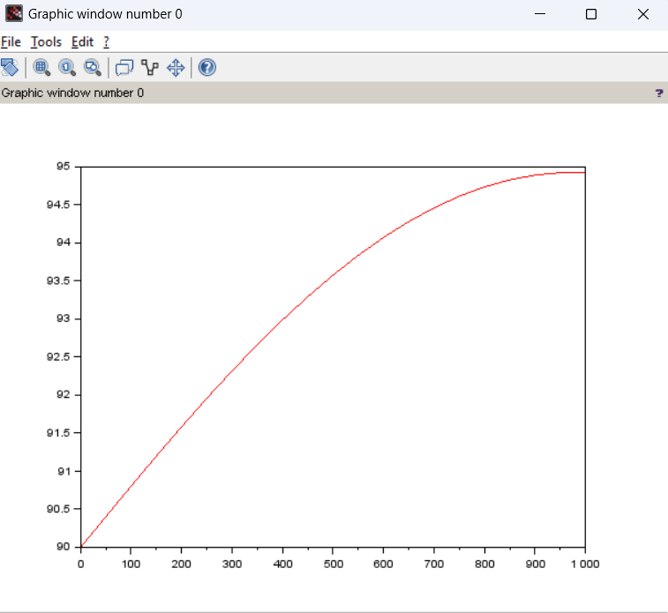

**(9) GW_1D_Gauss_Seidel**:







clc

clear

function [**count**, **rmse**, **phi**]=gseidel(**A**, **r**, **phio**, **eps_max**, **omega**)

*//Linear Equation:A*phi=r*

[nr_A,nc_A]=size(**A**)*//size of A*

[nr_r,nc_r]=size (**r**)*//size of r*

if nc_A<>nr_A then

error('A is not a square matrix')

abort;

end

if nc_A<>nr_r then

error('Not compatible matrices')

abort;

end

n=nc_A

**count**=0

**rmse**=1

**phi**=**phio**

while **rmse**>**eps_max**

**rmse**=0

for i=1:1:n

resi=**r**(i)

for j=1:n

resi=resi-**A**(i,j)\***phi**(j)

end

**phi**(i)=**phi**(i)+**omega**\*resi/**A**(i,i)

**rmse**=**rmse**+(**omega**\*resi/**A**(i,i)).^2

end

**rmse**=sqrt(**rmse**/n)

**count**=**count**+1;

disp("Count rmse",[count rmse])

end

endfunction

*//....Problem dependent parameters*

nnode=31; *//number of nodes*

xl=0;*//coordinate of left end boundary xL*

xr=1000;

cconf=1e-11;

T=2e-5;

hs=90;

c0=90;

c1=0.06;

c2=-0.00003;

x=linspace(xl,xr,nnode);*//In between left and right boundary, nnode numbers of x coordinates has been generated.*

delx=x(2)-x(1);*//gird size*

*//.....Initialization of matrices...*

h=zeros(nnode,1);

A=zeros(nnode,nnode);

r=zeros(nnode,1);

*//Left boundary*

A(1,1)=1.0;

r(1)=hs;

*//Interior nodes*

for i=2:nnode-1

A(i,i-1)=(1.0/(delx^2))*delx^2;

A(i,i)=-((cconf/T)+2.0/(delx^2))*delx^2;

A(i,i+1)=(1.0/(delx^2))*delx^2;

r(i)=-(cconf/T)*(c0+c1*x(i)+c2*x(i)^2)*delx^2;*//delx^2 is multiplied with each term for scaling*

end

*//Right boundary*

*//Two point*

A(nnode,nnode)=(1/delx)*delx;

A(nnode,nnode-1)=-(1/delx)*delx;*//delx is multiplied for scaling*

r(nnode)=0;

*//....*

ho=hs*ones(nnode,1); *//Initial guess =value specified at left hand boundary*

eps_max=1e-6

omega=1

[count,rmse,h]=gseidel(A,r,ho,eps_max,omega)

plot(x,h','-g')

[L,U,E]=lu(A)

D=diag(diag(A))

for i=1:nnode

L(i,i)=0

U(i,i)=0

end

c=-inv(D)*(L+U)

eigv=max(abs(spec(c)))

disp("Eigenvalue",eigv)

Output:

"Count rmse"

1. 0.0117472

"Count rmse"

2. 0.0117093

"Count rmse"

3. 0.0116714

"Count rmse"

4. 0.0116335

"Count rmse"

5. 0.0115956

.

.

.

.

"Count rmse"

2858. 0.000001

"Count rmse"

2859. 0.000001

"Eigenvalue"

0.9740632

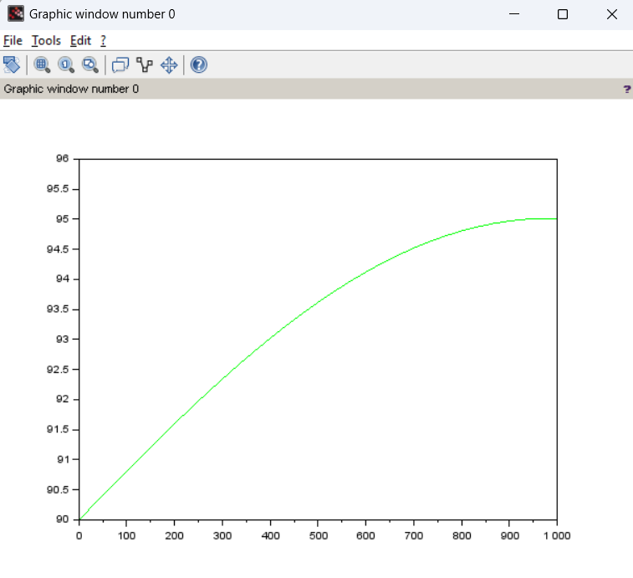

**(10) GW_LAPLACE_2D**

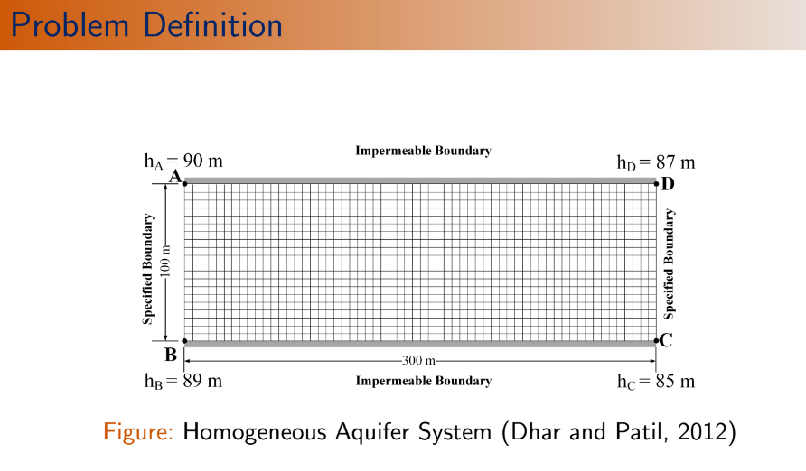

*//GW LAPLACE 2D*

clc

clear

*//...problem dependent parameters...*

mnode=31;

nnode=21;

Lx=300;

Ly=100;

hA=90;

hB=89;

hC=85;

hD=87;

*//calculated values of parameters*

delta_x=Lx/(mnode-1);

delta_y=Ly/(nnode-1);

x=0:delta_x:Lx;

y=0:delta_y:Ly;

alphax=1/(delta_x)^2;

alphay=1/(delta_y)^2;

mnnode=mnode*nnode;

A=zeros(mnnode,mnnode);

r=zeros(mnnode,1);

for j=1:nnode

for i=1:mnode

l=i+(j-1)*mnode; *//single index notation*

*//corner points are considered at specified boundary condition*

*//node A*

if (i==1 & j==nnode) then

A(l,l)=1;

r(l)=hA;

end

*//node B*

if (i==1 &j==1) then

A(l,l)=1;

r(l)=hB;

end

*//Node c*

if (i==mnode & j==1)then

A(l,l)=1;

r(l)=hC;

end

*//Node D*

if (i==mnode & j==nnode)then

A(l,l)=1;

r(l)=hD;

end

*//Interior points*

if (i>1 & i<mnode) then

if(j>1 & j<nnode)then

A(l,l-mnode)=alphay;

A(l,l-1)=alphax;

A(l,l)=-2*(alphax+alphay)

A(l,l+1)=alphax;

A(l,l+mnode)=alphay;

r(l)=0;

end

end

*//specified LBC*

if (i==1) then

if (j>1 & j<nnode)then

A(l,l)=1.0;

r(l)=hB+(hA-hB)*(j-1)*(delta_y/Ly);

end

end

*//specified RBC*

if (i==mnode) then

if (j>1 & j<nnode)then

A(l,l)=1.0;

r(l)=hC+(hD-hC)*(j-1)*(delta_y/Ly);

end

end

*//No flow BBC*

if (j==1)then

if (i>1 & i<mnode)then

*//3 point boundary*

A(l,l)=-3/(2*delta_y);

A(l,l+mnode)=4/(2*delta_y);

A(l,l+2*mnode)=-1/(2*delta_y);

r(l)=0;

end

end

*//No flow TBC*

if (j==nnode) then

if (i>1 & i<mnode)then

*//3 point boundary*

A(l,l)=-3/(2*delta_y);

A(l,l-mnode)=4/(2*delta_y);

A(l,l-2*mnode)=-1/(2*delta_y);

r(l)=0;

end

end

end

end

*//Solution of system*

h=A\r

for j=1:nnode

for i=1:mnode

l=i+(j-1)*mnode;

hdata(i,j)=h(l);

end

end

contour(x,y,hdata,30)

xtitle("2D model","x axis","y axis");

plot([0 300],[100 100],'-')

plot([300,300],[0 100],'-')

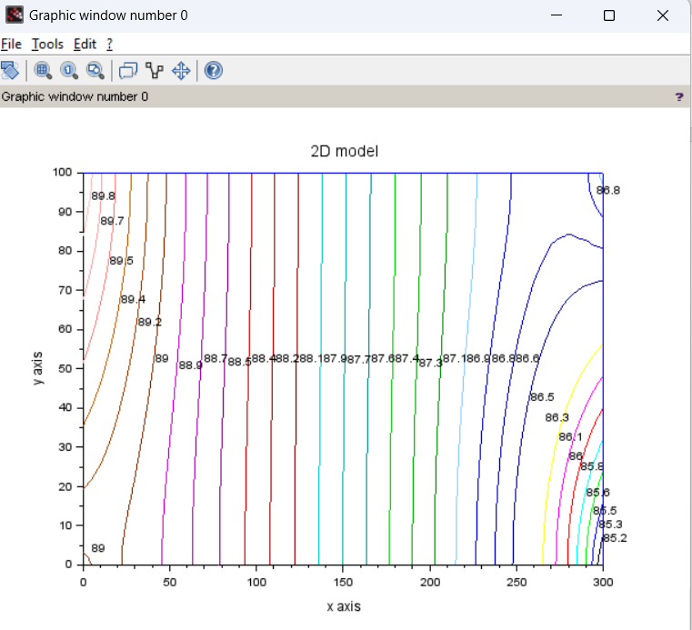

Output:

**(11) GW_STEADY_LAPLACE_2D_ITERATIVE**

clc

clear

*//...problem dependent parameters...*

mnode=31;

nnode=21;

Lx=300;

Ly=100;

hA=90;

hB=89;

hC=85;

hD=87;

omega=1.0;

*//calculated values of parameters*

delta_x=Lx/(mnode-1);

delta_y=Ly/(nnode-1);

x=0:delta_x:Lx;

y=0:delta_y:Ly;

alphax=1/(delta_x)^2;

alphay=1/(delta_y)^2;

eps_max=1e-3;



*//initialization*

h=hA*ones(mnode,nnode);

count=0;

rmse=1

while rmse>eps_max

rmse=0;

for j=1:nnode

for i=1:mnode

if (i>1 & i<mnode) then

if (j>1 & j<nnode) then *//interor nodes*

cencoff=-2*(alphax+alphay);

res=-alphay*h(i,j-1)-alphax*h(i-1,j)+2*(alphax+alphay)*h(i,j)-alphax*h(i+1,j)-alphay*h(i,j+1);

h(i,j)=h(i,j)+omega*res/cencoff

rmse=rmse+(omega*res/cencoff).^2;

end

end

*//Node A*

if (i==1 & j==nnode)then

h(i,j)=hA;

end

*//Node B*

if (i==1 & j==1) then h(i,j)=hB; end

*//Node C*

if (i==mnode & j==1) then h(i,j)=hC; end

*//Node D*

if (i==mnode & j==nnode) then h(i,j)=hD;end

*//Specified LBC*

if (i==1) then

if (j>1 & j<nnode)then

h(i,j)=hB+(hA-hB)*(j-1)*(delta_y/Ly);

end

end

*//Specified RBC*

if (i==mnode) then

if (j>1 & j<nnode) then

h(i,j)=hC+(hD-hC)*(j-1)*(delta_y/Ly);

end

end

*//Neuman BBC*

if (j==1) then

if(i>1 & i<mnode) then

h(i,j)=(4*h(i,j+1)-h(i,j+2))/3;

end

end

*//Neumann TBC*

if (j==nnode) then

if (i>1 & i<mnode)then

*//3 point*

h(i,j)=(4*h(i,j-1)-h(i,j-2))/3;

end

end

end

end

rmse=sqrt(rmse/(mnode*nnode)); *//overall rmse value*

count=count+1

disp([count rmse])

end

contour(x,y,h,50)

xtitle("2D model","x axis","y axis");

plot([0 300],[100 100],'-')

plot([300,300],[0 100],'-')

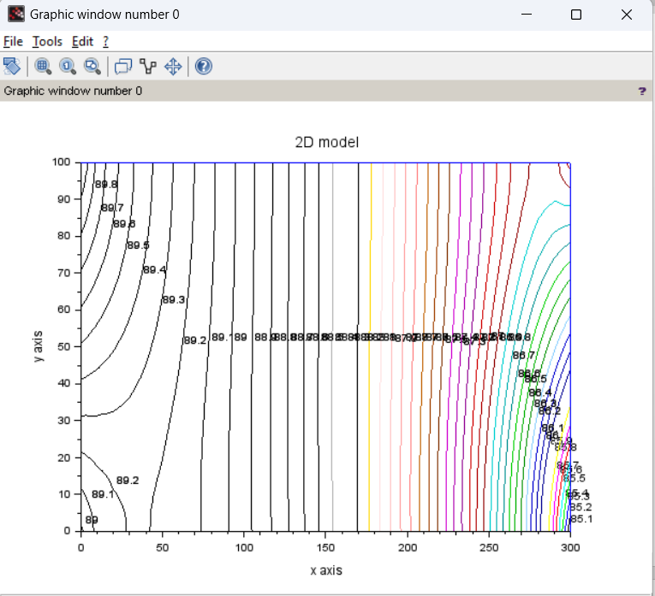

**Output:**

1. 0.0158392

2. 0.1121481

3. 0.0803617

4. 0.0624525

5. 0.0513152

.

.

.

.

663. 0.0010074

664. 0.0010054

665. 0.0010033

666. 0.0010012

667. 0.0009991

**(12) GW_UNSTEADY_2D_EXPLICIT**

***//Error level: low. ( Some cross-contours in graph). ☹***

clc

clear

*//....Problem dependent paramaters...*

mnode=31;

nnode=21;

Lx=300;

Ly=100;

hA=90;

hB=89;

hC=85;

hD=87;

Time_max=5;

eps_max=1e-3;

S=5e-5;*//storativity*

T=200;*//Transmissivity*

*//Calculated parameter values*

delta_x=Lx/(mnode-1);

delta_y=Ly/(nnode-1);

x=0:delta_x:Lx;

y=0:delta_y:Ly;

delta_t=0.5;*//we assumed. May need to be recalculated based on alphax and alphay values.*

alphax=(T*delta_t)/(S*delta_x^2);

alphay=(T*delta_t)/(S*delta_y^2);

sumalpha=alphax+alphay;



while sumalpha>0.5

delta_t=delta_t/2

alphax=(T*delta_t)/(S*delta_x^2);

alphay=(T*delta_t)/(S*delta_y^2);

sumalpha=alphax+alphay;*//this while loop is to ensure stability criteria of explicit problem and to take appropriate delta_t value.*

End

disp("delta_t",delta_t)

*//Initialization*

ho=hA*ones(mnode,nnode);*//ho for old time level*

hn=zeros(mnode,nnode);*//hn for new time level*

*//Boundary Condition*

for j=1:nnode

*//Dirichlet LBC*

ho(1,j)=hB+(hA-hB)*(j-1)*(delta_y/Ly);

*//Dirichlet RBC*

ho(mnode,j)=hC+(hD-hC)*(j-1)*(delta_y/Ly);

end

count=0;

rmse=1;

t=0;

*//Time loop*

while t<Time_max

t=t+delta_t;

*//Interior node*

for j=1:nnode

for i=1:mnode

if (i>1 & i<mnode)then

if (j>1 & j<nnode)then

hn(i,j)=alphay*ho(i,j-1)+alphax*ho(i-1,j)+(1-2*(alphax+alphay))*ho(i,j)+alphax*ho(i+1,j)+alphay*ho(i,j+1);

end

end

end

end

*//Boundary nodes*

for j=1:nnode

for i=1:mnode

*//node A*

if (i==1 & j==nnode)then

hn(i,j)=hA;

end

*//Node B*

if (i==1 & j==1) then hn(i,j)=hB; end

*//Node C*

if (i==mnode & j==1) then hn(i,j)=hC; end

*//Node D*

if (i==mnode & j==nnode) then hn(i,j)=hD;end

*//Specified LBC*

if (i==1) then

if (j>1 & j<nnode)then

hn(i,j)=hB+(hA-hB)*(j-1)*(delta_y/Ly);

end

end

*//Specified RBC*

if (i==mnode) then

if (j>1 & j<nnode) then

hn(i,j)=hC+(hD-hC)*(j-1)*(delta_y/Ly);

end

end

*//Neuman BBC*

if (j==1) then

if(i>1 & i<mnode) then

hn(i,j)=(4*hn(i,j+1)-hn(i,j+2))/3;

end

end

*//Neumann TBC*

if (j==nnode) then

if (i>1 & i<mnode)then

*//3 point*

hn(i,j)=(4*hn(i,j-1)-hn(i,j-2))/3; *//Boundary conditions are evaluated based on new time level values*

end

end

end

end

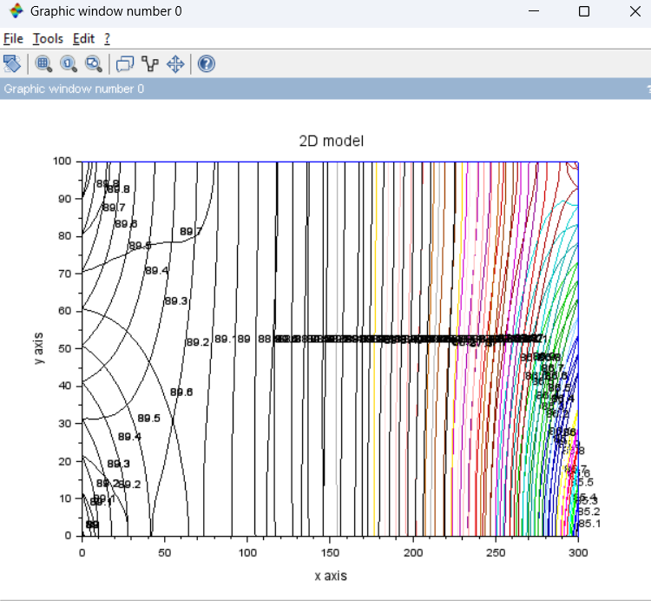

Output:

"delta_t"

0.0000019

"t rmse"

0.0000019 0.0559856

"t rmse"

0.0000038 0.0476177

"t rmse"

0.0000057 0.0411457

.

.

.

.

"t rmse"

0.0012608 0.0010001

"t rmse"

0.0012627 0.0009991

rmse=0;

for j=1:nnode

for i=1:mnode

rmse=rmse+(hn(i,j)-ho(i,j)).^2;

ho(i,j)=hn(i,j);

end

end

rmse=sqrt(rmse/(mnode*nnode));

disp("t rmse",[t rmse])

if (rmse<eps_max) then

break *//while loop terminated*

end

end

contour(x,y,hn,50)

xtitle("2D model","x axis","y axis");

plot([0 300],[100 100],'-')

plot([300,300],[0 100],'-')

**(13) GW_UNSTEADY_2D_IMPLICIT_ITERATIVE**

clc

clear

*//....Problem dependent paramaters...*

mnode=31;

nnode=21;

Lx=300;

Ly=100;

hA=90;

hB=89;

hC=85;

hD=87;

Time_max=5;

eps_max=1e-3;

S=5e-5;*//storativity*

T=200;*//Transmissivity*

omega=1;

delta_x=Lx/(mnode-1);

delta_y=Ly/(nnode-1);

x=0:delta_x:Lx;

y=0:delta_y:Ly;

delta_t=0.5;*//Implicit scheme is unconditionally stable.No need to update*

alphax=(T*delta_t)/(S*delta_x^2);

alphay=(T*delta_t)/(S*delta_y^2);



*//Initialization*

ho=hA*ones(mnode,nnode);

hn=zeros(mnode,nnode);

*//Boundary Condition*

for j=1:nnode

*//Dirichlet LBC*

ho(1,j)=hB+(hA-hB)*(j-1)*(delta_y/Ly);

*//Dirichlet RBC*

ho(mnode,j)=hC+(hD-hC)*(j-1)*(delta_y/Ly);

end

*//Time loop*

t=0;

while t<Time_max

t=t+delta_t;

count=0;

rmse=1;

*//space loop*

while rmse>eps_max

rmse=0;

for j=1:nnode

for i=1:mnode

if (i>1 & i<mnode) then

if (j>1 & j<nnode) then *//interor nodes*

cencoff=-(1+2*(alphax+alphay));

res=-ho(i,j)-alphay*hn(i,j-1)-alphax*hn(i-1,j)+(1+2*(alphax+alphay)*hn(i,j))-alphax*hn(i+1,j)-alphay*hn(i,j+1);

hn(i,j)=hn(i,j)+omega*res/cencoff

rmse=rmse+(omega*res/cencoff).^2;

end

end

*//node A*

if (i==1 & j==nnode)then

hn(i,j)=hA;

end

*//Node B*

if (i==1 & j==1) then hn(i,j)=hB; end

*//Node C*

if (i==mnode & j==1) then hn(i,j)=hC; end

*//Node D*

if (i==mnode & j==nnode) then hn(i,j)=hD;end

*//Specified LBC*

if (i==1) then

if (j>1 & j<nnode)then

hn(i,j)=hB+(hA-hB)*(j-1)*(delta_y/Ly);

end

end

*//Specified RBC*

if (i==mnode) then

if (j>1 & j<nnode) then

hn(i,j)=hC+(hD-hC)*(j-1)*(delta_y/Ly);

end

end

*//Neuman BBC*

if(j==1)then

if (i>1 & i<mnode) then

res=hn(i,j+1)-hn(i,j);

hn(i,j)=hn(i,j)+omega*(hn(i,j+1)-hn(i,j));*//evaluated considering 2 points*

rmse=rmse+(omega*res).^2; *//sum of individual errors*

end

end

*//Neuman TBC*

if(j==nnode)then

if (i>1 & i<mnode) then

res=hn(i,j-1)-hn(i,j);

hn(i,j)=hn(i,j)+omega*(hn(i,j-1)-hn(i,j));

rmse=rmse+(omega*res).^2;

end

end

end

end

rmse=sqrt(rmse/(mnode*nnode)); *//overall rmse value*

count=count+1

disp([count rmse])

end

rmse=0;

for j=1:nnode

for i=1:mnode

rmse=rmse+(hn(i,j)-ho(i,j)).^2;

ho(i,j)=hn(i,j);

end

end

if (rmse<eps_max) then

break *//while loop terminated*

end

end

contour(x,y,hn,30)

xtitle("2D model","x axis","y axis");

plot([0 300],[100 100],'-')

plot([300,300],[0 100],'-')

Output:

*//count rmse*

1. 2.5735614

2. 3.0996063

3. 2.3321854

4. 1.8629285

5. 1.5528867

.

.

.

2 425. 0.0010022

2426. 0.0010001

2427. 0.000998

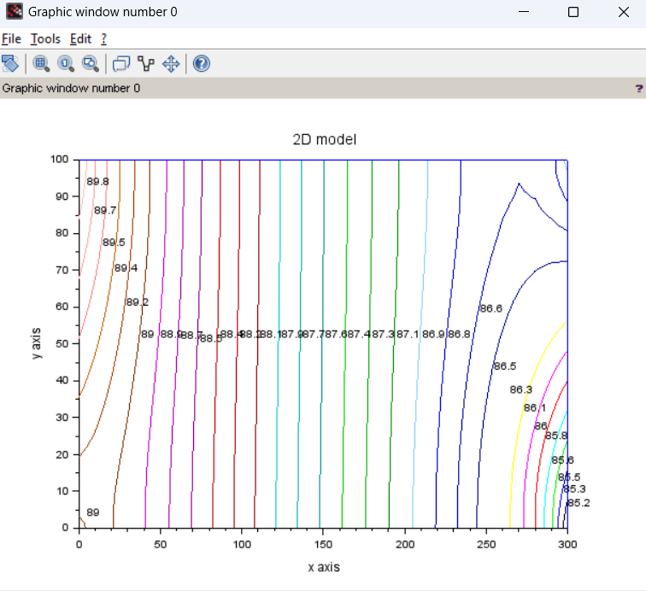

**(14)** **GW unsteady 2D iterative implicit FVM**

**//Error level: …… (Syntax error, no output is coming). ☹**

clc

clear

*//GW unsteady 2D iterative implicit FVM*

*//....Problem dependent parameters..*

mnode=31;

nnode=21;

mcell=mnode-1;

ncell=nnode-1;

Lx=300;

Ly=100;

hA=90;

hB=89;

hC=85;

hD=87;

Time_max=50;

eps_max=1e-3;

S=5e-5;*//storativity*

T=200;*//Transmissivity*

omega=1;

delta_x=Lx/(mnode-1);

delta_y=Ly/(nnode-1);

x=delta_x/2:delta_x:(Lx-delta_x/2);

y=delta_y/2:delta_y:(Ly-delta_y/2);

delta_t=0.5;

alphax=(T*delta_t)/(S*delta_x^2);

alphay=(T*delta_t)/(S*delta_y^2);



*//modified corner heads (Because, these values should be defined at cell centered positions, not at the corners anymore)*

hAm=hB+((hA-hB)/Ly)*(Ly-delta_y/2); *//Ly-delta_y/2 is the distance between corner point B and cell centered A.*

hBm=hB+((hA-hB)/Ly)*(delta_y/2);

hCm=hC+((hD-hC)/Ly)*(delta_y/2);

hDm=hC+((hD-hC)/Ly)*(Ly-delta_y/2);

*//Initialization*

ho=hA*ones(mcell,ncell);*//old time level*

hn=hA*ones(mcell,ncell);*//New time level*

*//Time loop*

t=0;

while t<Time_max

t=t+delta_t;

count=0;

rmse=1;

*//space loop*

while rmse>eps_max

rmse=0;

for j=1:ncell

for i=1:mcell

*//Interior nodes*

if(i>1 & i<mcell) then

if(j>1 & j<ncell)then

a_S=alphay;

a_W=alphax;

a_P=-1-(2*(alphax+alphay));

a_E=alphax;

a_N=alphay;

r_P=-ho(i,j);

res=r_P-(a_S*hn(i,j-1)+a_W*hn(i-1,j)+a_P*hn(i,j)+a_E*hn(i+1,j)+a_N*hn(i,j+1));

end

end

*//cell A*

if (i==1 & j==ncell) then

a_S=alphay;

a_W=0;

a_P=-1-4*alphax-alphay;

a_E=(4/3)*alphax;

a_N=0;

end

*//Cell B*

if (i==1 & j==1) then

a_S=0;

a_W=0;

a_P=-1-4*alphax-alphay;

a_E=(4/3)*alphax;

a_N=alphay;

r_P=-ho(i,j)-(8/3)*alphax*hBm;

res=r_P-(a_P*hn(i,j)+a_E*hn(i+1,j)+a_N*hn(i,j+1));

end

*//Cell C*

if (i==mcell & j==1) then

a_P=-1-4*alphax-alphay;

res=(-ho(i,j)-(8/3)*alphax*hCm)-((4/3)*alphax*hn(i-1,j)-(1+4*alphax+alphay)*hn(i,j)+alphay*hn(i,j+1));

end

*//Cell D*

if (i==mcell & j==ncell) then

a_P=-(1+4*alphax+alphay);

res=(-ho(i,j)-(8/3)*alphax*hDm)-(alphay*hn(i,j-1)+(4/3)*alphax*hn(i-1,j)-(1+4*alphax+alphay)*hn(i,j));

end

*//Specified LBC*

if (i==1) then

if (j>1 & j<ncell)then

a_P=-(1+4*alphax+2*alphay);

hvl=hBm+(hAm-hBm)*(j-1)*((delta_y)/(Ly-delta_y)); *//hvl=head value at the left boundary.As FVM considers cell centered values dimensions of the domain length=(Lx-delta_x) and width=(Ly-delta_y)*

res=(-ho(i,j)-(8/3)*alphax*hvl)-(alphay*hn(i,j-1)-(1+4*alphax+2*alphay)*hn(i,j)+(4/3)*alphax*hn(i+1,j)+alphay*hn(i,j+1));

end

end

*//Specified RBC*

if (i==mcell) then

if (j>1 & j<ncell)then

a_P=-(1+4*alphax+2*alphay);

hvr=hCm+(hDm-hCm)*(j-1)*delta_y/(Ly-delta_y);

res=(-ho(i,j)-(8/3)*alphax*hvr)-(alphay*hn(i,j-1)-(1+4*alphax+2*alphay)*hn(i,j)+(4/3)*alphax*hn(i-1,j)+alphay*hn(i,j+1))

end

*//Neumann TBC*

if (j==ncell) then

if (i>1 & i<mcell)then

a_P=-(1+2*alphax+alphay);

res=-ho(i,j)-(alphay*hn(i,j-1)+alphax*hn(i-1,j)-(1+2*alphax+alphay)*hn(i,j)+alphax*hn(i+1,j));

end

end

*//Neumann BBC*

if (j==1) then

if (i>1 & i<mcell)then

a_P=-(1+2*alphax+alphay);

res=-ho(i,j)-(alphax*hn(i-1,j)-(1+2*alphax+alphay)*hn(i,j)+alphax*hn(i+1,j)++alphay*hn(i,j+1));

end

end

*//Update*

hn(i,j)=hn(i,j)+omega*res/a_P;

rmse=rmse+(omega*res/a_P).^2;*//Total rmse*

end

end

rmse=sqrt(rmse/(mcell*ncell));*//Actual rmse*

count =count +1;

disp([count rmse])

end

*//To check whether things are converging with time or not*

rmse_t=0;

for j=1:ncell

for i=1:mcell

rmse_t=rmse_t+(hn(i,j)-ho(i,j)).^2;

ho(i,j)=hn(i,j);

end

end

*//Condition for steady state*

if (rmse_t<eps_max) then

break

end

end

*//Boundary information*

hdata=zeros(ncell+2,mcell+2);*//corner points need to be added to this matrix to get the picture of full domain. those points were excluded during FVM formulation.*

*//Internal cells*

for j=2:ncell+1;

for i=mcell+1

hdata(i,j)=hn(i-1,j-1);*//because, after updating, one extra row of nodes added to the bottom.*

end

end

*//Input the corner values at 'hdata' matrix*

hdata(1,ncell+2)=hA;

hdata(1,1)=hB;

hdata(mcell+2,1)=hC;

hdata(mcell+2,ncell+2)=hD;

*//Left and right boundary*

for j=2:ncell+1

hdata(1,j)=hBm+(hAm-hBm)*((j-2)*delta_y)/(Ly-delta_y);*//left boundary. along a column of 'hdata',1st node,h(1,1)=hB; 2nd node h(2,1)=hBm; etc.*

hdata(mcell+2,j)=hCm+(hDm-hCm)*(j-2)*(delta_y/(Ly-delta_y)); *//Right boundary*

end

*//Bottom and top boundary*

for i=2:mcell+1

hdata(i,1)=(9*hn(i-1,1)-hn(i-1,2))/8;*//Bottom boundary*

hdata(i,ncell+2)=(9*hn(i-1,1)-hn(i-1,ncell-1))/8;

end

end

xn=[0 x Lx];

yn=[0 y Ly];

contour(xn,yn,hdata,30)

xtitle("2D FVM","x axis","y axis");

plot([0 300],[100 100],'-')

plot([300,300],[0 100],'-')

Output:

at line 91 of function contour2d ( C:\Program Files\scilab-6.1.1\modules\graphics\macros\contour2d.sci line 103 )

at line 91 of function contour ( C:\Program Files\scilab-6.1.1\modules\graphics\macros\contour.sci line 104 )

at line 165 of executed file C:\Users\sayak\OneDrive\Desktop\CH_assignments\GW_UNSTEADY_2D_IMPLICIT_ITERATIVE_FVM.sce

contour2di: Wrong size for input arguments: Incompatible sizes.

**(15) GVF_FORWARD_EULER**

*//GRADUALLY VARIED FLOW-FORWARD EULER*

clc

clear all

*//Data given*

Q=20;

S0=0.0008;

B=15;*//m, Channel width @rectangular channel*

Lx=200;*//length of the channel reach*

y0=0.8;*//initial depth at x=0*

n=0.015;

g=9.81;

mnode=201;*//number of nodes in the x directions*

global('Q','S0','n','B','g')*//global variables . for writing multiple functions later, we can directly utilize these constant values.*

*//\*\*\*\*\*\*\*\*\*\*\*\*\*\*\*\*\*\*\*\*\*\*\*\*\*\*\*\*\*\*\*\*\*\*\*\*\*\*\*\*\*\*\*\*\*\*\**

*//calculation of critical depth*

yc=(Q^2/(g*B^2))^(1/3);*//for rectangular channel.equation (73)*

disp("Critical Depth",yc)

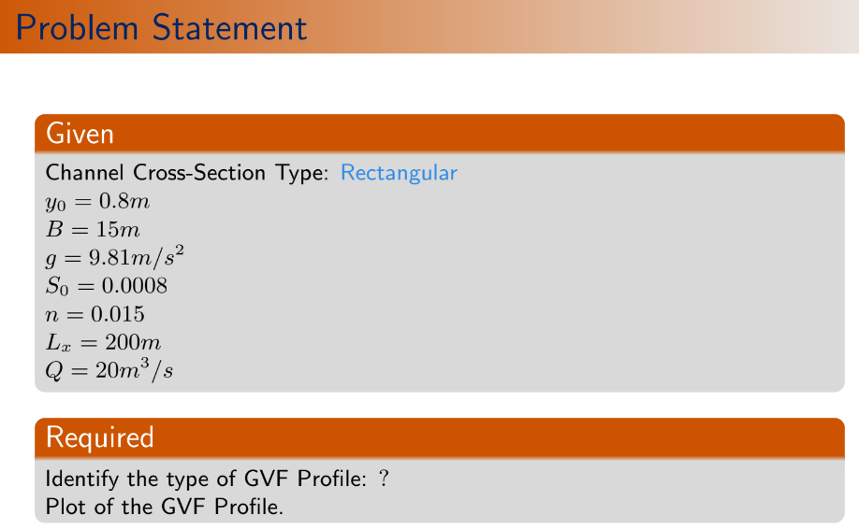

*//\*\*\*\*\*\*\*\*\*\*\*\*\*\*\*\*\*\*\*\*\*\*\*\*\*\*\*\*\*\*\*\*\*\*\*\*\*\*\*\*\*\*\*\*\*\*\*\*\*\*\**

*//calculation of normal depth using NR method [from equation (75.1)]*

*//To define G and G' functions*

function **Gval**=Gfunc(**y**)

**Gval**=(S0^(1/2)*B^(5/3)/n)*(**y**/(B+2\***y**))^(2/3)\***y**-Q;*//eqn(74)*

endfunction

function **Gpval**=Gderi(**y**)

term1=(S0^(1/2)*B^(5/3))/(3*n);

term2=**y**^(2/3)*(5*B+6\***y**);

term3=(B+2\***y**)^(5/3);

*// Gpval=(S0^(1/2)*B^(5/3))/(3*n)*y^(2/3)*(5*B+6*y)/(B+2*y)^(5/3);//G' from eqn (76)*

**Gpval**=term1*term2/term3;

endfunction

*//Newton-Raphson method (to solve nonlinear 'Gval' eqaution for getting yn)*

eps_max=1e-6;

aerror=1; *//absolute error*

yn=yc; *//To start the iteration loop, critical depth is our initial guess.*

while abs(aerror)>eps_max

aerror=(Gfunc(yn)/Gderi(yn));

yn=yn-aerror; *//yn(p)=yn(p-1)-(G(yn(p-1))/G'(yn(p-1)))..eqn(75.1))*

end

disp("Normal Depth",yn)

*//\*\*\*\*\*\*\*\*\*\*\*\*\*\*\*\*\*\*\*\*\*\*\*\*\*\*\*\*\*\*\*\*\*\*\*\*\*\*\*\**

*//dydx function calculation from Governing Equation*

function **dydx**=psi(**x**, **y**) *//equation (73)*

A_y=B\***y**;

P_y=B+2\***y**;

R_y=A_y/P_y;*//Area, Perimeter and hydraulic radius are function of y*

Sf=(n^2*Q^2)/(R_y^(4/3)*A_y^2);*//friction slope*

Frs=(Q^2*B)/(g*A_y^3);*//Fr^2*

**dydx**=(S0-Sf)/(1-Frs);

endfunction

*//\*\*\*\*\*\*\*\*\*\*\*\*\*\*\*\*\*\*\*\*\*\*\*\*\*\*\*\*\*\*\*\*\*\*\*\*\*\*\*\*\*\*\*\*\**

*//Forward Euler method [to get GVF profile for nodes along x direction]*

xc=linspace(0,Lx,mnode);*//x coordinate vector of nodes*

delta_x=Lx/(mnode-1);

yv=zeros(mnode,1);*//Initialization of flow depth vector*

yv(1)=y0;*//Input Boundary value in yv vector*

*//input other entries*

for i=2:mnode

yv(i)=yv(i-1)+delta_x*psi(xc(i-1),yv(i-1));

end

plot(xc,yv,"-b")

set(gca(),"auto_clear","off")

plot([0 Lx],[yn yn],'-m')

set(gca(),"auto_clear","off")

plot([0 Lx],[yc yc],'-b')

xtitle("GVF forward Euler Method","x axis(m)","flow depth(m)")

Output:

"Critical Depth"

0.5658954

"Normal Depth"

0.8478039

WARNING: Transposing row vector X to get compatible dimensions.

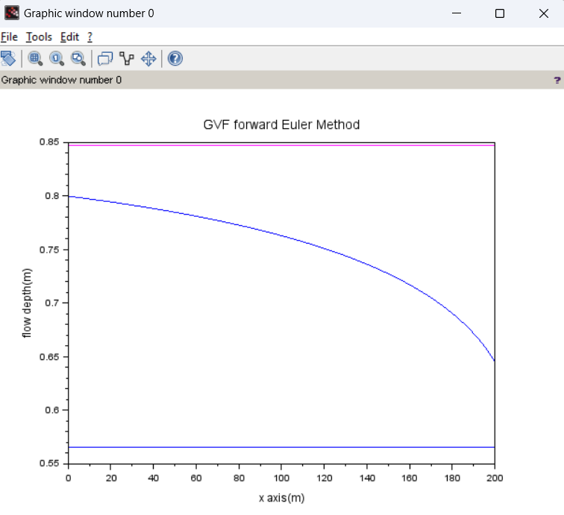

**(16) GVF_EULER_CAUCHY**

*//GRADUALLY VARIED FLOW- EULER CAUCHY METHOD*

clc

clear all

*//Data given*

Q=20;

S0=0.0008;

B=15;*//m, Channel width @rectangular channel*

Lx=200;*//length of the channel reach*

y0=0.8;*//initial depth at x=0*

n=0.015;

g=9.81;

mnode=201;*//number of nodes in the x directions*

global('Q','S0','n','B','g')*//global variables . for writing multiple functions later, we can directly utilize these constant values.*

*//\*\*\*\*\*\*\*\*\*\*\*\*\*\*\*\*\*\*\*\*\*\*\*\*\*\*\*\*\*\*\*\*\*\*\*\*\*\*\*\*\*\*\*\*\*\*\**

*//calculation of critical depth*

yc=(Q^2/(g*B^2))^(1/3);*//for rectangular channel.equation (73)*

disp("Critical depth",yc)



*//\*\*\*\*\*\*\*\*\*\*\*\*\*\*\*\*\*\*\*\*\*\*\*\*\*\*\*\*\*\*\*\*\*\*\*\*\*\*\*\*\*\*\*\*\*\*\*\*\*\*\**

*//calculation of normal depth using NR method [from equation (75.1)]*

*//To define G and G' functions*

function **Gval**=Gfunc(**y**)

**Gval**=(S0^(1/2)*B^(5/3)/n)*(**y**/(B+2\***y**))^(2/3)\***y**-Q;*//eqn(74)*

endfunction

function **Gpval**=Gderi(**y**)

term1=(S0^(1/2)*B^(5/3))/(3*n);

term2=**y**^(2/3)*(5*B+6\***y**);

term3=(B+2\***y**)^(5/3);

*// Gpval=(S0^(1/2)*B^(5/3))/(3*n)*y^(2/3)*(5*B+6*y)/(B+2*y)^(5/3);//G' from eqn (76)*

**Gpval**=term1*term2/term3;

endfunction

*//Newton-Raphson method (to solve nonlinear 'Gval' eqaution for getting yn)*

eps_max=1e-6;

aerror=1; *//absolute error*

yn=yc; *//To start the iteration loop, critical depth is our initial guess.*

while abs(aerror)>eps_max

aerror=(Gfunc(yn)/Gderi(yn));

yn=yn-aerror; *//yn(p)=yn(p-1)-(G(yn(p-1))/G'(yn(p-1)))..eqn(75.1))*

end

disp("Normal Depth",yn)

*//\*\*\*\*\*\*\*\*\*\*\*\*\*\*\*\*\*\*\*\*\*\*\*\*\*\*\*\*\*\*\*\*\*\*\*\*\*\*\*\**

*//dydx function calculation from Governing Equation*

function **dydx**=psi(**x**, **y**) *//equation (73)*

A_y=B\***y**;

P_y=B+2\***y**;

R_y=A_y/P_y;*//Area, Perimeter and hydraulic radius are function of y*

Sf=(n^2*Q^2)/(R_y^(4/3)*A_y^2);*//friction slope*

Frs=(Q^2*B)/(g*A_y^3);*//Fr^2*

**dydx**=(S0-Sf)/(1-Frs);

endfunction

*//\*\*\*\*\*\*\*\*\*\*\*\*\*\*\*\*\*\*\*\*\*\*\*\*\*\*\*\*\*\*\*\*\*\*\*\*\*\*\*\*\*\*\*\*\**

*//Euler-Cauchy method [to get GVF profile for nodes along x direction]*

xc=linspace(0,Lx,mnode);*//x coordinate vector of nodes*

delta_x=Lx/(mnode-1);

yv=zeros(mnode,1);*//Initialization of flow depth vector*

yv(1)=y0;*//Input Boundary value in yv vector*

*//input other entries*

for i=2:mnode

K1=delta_x*psi(xc(i-1),yv(i-1)); *//K1 and K2 for ith point are calculated from previous (i-1)th point data.(explicit)*

K2=delta_x*psi(xc(i-1)+delta_x,yv(i-1)+K1)

yv(i)=yv(i-1)+0.5*(K1+K2);*//Equation (78)*

end

plot(xc,yv,"-b")

set(gca(),"auto_clear","off")

plot([0 Lx],[yn yn],'-m')

set(gca(),"auto_clear","off")

plot([0 Lx],[yc yc],'-b')

xtitle("GVF Euler Cauchy Method","x axis(m)","flow depth")

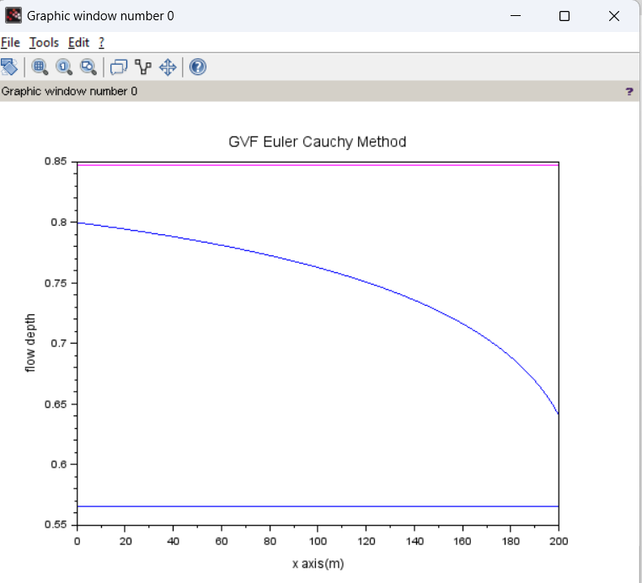

Output:

"Critical depth"

0.5658954

"Normal Depth"

0.8478039

WARNING: Transposing row vector X to get compatible dimensions

**(17) GVF_Modified_EULER**



*//GRADUALLY VARIED FLOW-MODIFIED EULER*

clc

clear all

*//Data given*

Q=20;

S0=0.0008;

B=15;*//m, Channel width @rectangular channel*

Lx=200;*//length of the channel reach*

y0=0.8;*//initial depth at x=0*

n=0.015;

g=9.81;

mnode=201;*//number of nodes in the x directions*

global('Q','S0','n','B','g')*//global variables . for writing multiple functions later, we can directly utilize these constant values.*

*//\*\*\*\*\*\*\*\*\*\*\*\*\*\*\*\*\*\*\*\*\*\*\*\*\*\*\*\*\*\*\*\*\*\*\*\*\*\*\*\*\*\*\*\*\*\*\**

*//calculation of critical depth*

yc=(Q^2/(g*B^2))^(1/3);*//for rectangular channel.equation (73)*

disp("yc",yc)

*//\*\*\*\*\*\*\*\*\*\*\*\*\*\*\*\*\*\*\*\*\*\*\*\*\*\*\*\*\*\*\*\*\*\*\*\*\*\*\*\*\*\*\*\*\*\*\*\*\*\*\**

*//calculation of normal depth using NR method [from equation (75.1)]*

*//To define G and G' functions*

function **Gval**=Gfunc(**y**)

**Gval**=(S0^(1/2)*B^(5/3)/n)*(**y**/(B+2\***y**))^(2/3)\***y**-Q;*//eqn(74)*

endfunction

function **Gpval**=Gderi(**y**)

term1=(S0^(1/2)*B^(5/3))/(3*n);

term2=**y**^(2/3)*(5*B+6\***y**);

term3=(B+2\***y**)^(5/3);

*// Gpval=(S0^(1/2)*B^(5/3))/(3*n)*y^(2/3)*(5*B+6*y)/(B+2*y)^(5/3);//G' from eqn (76)*

**Gpval**=term1*term2/term3;

endfunction

*//Newton-Raphson method (to solve nonlinear 'Gval' eqaution for getting yn)*

eps_max=1e-6;

aerror=1; *//absolute error*

yn=yc; *//To start the iteration loop, critical depth is our initial guess.*

while abs(aerror)>eps_max

aerror=(Gfunc(yn)/Gderi(yn));

yn=yn-aerror; *//yn(p)=yn(p-1)-(G(yn(p-1))/G'(yn(p-1)))..eqn(75.1))*

end

disp("yn",yn)

*//\*\*\*\*\*\*\*\*\*\*\*\*\*\*\*\*\*\*\*\*\*\*\*\*\*\*\*\*\*\*\*\*\*\*\*\*\*\*\*\**

*//dydx function calculation from Governing Equation*

function **dydx**=psi(**x**, **y**) *//equation (73)*

A_y=B\***y**;

P_y=B+2\***y**;

R_y=A_y/P_y;*//Area, Perimeter and hydraulic radius are function of y*

Sf=(n^2*Q^2)/(R_y^(4/3)*A_y^2);*//friction slope*

Frs=(Q^2*B)/(g*A_y^3);*//Fr^2*

**dydx**=(S0-Sf)/(1-Frs);

endfunction

*//\*\*\*\*\*\*\*\*\*\*\*\*\*\*\*\*\*\*\*\*\*\*\*\*\*\*\*\*\*\*\*\*\*\*\*\*\*\*\*\*\*\*\*\*\**

*//Modified Euler method [to get GVF profile for nodes along x direction]*

xc=linspace(0,Lx,mnode);*//x coordinate vector of nodes*

delta_x=Lx/(mnode-1);

yv=zeros(mnode,1);*//Initialization of flow depth vector*

yv(1)=y0;*//Input Boundary value in yv vector*

*//input other entries*

for i=2:mnode

K1=delta_x*psi(xc(i-1),yv(i-1)); *//K1 and K2 for ith point are calculated from previous (i-1)th point data.(explicit)*

K2=delta_x*psi(xc(i-1)+0.5*delta_x,yv(i-1)+0.5*K1)

yv(i)=yv(i-1)+K2;*//Equation (78)*

end

plot(xc,yv,"-r")

set(gca(),"auto_clear","off")

plot([0 Lx],[yn yn],'-m')

set(gca(),"auto_clear","off")

plot([0 Lx],[yc yc],'-b')

xtitle("GVF Modified Euler Method","x axis(m)","flow depth")

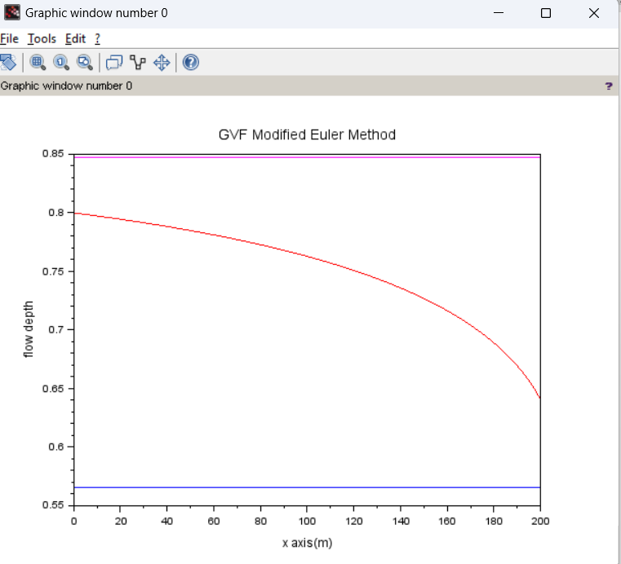

Output:

"yc"

0.5658954

"yn"

0.8478039

WARNING: Transposing row vector X to get compatible dimensions

**(18) GVF_IMPLICIT_BACKWARD_EULER**



*//GRADUALLY VARIED FLOW-IMPLICIT BACKWARD EULER*

clc

clear

*//Data given*

Q=20;

S0=0.0008;

B=15;*//m, Channel width @rectangular channel*

Lx=200;*//length of the channel reach*

y0=0.8;*//initial depth at x=0*

n=0.015;

g=9.81;

mnode=201;*//number of nodes in the x directions*

global('Q','S0','n','B','g')*//global variables . for writing multiple functions later, we can directly utilize these constant values.*

*//\*\*\*\*\*\*\*\*\*\*\*\*\*\*\*\*\*\*\*\*\*\*\*\*\*\*\*\*\*\*\*\*\*\*\*\*\*\*\*\*\*\*\*\*\*\*\**

*//calculation of critical depth*

yc=(Q^2/(g*B^2))^(1/3);*//for rectangular channel.equation (73)*

disp("yc",yc)

*//\*\*\*\*\*\*\*\*\*\*\*\*\*\*\*\*\*\*\*\*\*\*\*\*\*\*\*\*\*\*\*\*\*\*\*\*\*\*\*\*\*\*\*\*\*\*\**

*//calculation of critical depth*

yc=(Q^2/(g*B^2))^(1/3);*//for rectangular channel.equation (73)*

disp(yc)

*//\*\*\*\*\*\*\*\*\*\*\*\*\*\*\*\*\*\*\*\*\*\*\*\*\*\*\*\*\*\*\*\*\*\*\*\*\*\*\*\*\*\*\*\*\*\*\*\*\*\*\**

*//calculation of normal depth using NR method [from equation (75.1)]*

*//To define G and G' functions*

function **Gval**=Gfunc(**y**)

**Gval**=(S0^(1/2)*B^(5/3)/n)*(**y**/(B+2\***y**))^(2/3)\***y**-Q;*//eqn(127)*

endfunction

function **Gpval**=Gderi(**y**)

term1=(S0^(1/2)*B^(5/3))/(3*n);

term2=**y**^(2/3)*(5*B+6\***y**);

term3=(B+2\***y**)^(5/3);

*// Gpval=(S0^(1/2)*B^(5/3))/(3*n)*y^(2/3)*(5*B+6*y)/(B+2*y)^(5/3);//G'*

**Gpval**=term1*term2/term3;*//from eqn (129)*

endfunction

*//Newton-Raphson method (to solve nonlinear 'Gval' eqaution for getting yn)*

eps_max=1e-6;

aerror=1; *//absolute error*

yn=yc; *//To start the iteration loop, critical depth is our initial guess.*

while abs(aerror)>eps_max

aerror=(Gfunc(yn)/Gderi(yn));

yn=yn-aerror; *//yn(p)=yn(p-1)-(G(yn(p-1))/G'(yn(p-1)))..eqn(75.1))*

end

disp("yn",yn)

*//\*\*\*\*\*\*\*\*\*\*\*\*\*\*\*\*\*\*\*\*\*\*\*\*\*\*\*\*\*\*\*\*\*\*\*\*\*\*\*\**

*//dydx function calculation from Governing Equation*

function **dydx**=psi(**x**, **y**) *//equation (73)*

A_y=B\***y**;

P_y=B+2\***y**;

R_y=A_y/P_y;*//Area, Perimeter and hydraulic radius are function of y*

Sf=(n^2*Q^2)/(R_y^(4/3)*A_y^2);*//friction slope*

Frs=(Q^2*B)/(g*A_y^3);*//Fr^2*

**dydx**=(S0-Sf)/(1-Frs);

endfunction

*//function Fval=Ffunc(y,x,delta_x,yp)*

*// Fval=y-delta_x*psi(x,y)-yp //y=new value,yp=previous known value.Equation(134)*

*//endfunction*

*//function Fpval=Fderi(y,delta_x) //derivative of Fval wrt y(new)*

*// term1=(1-Q^2/(B^2*g*y^3))^(-1);*

*// term2=(2*n^2*Q^2)/(B^2*y^3);*

*// term3=(B*y/(B+2*y))^(-4/3);*

*// term4=(4*n^2*Q^2)/(3*B^2*y^2);*

*// term5=(B*y/(B+2*y))^(-7/3);*

*// term6=((B/(B+2*y))-(2*B*y/(B+2*y)^2));*

*// term7=(3*Q^2)/(B^2*g*y^4);*

*// term8=(1-Q^2/(B^2*g*y^3))^(-2);*

*// term9=S0;*

*// term10=(n^2*Q^2)/(B^2*y^2);*

*// term11=(B*y/(B+2*y))^(4/3);*

*// Fpval=1-delta_x*(term1*(term2*term3+term4*term5*term6)-term7*term8*(term9-term10*term11));*

*//endfunction*

*/////function psipval=psideri(x,y,delta_x)*

function **psipval**=psideri(**x**, **y**, **delta_x**)*//derivative of psival wrt y(new)*

term1=(1-Q^2/(B^2*g\***y**^3))^(-1);

term2=(2*n^2*Q^2)/(B^2\***y**^3);

term3=(B\***y**/(B+2\***y**))^(-4/3);

term4=(4*n^2*Q^2)/(3*B^2\***y**^2);

term5=(B\***y**/(B+2\***y**))^(-7/3);

term6=((B/(B+2\***y**))-(2*B\***y**/(B+2\***y**)^2));

term7=(3*Q^2)/(B^2*g\***y**^4);

term8=(1-Q^2/(B^2*g\***y**^3))^(-2);

term9=S0;

term10=(n^2*Q^2)/(B^2\***y**^2);

term11=(B\***y**/(B+2\***y**))^(4/3);

**psipval**=(1-**delta_x**\*(term1*(term2*term3+term4*term5*term6)-term7*term8*(term9-term10*term11))-1)/(-**delta_x**);*//using eqn(135.1)*

endfunction

*//\*\*\*\*\*\*\*\*\*\*\*\*\*\*\*\*\*\*\*\*\*\*\*\*\*\*\*\*\*\*\*\*\*\*\*\*\*\*\*\*\*\*\*\*\**

*//Implicit Backward Euler method [to get GVF profile for nodes along x direction]*

xc=linspace(0,Lx,mnode);*//x coordinate vector of nodes*

delta_x=Lx/(mnode-1);

yv=zeros(mnode,1);*//Initialization of flow depth vector*

yv(1)=y0;*//Input Boundary value in yv vector*

for i=2:mnode

K1=delta_x*(1-1*delta_x*psideri(xc(i-1)+1*delta_x,yv(i-1),delta_x))^(-1)*psi(xc(i-1)+1*delta_x,yv(i-1));*//using semi-implicit eqn (138) and putting values from (135.1) and (136.1)*

yv(i)=yv(i-1)+1*K1;

end

*//plot*

plot(xc,yv,"-b")

set(gca(),"auto_clear","off")

plot([0 Lx],[yn yn],'-m')

set(gca(),"auto_clear","off")

plot([0 Lx],[yc yc],'-b')

xtitle("GVF implicit Backward Euler Method","x axis(m)","flow depth(m)")

"yc"

0.5658954

"yn"

0.8478039

WARNING: Transposing row vector X to get compatible dimensions

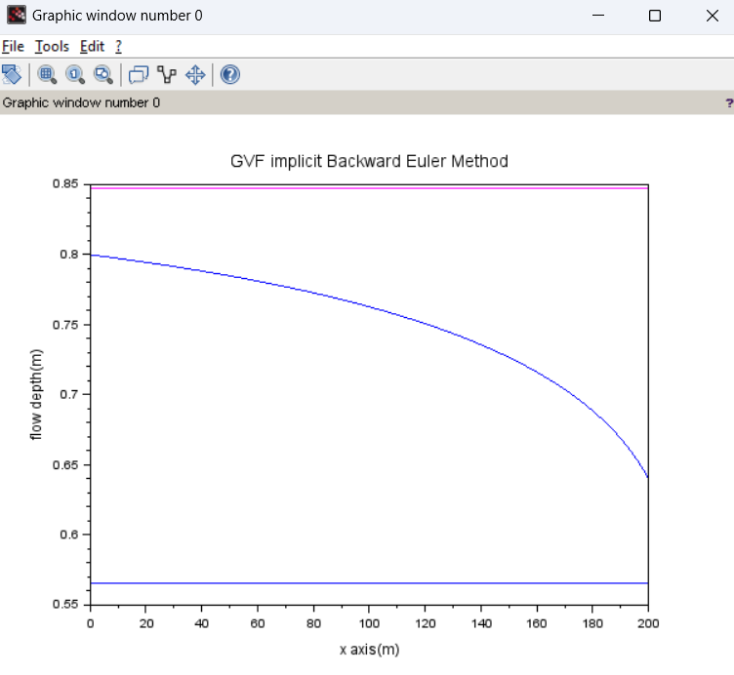

**(19) GVF_RK2**

*//GRADUALLY VARIED FLOW- RK_2 METHOD*

clc

clear all

*//Data given*

Q=20;

S0=0.0008;

B=15;*//m, Channel width @rectangular channel*

Lx=200;*//length of the channel reach*

y0=0.8;*//initial depth at x=0*

n=0.015;

g=9.81;

mnode=201;*//number of nodes in the x directions*

global('Q','S0','n','B','g')*//global variables . for writing multiple functions later, we can directly utilize these constant values.*

*//\*\*\*\*\*\*\*\*\*\*\*\*\*\*\*\*\*\*\*\*\*\*\*\*\*\*\*\*\*\*\*\*\*\*\*\*\*\*\*\*\*\*\*\*\*\*\**

*//calculation of critical depth*

yc=(Q^2/(g*B^2))^(1/3);*//for rectangular channel.equation (73)*

disp("yc",yc)



*//\*\*\*\*\*\*\*\*\*\*\*\*\*\*\*\*\*\*\*\*\*\*\*\*\*\*\*\*\*\*\*\*\*\*\*\*\*\*\*\*\*\*\*\*\*\*\*\*\*\*\**

*//calculation of normal depth using NR method [from equation (75.1)]*

*//To define G and G' functions*

function **Gval**=Gfunc(**y**)

**Gval**=(S0^(1/2)*B^(5/3)/n)*(**y**/(B+2\***y**))^(2/3)\***y**-Q;*//eqn(74)*

endfunction

function **Gpval**=Gderi(**y**)

term1=(S0^(1/2)*B^(5/3))/(3*n);

term2=**y**^(2/3)*(5*B+6\***y**);

term3=(B+2\***y**)^(5/3);

*// Gpval=(S0^(1/2)*B^(5/3))/(3*n)*y^(2/3)*(5*B+6*y)/(B+2*y)^(5/3);//G' from eqn (76)*

**Gpval**=term1*term2/term3;

endfunction

*//Newton-Raphson method (to solve nonlinear 'Gval' eqaution for getting yn)*

eps_max=1e-6;

aerror=1; *//absolute error*

yn=yc; *//To start the iteration loop, critical depth is our initial guess.*

while abs(aerror)>eps_max

aerror=(Gfunc(yn)/Gderi(yn));

yn=yn-aerror; *//yn(p)=yn(p-1)-(G(yn(p-1))/G'(yn(p-1)))..eqn(75.1))*

end

disp("yn",yn)

*//\*\*\*\*\*\*\*\*\*\*\*\*\*\*\*\*\*\*\*\*\*\*\*\*\*\*\*\*\*\*\*\*\*\*\*\*\*\*\*\**

*//dydx function calculation from Governing Equation*

function **dydx**=psi(**x**, **y**) *//equation (73)*

A_y=B\***y**;

P_y=B+2\***y**;

R_y=A_y/P_y;*//Area, Perimeter and hydraulic radius are function of y*

Sf=(n^2*Q^2)/(R_y^(4/3)*A_y^2);*//friction slope*

Frs=(Q^2*B)/(g*A_y^3);*//Fr^2*

**dydx**=(S0-Sf)/(1-Frs);

endfunction

*//\*\*\*\*\*\*\*\*\*\*\*\*\*\*\*\*\*\*\*\*\*\*\*\*\*\*\*\*\*\*\*\*\*\*\*\*\*\*\*\*\*\*\*\*\**

*//Euler-Cauchy method [to get GVF profile for nodes along x direction]*

xc=linspace(0,Lx,mnode);*//x coordinate vector of nodes*

delta_x=Lx/(mnode-1);

yv=zeros(mnode,1);*//Initialization of flow depth vector*

yv(1)=y0;*//Input Boundary value in yv vector*

*//input other entries*

for i=2:mnode

K1=delta_x*psi(xc(i-1),yv(i-1)); *//K1 and K2 for ith point are calculated from previous (i-1)th point data.(explicit)*

K2=delta_x*psi(xc(i-1)+(2/3)*(delta_x),yv(i-1)+(2/3)*K1)

yv(i)=yv(i-1)+0.25*(K1+3*K2);*//Equation (80)*

end

plot(xc,yv,"-m")

set(gca(),"auto_clear","off")

plot([0 Lx],[yn yn],'-m')

set(gca(),"auto_clear","off")

plot([0 Lx],[yc yc],'-b')

xtitle("GVF RK2 Method","x axis(m)","flow depth")

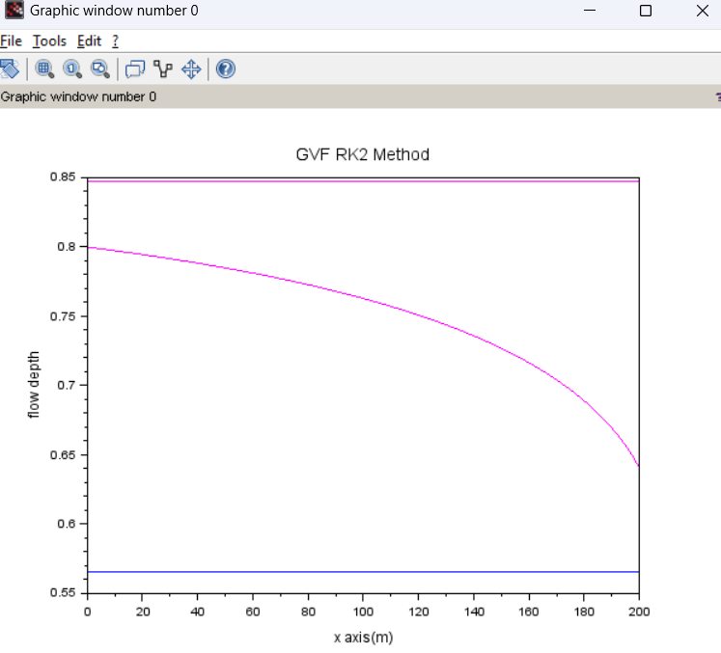

"yc"

0.5658954

"yn"

0.8478039

WARNING: Transposing row vector X to get compatible dimensions

**(20) GVF_RK3**

*//GRADUALLY VARIED FLOW- RK_3 METHOD*

clc

clear all

*//Data given*

Q=20;

S0=0.0008;

B=15;*//m, Channel width @rectangular channel*

Lx=200;*//length of the channel reach*

y0=0.8;*//initial depth at x=0*

n=0.015;

g=9.81;

mnode=201;*//number of nodes in the x directions*

global('Q','S0','n','B','g')*//global variables . for writing multiple functions later, we can directly utilize these constant values.*

*//\*\*\*\*\*\*\*\*\*\*\*\*\*\*\*\*\*\*\*\*\*\*\*\*\*\*\*\*\*\*\*\*\*\*\*\*\*\*\*\*\*\*\*\*\*\*\**

*//calculation of critical depth*

yc=(Q^2/(g*B^2))^(1/3);*//for rectangular channel.equation (73)*

disp("yc",yc)



*//\*\*\*\*\*\*\*\*\*\*\*\*\*\*\*\*\*\*\*\*\*\*\*\*\*\*\*\*\*\*\*\*\*\*\*\*\*\*\*\*\*\*\*\*\*\*\*\*\*\*\**

*//calculation of normal depth using NR method [from equation (75.1)]*

*//To define G and G' functions*

function **Gval**=Gfunc(**y**)

**Gval**=(S0^(1/2)*B^(5/3)/n)*(**y**/(B+2\***y**))^(2/3)\***y**-Q;*//eqn(74)*

endfunction

function **Gpval**=Gderi(**y**)

term1=(S0^(1/2)*B^(5/3))/(3*n);

term2=**y**^(2/3)*(5*B+6\***y**);

term3=(B+2\***y**)^(5/3);

*// Gpval=(S0^(1/2)*B^(5/3))/(3*n)*y^(2/3)*(5*B+6*y)/(B+2*y)^(5/3);//G' from eqn (76)*

**Gpval**=term1*term2/term3;

endfunction

*//Newton-Raphson method (to solve nonlinear 'Gval' eqaution for getting yn)*

eps_max=1e-6;

aerror=1; *//absolute error*

yn=yc; *//To start the iteration loop, critical depth is our initial guess.*

while abs(aerror)>eps_max

aerror=(Gfunc(yn)/Gderi(yn));

yn=yn-aerror; *//yn(p)=yn(p-1)-(G(yn(p-1))/G'(yn(p-1)))..eqn(75.1))*

end

disp("yn",yn)

*//\*\*\*\*\*\*\*\*\*\*\*\*\*\*\*\*\*\*\*\*\*\*\*\*\*\*\*\*\*\*\*\*\*\*\*\*\*\*\*\**

*//dydx function calculation from Governing Equation*

function **dydx**=psi(**x**, **y**) *//equation (73)*

A_y=B\***y**;

P_y=B+2\***y**;

R_y=A_y/P_y;*//Area, Perimeter and hydraulic radius are function of y*

Sf=(n^2*Q^2)/(R_y^(4/3)*A_y^2);*//friction slope*

Frs=(Q^2*B)/(g*A_y^3);*//Fr^2*

**dydx**=(S0-Sf)/(1-Frs);

endfunction

*//\*\*\*\*\*\*\*\*\*\*\*\*\*\*\*\*\*\*\*\*\*\*\*\*\*\*\*\*\*\*\*\*\*\*\*\*\*\*\*\*\*\*\*\*\**

*//RK3 method [to get GVF profile for nodes along x direction]*

xc=linspace(0,Lx,mnode);*//x coordinate vector of nodes*

delta_x=Lx/(mnode-1);

yv=zeros(mnode,1);*//Initialization of flow depth vector*

yv(1)=y0;*//Input Boundary value in yv vector*

*//input other entries*

for i=2:mnode

K1=delta_x*psi(xc(i-1),yv(i-1)); *//K1 and K2 for ith point are calculated from previous (i-1)th point data.(explicit)*

K2=delta_x*psi(xc(i-1)+(0.5)*(delta_x),yv(i-1)+(0.5)*K1);

K3=delta_x*psi(xc(i-1)+(delta_x),yv(i-1)-K1+2*K2);

yv(i)=yv(i-1)+(1/6)*(K1+4*K2+K3);*//Equation (81)*

end

plot(xc,yv,"-b")

set(gca(),"auto_clear","off")

plot([0 Lx],[yn yn],'-m')

set(gca(),"auto_clear","off")

plot([0 Lx],[yc yc],'-b')

xtitle("GVF RK3 Method","x axis(m)","flow depth")

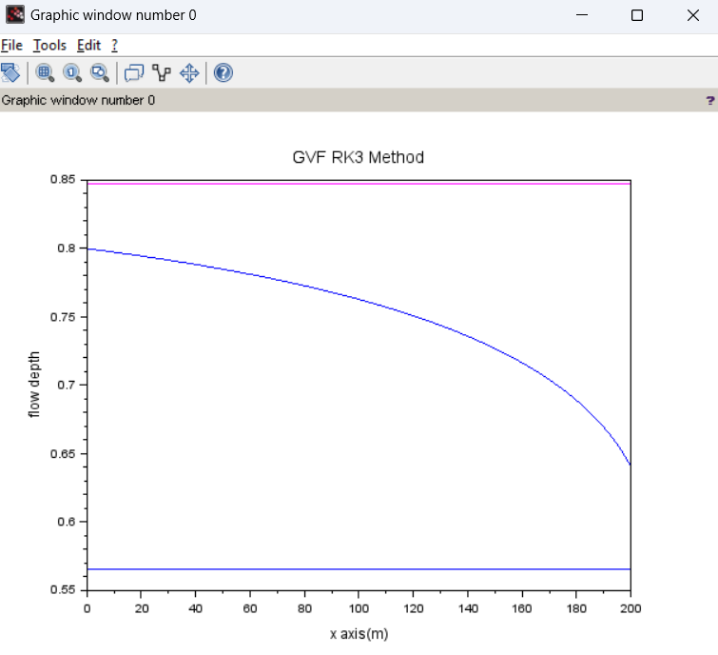

Output:

"yc"

0.5658954

"yn"

0.8478039

WARNING: Transposing row vector X to get compatible dimensions

**(21) GVF_RK4**



*//GRADUALLY VARIED FLOW- RK_4 METHOD*

clc

clear all

*//Data given*

Q=20;

S0=0.0008;

B=15;*//m, Channel width @rectangular channel*

Lx=200;*//length of the channel reach*

y0=0.8;*//initial depth at x=0*

n=0.015;

g=9.81;

mnode=201;*//number of nodes in the x directions*

global('Q','S0','n','B','g')*//global variables . for writing multiple functions later, we can directly utilize these constant values.*

*//\*\*\*\*\*\*\*\*\*\*\*\*\*\*\*\*\*\*\*\*\*\*\*\*\*\*\*\*\*\*\*\*\*\*\*\*\*\*\*\*\*\*\*\*\*\*\**

*//calculation of critical depth*

yc=(Q^2/(g*B^2))^(1/3);*//for rectangular channel.equation (73)*

disp("yc",yc)

*//\*\*\*\*\*\*\*\*\*\*\*\*\*\*\*\*\*\*\*\*\*\*\*\*\*\*\*\*\*\*\*\*\*\*\*\*\*\*\*\*\*\*\*\*\*\*\*\*\*\*\**

*//calculation of normal depth using NR method [from equation (75.1)]*

*//To define G and G' functions*

function **Gval**=Gfunc(**y**)

**Gval**=(S0^(1/2)*B^(5/3)/n)*(**y**/(B+2\***y**))^(2/3)\***y**-Q;*//eqn(74)*

endfunction

function **Gpval**=Gderi(**y**)

term1=(S0^(1/2)*B^(5/3))/(3*n);

term2=**y**^(2/3)*(5*B+6\***y**);

term3=(B+2\***y**)^(5/3);

*// Gpval=(S0^(1/2)*B^(5/3))/(3*n)*y^(2/3)*(5*B+6*y)/(B+2*y)^(5/3);//G' from eqn (76)*

**Gpval**=term1*term2/term3;

endfunction

*//Newton-Raphson method (to solve nonlinear 'Gval' eqaution for getting yn)*

eps_max=1e-6;

aerror=1; *//absolute error*

yn=yc; *//To start the iteration loop, critical depth is our initial guess.*

while abs(aerror)>eps_max

aerror=(Gfunc(yn)/Gderi(yn));

yn=yn-aerror; *//yn(p)=yn(p-1)-(G(yn(p-1))/G'(yn(p-1)))..eqn(75.1))*

end

disp("yn",yn)

*//\*\*\*\*\*\*\*\*\*\*\*\*\*\*\*\*\*\*\*\*\*\*\*\*\*\*\*\*\*\*\*\*\*\*\*\*\*\*\*\**

*//dydx function calculation from Governing Equation*

function **dydx**=psi(**x**, **y**) *//equation (73)*

A_y=B\***y**;

P_y=B+2\***y**;

R_y=A_y/P_y;*//Area, Perimeter and hydraulic radius are function of y*

Sf=(n^2*Q^2)/(R_y^(4/3)*A_y^2);*//friction slope*

Frs=(Q^2*B)/(g*A_y^3);*//Fr^2*

**dydx**=(S0-Sf)/(1-Frs);

endfunction

*//\*\*\*\*\*\*\*\*\*\*\*\*\*\*\*\*\*\*\*\*\*\*\*\*\*\*\*\*\*\*\*\*\*\*\*\*\*\*\*\*\*\*\*\*\**

*//RK3 method [to get GVF profile for nodes along x direction]*

xc=linspace(0,Lx,mnode);*//x coordinate vector of nodes*

delta_x=Lx/(mnode-1);

yv=zeros(mnode,1);*//Initialization of flow depth vector*

yv(1)=y0;*//Input Boundary value in yv vector*

*//input other entries*

for i=2:mnode

K1=delta_x*psi(xc(i-1),yv(i-1)); *//K1 and K2 for ith point are calculated from previous (i-1)th point data.(explicit)*

K2=delta_x*psi(xc(i-1)+(0.5)*(delta_x),yv(i-1)+(0.5)*K1);

K3=delta_x*psi(xc(i-1)+(0.5)*(delta_x),yv(i-1)+(0.5)*K2);

K4=delta_x*psi(xc(i-1)+delta_x,yv(i-1)+K3);

yv(i)=yv(i-1)+(1/6)*(K1+4*K2+K3);*//Equation (82)*

end

plot(xc,yv,"-r")

set(gca(),"auto_clear","off")

plot([0 Lx],[yn yn],'-m')

set(gca(),"auto_clear","off")

plot([0 Lx],[yc yc],'-b')

xtitle("GVF RK4 Method","x axis(m)","flow depth")

Output:

"yc"

0.5658954

"yn"

0.8478039

WARNING: Transposing row vector X to get compatible dimensions

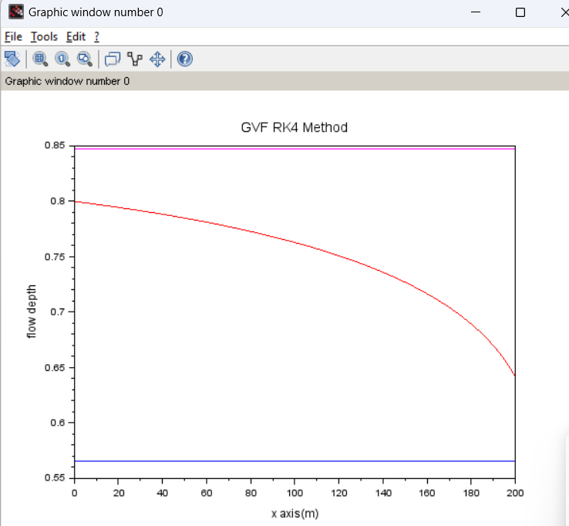

**(22) GVF_IMPLICIT_RK2**

*//GRADUALLY VARIED FLOW-IMPLICIT RK2*

clc

clear

*//Data given*

Q=20;

S0=0.0008;

B=15;*//m, Channel width @rectangular channel*

Lx=200;*//length of the channel reach*

y0=0.8;*//initial depth at x=0*

n=0.015;

g=9.81;

mnode=201;*//number of nodes in the x directions*

global('Q','S0','n','B','g')*//global variables . for writing multiple functions later, we can directly utilize these constant values.*

*//\*\*\*\*\*\*\*\*\*\*\*\*\*\*\*\*\*\*\*\*\*\*\*\*\*\*\*\*\*\*\*\*\*\*\*\*\*\*\*\*\*\*\*\*\*\*\**

*//calculation of critical depth*

yc=(Q^2/(g*B^2))^(1/3);*//for rectangular channel.equation (73)*

disp("yc",yc)



*//\*\*\*\*\*\*\*\*\*\*\*\*\*\*\*\*\*\*\*\*\*\*\*\*\*\*\*\*\*\*\*\*\*\*\*\*\*\*\*\*\*\*\*\*\*\*\*\*\*\*\**

*//calculation of normal depth using NR method [from equation (75.1)]*

*//To define G and G' functions*

function **Gval**=Gfunc(**y**)

**Gval**=(S0^(1/2)*B^(5/3)/n)*(**y**/(B+2\***y**))^(2/3)\***y**-Q;*//eqn(127)*

endfunction

function **Gpval**=Gderi(**y**)

term1=(S0^(1/2)*B^(5/3))/(3*n);

term2=**y**^(2/3)*(5*B+6\***y**);

term3=(B+2\***y**)^(5/3);

*// Gpval=(S0^(1/2)*B^(5/3))/(3*n)*y^(2/3)*(5*B+6*y)/(B+2*y)^(5/3);//G'*

**Gpval**=term1*term2/term3;*//from eqn (129)*

endfunction

*//Newton-Raphson method (to solve nonlinear 'Gval' eqaution for getting yn)*

eps_max=1e-6;

aerror=1; *//absolute error*

yn=yc; *//To start the iteration loop, critical depth is our initial guess.*

while abs(aerror)>eps_max

aerror=(Gfunc(yn)/Gderi(yn));

yn=yn-aerror; *//yn(p)=yn(p-1)-(G(yn(p-1))/G'(yn(p-1)))..eqn(75.1))*

end

disp("yn",yn)

*//\*\*\*\*\*\*\*\*\*\*\*\*\*\*\*\*\*\*\*\*\*\*\*\*\*\*\*\*\*\*\*\*\*\*\*\*\*\*\*\**

*//dydx function calculation from Governing Equation*

function **dydx**=psi(**x**, **y**) *//equation (73)*

A_y=B\***y**;

P_y=B+2\***y**;

R_y=A_y/P_y;*//Area, Perimeter and hydraulic radius are function of y*

Sf=(n^2*Q^2)/(R_y^(4/3)*A_y^2);*//friction slope*

Frs=(Q^2*B)/(g*A_y^3);*//Fr^2*

**dydx**=(S0-Sf)/(1-Frs);

endfunction

*//function Fval=Ffunc(y,x,delta_x,yp)*

*// Fval=y-delta_x*psi(x,y)-yp //y=new value,yp=previous known value.Equation(134)*

*//endfunction*

*//function Fpval=Fderi(y,delta_x) //derivative of Fval wrt y(new)*

*// term1=(1-Q^2/(B^2*g*y^3))^(-1);*

*// term2=(2*n^2*Q^2)/(B^2*y^3);*

*// term3=(B*y/(B+2*y))^(-4/3);*

*// term4=(4*n^2*Q^2)/(3*B^2*y^2);*

*// term5=(B*y/(B+2*y))^(-7/3);*

*// term6=((B/(B+2*y))-(2*B*y/(B+2*y)^2));*

*// term7=(3*Q^2)/(B^2*g*y^4);*

*// term8=(1-Q^2/(B^2*g*y^3))^(-2);*

*// term9=S0;*

*// term10=(n^2*Q^2)/(B^2*y^2);*

*// term11=(B*y/(B+2*y))^(4/3);*

*// Fpval=1-delta_x*(term1*(term2*term3+term4*term5*term6)-term7*term8*(term9-term10*term11));*

*//endfunction*

*/////function psipval=psideri(x,y,delta_x)*

function **psipval**=psideri(**x**, **y**)*//derivative of psival wrt y(new)*

term1=(1-Q^2/(B^2*g\***y**^3))^(-1);

term2=(2*n^2*Q^2)/(B^2\***y**^3);

term3=(B\***y**/(B+2\***y**))^(-4/3);

term4=(4*n^2*Q^2)/(3*B^2\***y**^2);

term5=(B\***y**/(B+2\***y**))^(-7/3);

term6=((B/(B+2\***y**))-(2*B\***y**/(B+2\***y**)^2));

term7=(3*Q^2)/(B^2*g\***y**^4);

term8=(1-Q^2/(B^2*g\***y**^3))^(-2);

term9=S0;

term10=(n^2*Q^2)/(B^2\***y**^2);

term11=(B\***y**/(B+2\***y**))^(4/3);

**psipval**=(term1*(term2*term3+term4*term5*term6)-term7*term8*(term9-term10*term11));*//using eqn(135.1)*

endfunction

*//\*\*\*\*\*\*\*\*\*\*\*\*\*\*\*\*\*\*\*\*\*\*\*\*\*\*\*\*\*\*\*\*\*\*\*\*\*\*\*\*\*\*\*\*\**

*//Implicit Backward Euler method [to get GVF profile for nodes along x direction]*

xc=linspace(0,Lx,mnode);*//x coordinate vector of nodes*

delta_x=Lx/(mnode-1);

yv=zeros(mnode,1);*//Initialization of flow depth vector*

yv(1)=y0;*//Input Boundary value in yv vector*

for i=2:mnode

K1=delta_x*(1-0.5*delta_x*psideri(xc(i-1)+0.5*delta_x,yv(i-1)))^(-1)*psi(xc(i-1)+0.5*delta_x,yv(i-1));*//using semi-implicit eqn (138) and putting values from (135.1) and (136.1)*

yv(i)=yv(i-1)+1*K1;

end

*//plot*

plot(xc,yv,"-g")

set(gca(),"auto_clear","off")

plot([0 Lx],[yn yn],'-m')*//Normal depth line*

set(gca(),"auto_clear","off")

plot([0 Lx],[yc yc],'-b') *//Critical depth line*

xtitle("GVF implicit RK2","x axis(m)","flow depth(m)")

Output:

"yc"

0.5658954

"yn"

0.8478039

WARNING: Transposing row vector X to get compatible dimensions

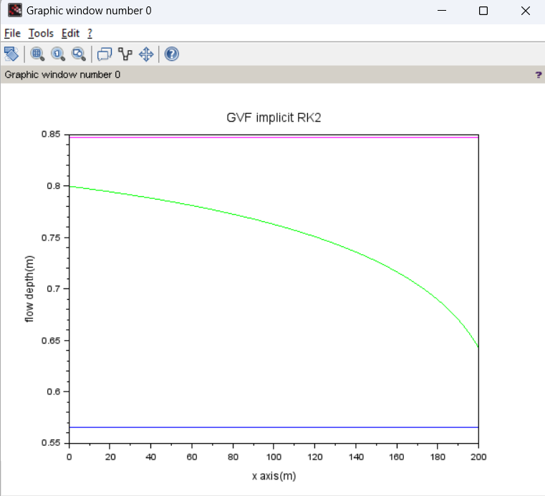

**(23) steady_1D_channel_single**

*//Error level: Medium. (Flow profile is not correct). Recheck! ☹*

clc

clear

*//~~~~~~given data~~~~~~~~*

Q=20; *//m3/s*

S0=0.0008;

n=0.015;

B=15;*//m*

g=9.81;*//m/s^2*

Lx=200 *//m*

yd=0.6;*//m*

mnode=201;

*//no of nodes in x direction*

eps_max=1e-6;

global('Q','S0','n','B','g')

*//~~~~~~~~problem dependent parameters~~~~~~*

alpha=1;

xc=linspace(0,Lx,mnode);

delta_x=Lx/(mnode-1);

zv(mnode)=0;

*//elevation at the end section is considered to be at datum.*

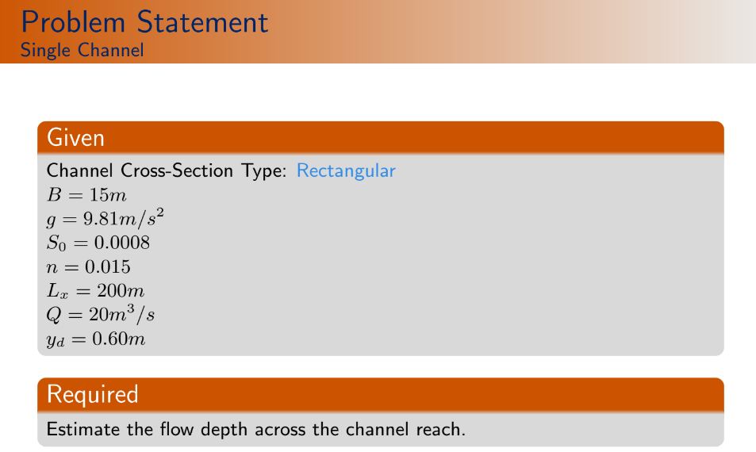

for i=mnode-1:-1:1

zv(i)=zv(i+1)+S0*delta_x

*//downsream section was considered to be the end section which has lowest elevation. Elv. linealy increases in u/s direction.*

end

yv=zeros(mnode,1);

*//It is the variable (water depth) defined for (Nl+1) number of nodes.*

C1=alpha*Q^2/(2*g);

C2=(1/2)*n^2*Q^2*delta_x;

*//c1 and c2 are constants. See equation (117)*

global('C1','C2','delta_x')

function **Av**=areav(**y**)

**Av**=B\***y**;

*//Cross-section area*

endfunction

function **dAv**=dareav(**y**)

**dAv**=B;

*//dAv gives dA/dy.*

endfunction

function **Rv**=HRv(**y**)

**Rv**=B\***y**/(B+2\***y**);

*//'Rv' gives hydraulic radius.*

endfunction

function **dRv**=dHRv(**y**)

**dRv**=B^2/(B+2\***y**)^2;

*//'dRv' gives dR/dy.*

endfunction

*//...........................*

function **Mliv**=Mli(**y1**, **y2**)

**Mliv**=(**y2**-**y1**)-S0*delta_x+C1*(areav(**y2**)^(-2)-areav(**y1**)^(-2))+C2*(HRv(**y2**)^(-4/3)*areav(**y2**)^(-2)+HRv(**y1**)^(-4/3)*areav(**y1**)^(-2));

*//It is momentum function M_{l,i}."-S0*delta_x" gives the the difference of the elevations of the two sections i.e."zv(2)-zv(1)". See equation (117).*

endfunction

function **dMdyiv**=dMdyi(**y**)

term1=(2/areav(**y**)^3*dareav(**y**));

term2=2*areav(**y**)^(-3)*HRv(**y**)^(-4/3)*dareav(**y**);

term3=(4/3)*areav(**y**)^(-2)*HRv(**y**)^(-7/3)*dHRv(**y**);

**dMdyiv**=1+C1*term1-C2*(term2+term3);

*//dMdyiv is nothing but dM_{l,i}/dy_{l,i}. See equation (118)*

endfunction

function **dMdyip1v**=dMdyip1(**y**)

term1=(2/areav(**y**)^3)*dareav(**y**);

term2=2*areav^(-3)*HRv^(-4/3)*dareav(**y**);

term3=(4/3)*areav(**y**)^(-2)*HRv^(-7/3)*dHRv(**y**);

**dMdyip1v**=1-C1*term1-C2*(term2+term3);

*//This gives dM_{l,i}/dy_{l,i+1}. See equation(119).*

endfunction

A=zeros(mnode,mnode)

*//Elements of jacobian matrix should be inserted in this 'A' matrix.*

r=zeros(mnode,1);

count=0;

rmse=1;

yv=yd*ones(mnode,1);

*//Downstream end value (yd) is taken as the initial guess value.*

*//~~~~~~~~~~~Space loop~~~~~~~~~~~~~*

while rmse>eps_max

*//While rmse>eps_max, then only we should iterate.*

rmse=0;

for i=1:mnode-1

A(i,i)=dMdyi(yv(i));

A(i,i+1)=dMdyip1(yv(i+1));

r=Mli(yv(i),yv(i+1));

end

*//~~~~~Subcritical boundary conditions~~~~~*

A(mnode,mnode)=1;

r(mnode)=-(yv(mnode)-yd);

*//Here, 'r' vector in "[A]{dely}={r}" equation contains "negative of momentum function"(see equation 123). From 116.1, we have d/s boundary condition i.e., "DB_{l,Nl+1}=y_{l,Nl+1}-y_{d}". Hence, value of 'r(mnode)' is justified.*

dely=A\r;

for i=1:mnode

yv(i)=yv(i)+dely(i);

*// Initially, yv(i)=yd; for all values of i. Then, it got modified.*

rmse=rmse+dely(i)^2;

*//Actually, using this loop, we are summing up the square of all the errors. RMSE was calculated later.( I.T--> initial rmse should be considered as 0. why 1?)*

end

rmse=sqrt(rmse/mnode);

count=count+1;

*//disp('COUNT RMSE')*

*//disp([count; rmse])*

end

*//~~~~~~figures and plots~~~~~~~~*

plot(xc',yv+zv,"-r")

plot([0 200],[zv(1) zv(mnode)],'b-')

xtitle("steady single channel flow","x axis","Flow depth")

**Output*: //*** *( It should not look like a straight line. It should be curved.)*

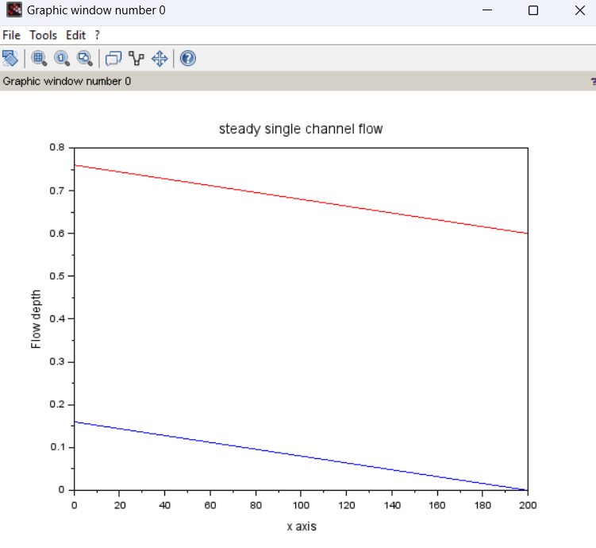

**(24) steady_1D_channel_series**

***//Error level: Medium. Flow profile is not matching properly. Recheck!***

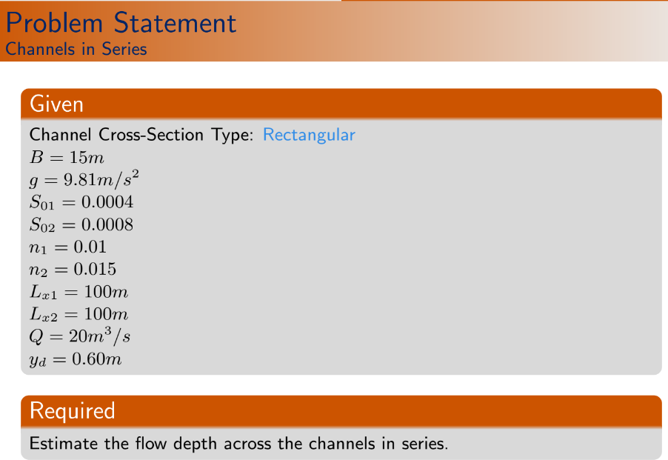

clc

clear

*//Question is at(5 no.-p-24). Lecture 37*

*//****This problem considers constant discharge Q. flow depth 'y' is the only variable here.***

*//~~~~~~Given Data~~~~~~*

chl=2;

*//We have two channels in series.*

Q=20;*//m^3/S*

S0=[0.0004 0.0008];

n=[0.010 0.015]

B=15;*//m*

g=9.81;*//m\s^2*

Lx=[100 100];

yd=0.6;*//m*

mnode=[101 101];

eps_max=1e-6;

global('Q','B','g')

*//Here, S0 and n are varying. So, we don't keep those as global variables.*

*//~~~~~problem dependent parameters~~~~~~~*

alpha=[1,1];

yv=zeros(sum(mnode),1);

*// Here,sum(mnode)=sum of all elements in 'mnode' matrix.Therefore, yv=zeros(202,1). Because, total number of sections=101*2=202.*

for l=1:chl

*//Here, l is the channel numbering. chl is number of channels(=2 here).*

delta_x(l)=Lx(l)/(mnode(l)-1);

C1(l)=alpha(l)*Q^2/(2*g);

C2=(1/2)*n(l)^2*Q^2*delta_x(l);

*//Here, two loops will run. for l=1 and l=2.*

end

mc=sum(mnode);

*// It gives total number of sections (i.e.sum of all elements in 'mnode' matrix). Because, we need to get those many 'depth' values.*

for l=chl:-1:1

*// i.e. l=2:-1:1 ,for this case.*

for i=mnode(l):-1:1

if(l==chl & i==mnode(l))then

zv(mc)=0;

*//Here, 'l' represents channel numbering. Number of channel is 2. So, chl=2. Therefore, this condition means l==2 and i=mnode(2)=101; i.e. the downstream section.*

end

if(l<>chl & i==mnode(l)) then

*// end section of a channel other than the last channel.*

mc=mc-1;

zv(mc)=zv(mc+1)

*// This 'if' loop will be executed (i.e. will take a value ,other than zero, for 101-th row of the 'zv' vector) when the next 'if' loop will evaluate the zv value of the 1st section of the second channel(i.e. 102-th entry of 'zv' vector).*

end

if (i<>mnode(l)) then

mc=mc-1;

zv(mc)=zv(mc+1)+S0(l)*delta_x(l);

*//This 'if' loop is for all other general setions. In first iteration, this 3rd 'if' loop will evaluate nothing. Only 1st 'if' loop will be executed for l=2 & i==mnode(2)=101-->zv=0. for 2nd loop,*

*//l=2,i=mnode-1=100 and mc=201; (i.e. zv(201)=zv(202)+S0(2)*delta_x(2).*

*//Then, l=2,i=99 and mc=200; (i.e. zv(200)=zv(201)+S0(2)*delta_x(2)...and so on.....*

*//When "l=2, i=1 and mc=102; (i.e. zv(102)=zv(103)+S0(2)*delta_x(2)" is done, then 2nd if loop will take non-zero value.i.e. l=1,i=101 & mc=102-1=101--> zv(101)=zv(101+1)=zv(102). Because last section of a channel and the 1st section of the very next channel will have same elevation.*

end

end

end

xv=[linspace(0,Lx(1),mnode(1)) linspace(Lx(1),Lx(1)+Lx(2),mnode(2))]

function **Av**=areav(**y**)

**Av**=B\***y**;

*//Cross-section area*

endfunction

function **dAv**=dareav(**y**)

**dAv**=B;

*//dAv gives dA/dy.*

endfunction

function **Rv**=HRv(**y**)

**Rv**=B\***y**/(B+2\***y**);

*//'Rv' gives hydraulic radius.*

endfunction

function **dRv**=dHRv(**y**)

**dRv**=B^2/(B+2\***y**)^2;

*//'dRv' gives dR/dy.*

endfunction

*//...........................*

function **Mliv**=Mli(**y1**, **y2**, **S0**, **delta_x**, **C1**, **C2**);

*//Previously, "S0,delta_x,C1,C2" were global values. But, now these are different for different channels.*

**Mliv**=(**y2**-**y1**)-**S0**\***delta_x**+**C1**\*(areav(**y2**)^(-2)-areav(**y1**)^(-2))+**C2**\*(HRv(**y2**)^(-4/3)*areav(**y2**)^(-2)+HRv(**y1**)^(-4/3)*areav(**y1**)^(-2));

endfunction

function **dMdyiv**=dMdyi(**y**, **C1**, **C2**)

term1=(2/areav(**y**)^3*dareav(**y**));

term2=2*areav(**y**)^(-3)*HRv(**y**)^(-4/3)*dareav(**y**);

term3=(4/3)*areav(**y**)^(-2)*HRv(**y**)^(-7/3)*dHRv(**y**);

**dMdyiv**=1+**C1**\*term1-**C2**\*(term2+term3);

*//dMdyiv is nothing but dM_{l,i}/dy_{l,i}. See equation (118)*

endfunction

function **dMdyip1v**=dMdyip1(**y**, **C1**, **C2**)

term1=(2/areav(**y**)^3)*dareav(**y**);

term2=2*areav(**y**)^(-3)*HRv^(-4/3)*dareav(**y**);

term3=(4/3)*areav(**y**)^(-2)*HRv^(-7/3)*dHRv(**y**);

**dMdyip1v**=1-**C1**\*term1-**C2**\*(term2+term3);

*//This gives dM_{l,i}/dy_{l,i+1}. See equation(119).*

endfunction

A=zeros(sum(mnode),sum(mnode))

*//Elements of jacobian matrix should be inserted in this 'A' matrix.No of rows and columns in A matrix= total number of nodes/sections in all channels.*

r=zeros(sum(mnode),1);

count=0;

rmse=1;

yv=yd*ones(sum(mnode),1);

*//Downstream end value (yd) is taken as the initial guess value.*

*//~~~~~~~~~~~Space loop~~~~~~~~~~~~~*

while rmse>eps_max

rmse=0;

mc=0

*//Here, mc is nothing but the counter of iteration.*

for l=1:chl

for i=1:mnode(l)

mc=mc+1

if (l==chl & i==mnode(l)) then

A(mc,mc)=1;

r(mc)=-(yv(mc)-yd);

*//This if loop is applicable for downstream section of the last channel. For this 'if' loop, mc=0+1=1. if l=2 & i=mnode(2)=101 then, A(202,202)=1; r(202)=-(yv(1)-yd).*

*// This satisfy the equation "DB_{2,mnode}=yv_{l,Nl+1}-y_{d}"(see equation 116.1).So, r(202)=-DB_{2,mnode}=-(yv(1)-yd);(See equation 123).*

*//Clearly, this 'if' loop will be executed at last iteration for "l=chl & i=mnode(= 101)".*

else

if (i==mnode(l)) then

A(mc,mc)=1;

A(mc,mc+1)=-1;

r(mc)=-(yv(mc)-yv(mc+1));

*//This 'if' loop is applicable for the last section of all channel(s) other than end one.For this problem, this 'if' loop will be executed for 101-th iteration i.e when mc=101.*

*//Here, for l=1, if i==mnode(1)=101,mc=101--> A(101,101)=1, A(101,102)=-1, r(101)=-(yv(101)-yv(102))*

*//This should satisfy the junction condition (Depth continuity) "y_{1,mnode}=y_{2,1}". Therefore in equation form,"Mliv=y_{1,mnode}-y_{2,1}". So,r(101)=-Mliv=-(y_{1,mnode}-y_{2,1}).(See equation 123).*

else

A(mc,mc)=dMdyi(yv(mc),C1(l),C2(l));

A(mc,mc+1)=dMdyip1(yv(mc+1),C1(l),C2(l));

r(mc)=-Mli(yv(mc),yv(mc+1),S0(l),delta_x(l),C1(l),C2(l));

end

end

end

end

dely=A\r;

for i=1:sum(mnode)

yv(i)=yv(i)*dely(i);

rmse=rmse+dely(i)^2;

end

rmse=sqrt(rmse/sum(mnode));

count=count+1;

disp([count rmse])

end

*//Figures and Plots*

plot(xv,yv+zv,"-r")

plot([Lx(1) Lx(1)+Lx(2)],[zv(mnode(1)+1) zv(sum(mnode))],'m-')

plot([0,Lx(1)],[zv(1),zv(mnode(1))],'m-')

xtitle('steady channel flow', 'x axis','Flow depth')

**Output*: //*** *( It should not look like a straight line. It should be curved.)*

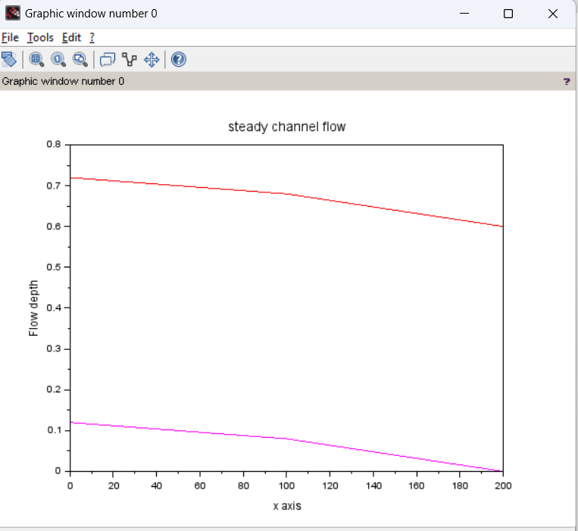

**(25) Steady_1D_channel_network**

***//Error level: Medium. Flow profile is not matching properly. Recheck!***



clc

clear

***//Lecture 39. variables: y and Q Both.***

*//~~~~~~Given Data~~~~~~~*

junc=1;

chl=2;

QI=20;*//m^3/s*

S0=[0.0004 0.0008];

n=[0.010 0.015];

B=15;*//m*

g=9.81;*//m/s^2*

Lx=[100 100];

yd=0.6;*//m*

*//Depth at the downstream section.*

mnode=[101 101];

eps_max=1e-3;

global('B','g')

*//here two channels are there in series. So, C1, C2, S0, n values are different for the channels. Also, Q is considered as variable, no constant discharge for this problem.*

juni=[1 2 101 1];

*//I.T-->Coordinate of the junction =(channel number, node number)=(1,101)=(2,1).*

*//~~~~~~~~Problem Dependent Parameters~~~~~~~~~~*

alpha=[1,1];

yv=yd*ones(sum(mnode),1);

Qv=QI*ones(sum(mnode),1);

*//We will initialize the problem with yd and QI values of depth and discharge.Both are (202*1) matrices.*

gv=zeros(2*sum(mnode),1);

*//"gv" is the general variable with both y and Q.*

*//~~~~~~General Identification matrix~~~~~*

idv=0;

for l=1:chl

for i=1:mnode(l)

idv=idv+1

gid(l,i)=idv

*//Previously, we used local numbering of a section i.e.(l,i).Now, this local numberings are converted to the global numbering and stored in 'gid' matrix. Eg. for l=chl=2, for i=mnode(2)=101, gid(2,101)=202.*

end

end

for l=1:chl

for i=1:mnode(l)

gv(2*gid(l,i)-1)=yv(gid(l,i))

gv(2*gid(l,i))=Qv(gid(l,i))

*//Here, yv and Qv vectors store depth and dischage informations of the sections (size 202*1 for each). Where, 'gv'(size 404*1) is the "general variable" vector which collects data from 'yv' and 'Qv' vectors.*

*//Here, equation looks like, "J*del_phi=r".Whare, J=Jacobian matrix,*

*//del_phi={del_y1; del_Q1; del_y2; del_Q2;......},*

*//r=[-UB_{1,1}; -C_{1,1}; -M_{1,1}; -C_{1,2}; -M_{1,2}; .........;-C_{chl,mnode(chl)}; -M_{chl,mnode(chl)};-DB_{chl,mnode(chl)}]*

end

end

for l=1:chl

delta_x(l)=Lx(l)/(mnode(l)-1);

D1(l)=alpha(l)/(2*g);

D2(l)=(1/2)*n(l)^2*delta_x(l);

*//These three are channel reach dependent parameters.*

end

mc=sum(mnode);

for l=chl:-1:1

for i=mnode(l):-1:1

if (l==chl & i==mnode(l)) then

zv(mc)=0;

*//This 1st 'if' loop evaluates the bed elevation for end section of the last channel reach.*

end

if(l<>chl & i==mnode(l)) then

mc=mc-1;

zv(mc)=zv(mc+1);

*//This 'if' loop evaluates the bed elevation for end section of other channel reaches.*

end

if(i<>mnode(l)) then

mc=mc-1;

zv(mc)=zv(mc+1)+S0(l)*delta_x(l);

end

end

end

xv=[linspace(0,Lx(1),mnode(1)) linspace(Lx(1),Lx(1)+Lx(2),mnode(2))]

function **Av**=areav(**y**)

**Av**=B\***y**;

*//Cross-section area*

endfunction

function **dAv**=dareav(**y**)

**dAv**=B;

*//dAv gives dA/dy.*

endfunction

function **Rv**=HRv(**y**)

**Rv**=B\***y**/(B+2\***y**);

*//'Rv' gives hydraulic radius.*

endfunction

function **dRv**=dHRv(**y**)

**dRv**=B^2/(B+2\***y**)^2;

*//'dRv' gives dR/dy.*

endfunction

*//...........................*

function **Mliv**=Mli(**y1**, **Q1**, **y2**, **Q2**, **S0**, **delta_x**, **D1**, **D2**)

**Mliv**=(**y2**-**y1**)-**S0**\***delta_x**+**D1**\*(**Q2**\*abs(**Q2**)*areav(**y2**)^(-2)-**Q1**\*abs(**Q1**)*areav(**y1**)^(-2))+**D2**\*(**Q2**\*abs(**Q2**)*HRv(**y2**)^(-4/3)*areav(**y2**)^(-2)+**Q1**\*abs(**Q1**)*HRv(**y1**)^(-4/3)*areav(**y1**)^(-2));

*//See Equation (146).*

*//Here, coefficients are D1 and D2, not C1 and C2. C1 and C2 was considered for the code "steady_1D_channel_series", Where 'discharge Q' was not considered as a variable.*

*//////////////Why Q|Q| in Kineric head term?????*

endfunction

function **dMdyiv**=dMdyi(**y**, **Q**, **D1**, **D2**)

term1=(2\***Q**^2/areav(**y**)^(3))*dareav(**y**);

term2=2\***Q**^2*areav(**y**)^(-3)*HRv(**y**)^(-4/3)*dareav(**y**);

term3=(4/3)\***Q**^2*areav(**y**)^(-2)*HRv(**y**)^(-7/3)*dHRv(**y**);

**dMdyiv**=-1+**D1**\*term1-**D2**\*(term2+term3);

*//From equation (147.1).Evaluates dM_{l,i}/dy_{l,i}.*

endfunction

function **dMdyip1v**=dMdyi(**y**, **Q**, **D1**, **D2**)

term1=(2\***Q**^2/area(**y**)^(3))*dareav(**y**);

term2=2\***Q**^2*areav(**y**)^(-3)*HRv(**y**)^(-4/3)*dareav(**y**);

term3=(4/3)\***Q**^2*areav(**y**)^(-2)*HRv(**y**)^(-7/3)*dHRv(**y**);

dMdyiv=-1-**D1**\*term1-**D2**\*(term2+term3);

*//From equation (147.3). Evaluates dM_{l,i}/dy_{l,i+1}.*

endfunction

function **dMdQip1v**=dMdQip1(**y**, **Q**, **D1**, **D2**)

term1=2\***Q**\*areav(**y**)^(-3);

term2=2\***Q**\*areav(**y**^(-2)*HRv(**y**)^(-4/3));

**dMdQip1v**=**D1**\*term1+**D2**\*term2;

*//From equation (147.4).*

endfunction

function **dMdQiv**=dMdQi(**y**, **Q**, **D1**, **D2**)

term1=2\***Q**\*areav(**y**)^(-3);

term2=2\***Q**\*areav(**y**^(-2)*HRv(**y**)^(-4/3));

dMdQip1v=-**D1**\*term1+**D2**\*term2;

*//From equation (147.2).*

endfunction

A=zeros(2*sum(mnode),2*sum(mnode));

r=zeros(2*sum(mnode),1);

*// We have total 101*2=202 nodes in two channels. So, we have 202*2=404 variables in total (considering y & Q).*

count=0;

rmse=1;

*//~~~~~~~~~~~~~~~~~~~~~~~~~~Space Loop~~~~~~~~~~~~~~~~~~~~~~~~~*

while rmse>eps_max

rmse=0;

eqn=1;

*//Equation number.*

*//~~~Upstream Boundary~~~~*

A(1,2)=1;

r(1)=-(Qv(1)-QI);

*//See (5no-P 133). Here, UB_{1,1}=Q_{1,1}-Q_u. A(1,1)=del(UB)/del_(y_{1,1})=0. So, this satisfy "A*phi=r", means "Jacobian*del_(y and Q)=-(C_{l,i} and M_{l,i})". See (5no-P 33).*

*//~~~~~~~~~~~Equations Corresponding to segments~~~~~~~~~~*

for l=1:chl

for i=1:mnode(l)-1

*// Because, we get one continuity and one momentum equation corresponding to each segment. and for lth channel reach, number of segments=mnode(l)-1. Here, (l,i) means the segment number which have (l,i)th and (l,i+1)th sections.*

eqn=eqn+1;

*//~~~~~~Jacobians for Continuity eqn~~~~~~~*

A(eqn,2*gid(l,i)-1)=0;

*//del(C_{l,i})/del(y_{l,i}).See equation (156).*

A(eqn,2*gid(l,i))=-1;

*//del(C_{l,i})/del(Q_{l,i}).*

A(eqn,2*gid(l,i+1)-1)=0;

*//del(C_{l,i})/del(y_{l,i+1}).*

A(eqn,2*gid(l,i+1))=1;

*//del(C_{l,i})/del(Q_{l,i+1}).*

r(eqn)=0;

*// Value of each continuity functions (i.e, C_{l,i}) is zero! See equation (143) & (155.1).*

eqn=eqn+1;

*//This 'increment of counter' is for 'momentum equation' of the same segment.*

*//~~~~~~~Jacobians for Momentum eqn~~~~~~~~*

A(eqn,2*gid(l,i)-1)=dMdyi(yv(gid(l,i)),Qv(gid(l,i)),D1(l),D2(l));

*//del(M_{l,i})/del(y_{l,i}).See page 37 & equation (147.1).*

A(eqn,2*gid(l,i))=dMdQi(yv(gid(l,i)),Qv(gid(l,i)),D1(l),D2(l));

*//del(M_{l,i})/del(Q_{l,i}).See equation (147.2).*

A(eqn,2*gid(l,i+1)-1)=dMdyip1(yv(gid(l,i+1)),Qv(gid(l,i+1)),D1(l),D2(l));

*//del(M_{l,i})/del(y_{l,i+1}).See equation (147.3).*

A(eqn,2*gid(l,i+1))=dMdQip1(yv(gid(l,i+1)),Qv(gid(l,i+1)),D1(l),D2(l));

*//del(M_{l,i})/del(Q_{l,i+1}).See equation (147.4).*

r(eqn)=-Mli(yv(gid(l,i)),Qv(gid(l,i)),yv(gid(l,i+1)),Qv(gid(l,i+1)),S0(l),delta_x(l),D1(l),D2(l));

end

end

*// Explanation of 'equations corresponding to segments' of 'space loop':*

*//1st iteration (When l=1 & i=1): Continuity part:eqn=1+1=2 (i.e. 2nd row of Jacobian matrix). gid(1,1)=1 and gid(1,2)=2. Therefore, A(2,1)=0; A(2,2)=-1; A(2,3)=0; A(2,4)=1. Momentum part: eqn=2+1=3 (i.e. 3rd row of Jacobian matrix). gid(1,1)=1. To evaluate A(3,1), A(3,2), A(3,3)and A(3,4) equation (147)'s are used.*

*//2nd iteration(When l=1 & i=2): then eqn=4. gid(1,2)=2 and gid(1,3)=3. Therefore, A(4,3)=0; A(4,4)=-1; A(4,5)=0; A(4,6)=1....and so on...*

*//~~~~~~~~~Junction Condition~~~~~~*

*///////Doubt: If junction condition executes after all segments, is the position of junction equation not already occupied???*

*//~~~~Junction Continuity~~~*

eqn=eqn+1;

A(eqn,2*gid(juni(1),juni(3)))=-1;

A(eqn,2*gid(juni(2),juni(4)))=1;

r(eqn)=-(Qv(gid(juni(2),juni(4)))-Qv(gid(juni(1),juni(3))));

*////I.T=>[eqn=203 should be here(Because, previously 202 eqns are there i.e. 1 u/s condition and 200 equations for 1st 100 segments and 1 junction energy condition (because, delta_y comes before delta_Q.).*

*//A(202,2*gid(1,101))=A(202,2*101)=A(202,202)=-1 ;*

*//A(202,gid(2,1))=A(202,2*102)=A(202,204)=1 and*

*//r(202)=-(Qv(102)-Qv(101))=-(Qv_{2,1}-Qv_{1,101})*

*//So, equation becomes, -delta_Qv(101)+delta_Qv(102)=-(Qv(102)-Qv(101)). ****Remember, delta_Qv(101), delta_Qv(102) these are difference of current and previous iteration values from Newton-Raphson's method, not the difference between two node values.]*

*//~~~~Junction Energy~~~*

eqn=eqn+1;

A(eqn,2*gid(juni(1),juni(3))-1)=1;

A(eqn,2*gid(juni(2),juni(4))-1)=-1;

r(eqn)=-(yv(gid(juni(1),juni(3)))-yv(gid(juni(2),juni(4))));

*/////I.T--> eqn=202 should be here. Because, junction energy comes before junction continuity (i.e, delta_y comes before delta_Q). But, in code it gets more counter(as, eqn=eqn+1 used). Is it right?????*

*////I.T--> [We have total 101+101=202 sections=>202*2=404 variables. We have 1 upstream discharge condition; 100+100=200 segments=>200*2=400 equations(Continuity & momentum); 2 junction conditions (Continuity & momentum); 1 downstrem depth condition i.e. 1+400+2+1=404 equations].*

*//~~~~~Downstream Boundary~~~~~~~~~*

eqn=eqn+1;

A(eqn,2*gid(2,mnode(2))-1)=-1;

*// d/s depth boundary, coff corresponding to delta_y(202).*

r(eqn)=-(yd-yv(gid(2,mnode(2))));

*//So, d/s becomes, -delta_y(202)=-(yd-yv(202))*

delyQ=A\r;

for i=1:2*sum(mnode)

*//Because, 2*sum(mnode)=2*202=404 is total number of variables.*

gv(i)=gv(i)+delyQ(i);

*//All the variables are being updated in each iteration.*

rmse=rmse+delQ(i)^2;

end

*//Initial Value*

for l=1:chl

for i=1:mnode(l)

yv(gid(l,i))=gv(2*gid(l,i)-1);

Qv(gid(l,i))=gv(2*gid(l,i));

end

end

rmse=sqrt(rmse/sum(mnode));

count=count+1;

disp([count rmse])

end

*//figure*

plot(xv,yv+zv,"-r")

plot([Lx(1) Lx(1)+Lx(2)],[zv(mnode(1)+1) zv(sum(mnode))],'m-')

plot([0,Lx(1)],[zv(1),zv(mnode(1))],'m-')

xtitle('steady channel flow', 'x axis','Flow depth')

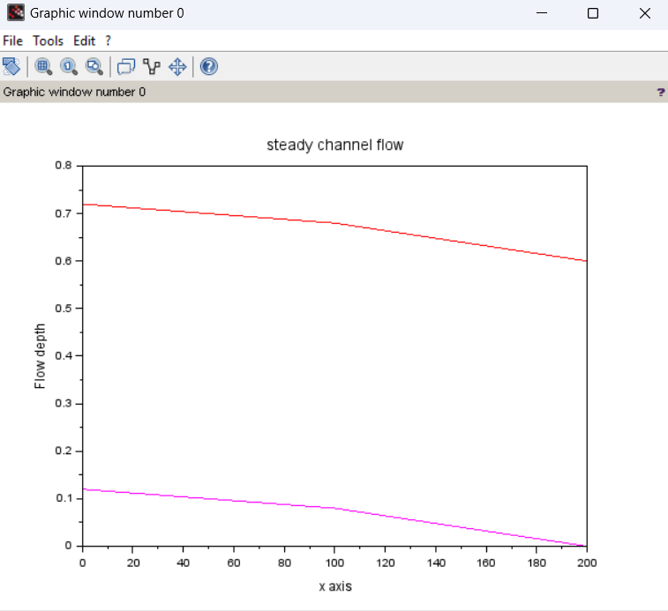

**(26) Steady_1D_channel_network (1):**

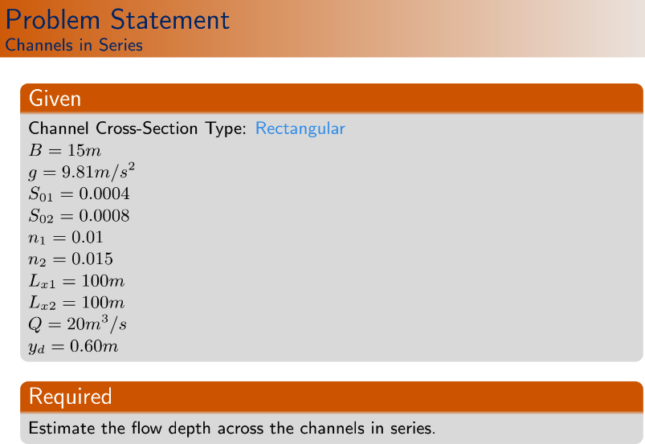

clc

clear

*//Lecture 39. variables: y and Q Both.*

*//~~~~~~Given Data~~~~~~~*

junc=1;

chl=2;

QI=20;*//m^3/s*

S0=[0.0004 0.0008];

n=[0.010 0.015];

B=15;*//m*

g=9.81;*//m/s^2*

Lx=[100 100];

yd=0.6;*//m*

*//Depth at the downstream section.*

mnode=[101 101];

eps_max=1e-6;

global('B','g')

*//here two channels are there in series. So, C1,C2,S0,n values are different for the channels. Also Q is considered as variable, no constant dischargefor this problem.*

juni=[1 2 101 1];

*//I.T-->Coordinate of the junction =(channel number, node number)=(1,101)=(2,1).*

*//~~~~~~~~Problem Dependent Parameters~~~~~~~~~~*

alpha=[1,1];

yv=yd*ones(sum(mnode),1);

Qv=QI*ones(sum(mnode),1);

*//We will initialize the problem with yd and QI values of depth and discharge.Both are (202*1) matrices.*

gv=zeros(2*sum(mnode),1);

*//"gv" is the general variable with both y and Q.*

*//~~~~~~General Identification matrix~~~~~*

idv=0;

for l=1:chl

for i=1:mnode(l)

idv=idv+1

gid(l,i)=idv

*//Previously, we used local numbering of a section i.e.(l,i).Now, this local numberings are converted to the global numbering and stored in 'gid' matrix. Eg. for l=chl=2, for i=mnode(2)=101, gid(2,101)=202.*

end

end

for l=1:chl

for i=1:mnode(l)

gv(2*gid(l,i)-1)=yv(gid(l,i))

gv(2*gid(l,i))=Qv(gid(l,i))

*//Here, yv and Qv vectors store depth and dischage informations of the sections (size 202*1 for each). Where, 'gv'(size 404*1) is the "general variable" vector which collects data from 'yv' and 'Qv' vectors.*

*//Here, equation looks like, "J*del_phi=r".Whare, J=Jacobian matrix,*

*//del_phi={del_y1; del_Q1; del_y2; del_Q2;......},*

*//r=[-UB_{1,1}; -C_{1,1}; -M_{1,1}; -C_{1,2}; -M_{1,2}; .........;-C_{chl,mnode(chl)}; -M_{chl,mnode(chl)};-DB_{chl,mnode(chl)}]*

end

end

for l=1:chl

delta_x(l)=Lx(l)/(mnode(l)-1);

D1(l)=alpha(l)/(2*g);

D2(l)=(1/2)*n(l)^2*delta_x(l);

*//These three are channel reach dependent parameters.*

end

mc=sum(mnode);

for l=chl:-1:1

for i=mnode(l):-1:1

if (l==chl & i==mnode(l)) then

zv(mc)=0;

*//This 1st 'if' loop evaluates the bed elevation for end section of the last channel reach.*

end

if(l<>chl & i==mnode(l)) then

mc=mc-1;

zv(mc)=zv(mc+1);

*//This 'if' loop evaluates the bed elevation for end section of other channel reaches.*

end

if(i<>mnode(l)) then

mc=mc-1;

zv(mc)=zv(mc+1)+S0(l)*delta_x(l);

end

end

end

xv=[linspace(0,Lx(1),mnode(1)) linspace(Lx(1),Lx(1)+Lx(2),mnode(2))]

function **Av**=areav(**y**)

**Av**=B\***y**;

*//Cross-section area*

endfunction

function **dAv**=dareav(**y**)

**dAv**=B;

*//dAv gives dA/dy.*

endfunction

function **Rv**=HRv(**y**)

**Rv**=B\***y**/(B+2\***y**);

*//'Rv' gives hydraulic radius.*

endfunction

function **dRv**=dHRv(**y**)

**dRv**=B^2/(B+2\***y**)^2;

*//'dRv' gives dR/dy.*

endfunction

*//...........................*

function **Mliv**=Mli(**y1**, **Q1**, **y2**, **Q2**, **S0**, **delta_x**, **D1**, **D2**)

**Mliv**=(**y2**-**y1**)-**S0**\***delta_x**+**D1**\*(**Q2**\*abs(**Q2**)*areav(**y2**)^(-2)-**Q1**\*abs(**Q1**)*areav(**y1**)^(-2))+**D2**\*(**Q2**\*abs(**Q2**)*HRv(**y2**)^(-4/3)*areav(**y2**)^(-2)+**Q1**\*abs(**Q1**)*HRv(**y1**)^(-4/3)*areav(**y1**)^(-2));

*//See Equation (146).*

*//Here, coefficients are D1 and D2, not C1 and C2. C1 and C2 was considered for the code "steady_1D_channel_series", Where 'discharge Q' was not considered as a variable.*

*//////////////Why Q|Q| in Kineric head term?????*

endfunction

function **dMdyiv**=dMdyi(**y**, **Q**, **D1**, **D2**)

term1=(2\***Q**^2/areav(**y**)^(3))*dareav(**y**);

term2=2\***Q**^2*areav(**y**)^(-3)*HRv(**y**)^(-4/3)*dareav(**y**);

term3=(4/3)\***Q**^2*areav(**y**)^(-2)*HRv(**y**)^(-7/3)*dHRv(**y**);

**dMdyiv**=-1+**D1**\*term1-**D2**\*(term2+term3);

*//From equation (147.1).Evaluates dM_{l,i}/dy_{l,i}.*

endfunction

function **dMdyip1v**=dMdyi(**y**, **Q**, **D1**, **D2**)

term1=(2\***Q**^2/area(**y**)^(3))*dareav(**y**);

term2=2\***Q**^2*areav(**y**)^(-3)*HRv(**y**)^(-4/3)*dareav(**y**);

term3=(4/3)\***Q**^2*areav(**y**)^(-2)*HRv(**y**)^(-7/3)*dHRv(**y**);

dMdyiv=-1-**D1**\*term1-**D2**\*(term2+term3);

*//From equation (147.3). Evaluates dM_{l,i}/dy_{l,i+1}.*

endfunction

function **dMdQip1v**=dMdQip1(**y**, **Q**, **D1**, **D2**)

term1=2\***Q**\*areav(**y**)^(-3);

term2=2\***Q**\*areav(**y**)^(-2)*HRv(**y**)^(-4/3);

**dMdQip1v**=**D1**\*term1+**D2**\*term2;

*//From equation (147.4).*

endfunction

function **dMdQiv**=dMdQi(**y**, **Q**, **D1**, **D2**)

term1=2\***Q**\*areav(**y**)^(-3);

term2=2\***Q**\*areav(**y**)^(-2)*HRv(**y**)^(-4/3);

dMdQip1v=-**D1**\*term1+**D2**\*term2;

*//From equation (147.2).*

endfunction

A=zeros(2*sum(mnode),2*sum(mnode));

r=zeros(2*sum(mnode),1);

*// We have total 101*2=202 nodes in two channels. So, we have 202*2=404 variables in total (considering y & Q).*

count=0;

rmse=1;

*//~~~~~~~~~~~~~~~~~~~~~~~~~~Space Loop~~~~~~~~~~~~~~~~~~~~~~~~~*

while rmse>eps_max

rmse=0;

eqn=1;

*//Equation number.*

*//~~~Upstream Boundary~~~~*

A(1,2)=1;

r(1)=-(Qv(1)-QI);

*//See (5no-P 133). Here, UB_{1,1}=Q_{1,1}-Q_u. A(1,1)=del(UB)/del_(y_{1,1})=0. So, this satisfy "A*phi=r", means "Jacobian*del_(y and Q)=-(C_{l,i} and M_{l,i})". See (5no-P 33).*

*//~~~~~~~~~~~Equations Corresponding to segments~~~~~~~~~~*

for l=1:chl

for i=1:mnode(l)-1

*// Because, we get one continuity and one momentum equation corresponding to each segment. and for lth channel reach, number of segments=mnode(l)-1. Here, (l,i) means the segment number which have (l,i)th and (l,i+1)th sections.*

eqn=eqn+1;

*//~~~~~~Jacobians for Continuity eqn~~~~~~~*

A(eqn,2*gid(l,i)-1)=0;

*//del(C_{l,i})/del(y_{l,i}).See equation (156).*

A(eqn,2*gid(l,i))=-1;

*//del(C_{l,i})/del(Q_{l,i}).*

A(eqn,2*gid(l,i+1)-1)=0;

*//del(C_{l,i})/del(y_{l,i+1}).*

A(eqn,2*gid(l,i+1))=1;

*//del(C_{l,i})/del(Q_{l,i+1}).*

r(eqn)=0;

*// Value of each continuity functions (i.e, C_{l,i}) is zero! See equation (143) & (155.1).*

eqn=eqn+1;

*//This 'increment of counter' is for 'momentum equation' of the same segment.*

*//~~~~~~~Jacobians for Momentum eqn~~~~~~~~*

A(eqn,2*gid(l,i)-1)=dMdyi(yv(gid(l,i)),Qv(gid(l,i)),D1(l),D2(l));

*//del(M_{l,i})/del(y_{l,i}).See page 37 & equation (147.1).*

A(eqn,2*gid(l,i))=dMdQi(yv(gid(l,i)),Qv(gid(l,i)),D1(l),D2(l));

*//del(M_{l,i})/del(Q_{l,i}).See equation (147.2).*

A(eqn,2*gid(l,i+1)-1)=dMdyip1(yv(gid(l,i+1)),Qv(gid(l,i+1)),D1(l),D2(l));

*//del(M_{l,i})/del(y_{l,i+1}).See equation (147.3).*

A(eqn,2*gid(l,i+1))=dMdQip1(yv(gid(l,i+1)),Qv(gid(l,i+1)),D1(l),D2(l));

*//del(M_{l,i})/del(Q_{l,i+1}).See equation (147.4).*

r(eqn)=-Mli(yv(gid(l,i)),Qv(gid(l,i)),yv(gid(l,i+1)),Qv(gid(l,i+1)),S0(l),delta_x(l),D1(l),D2(l));

end

end

*// Explanation of 'equations corresponding to segments' of 'space loop':*

*//1st iteration (When l=1 & i=1): Continuity part:eqn=1+1=2 (i.e. 2nd row of Jacobian matrix). gid(1,1)=1 and gid(1,2)=2. Therefore, A(2,1)=0; A(2,2)=-1; A(2,3)=0; A(2,4)=1. Momentum part: eqn=2+1=3 (i.e. 3rd row of Jacobian matrix). gid(1,1)=1. To evaluate A(3,1), A(3,2), A(3,3)and A(3,4) equation (147)'s are used.*

*//2nd iteration(When l=1 & i=2): then eqn=4. gid(1,2)=2 and gid(1,3)=3. Therefore, A(4,3)=0; A(4,4)=-1; A(4,5)=0; A(4,6)=1....and so on...*

*//~~~~~~~~~Junction Condition~~~~~~*

*///////Doubt: If junction condition executes after all segments, is the position of junction equation not already occupied???*

*//~~~~Junction Continuity~~~*

eqn=eqn+1;

A(eqn,2*gid(juni(1),juni(3)))=-1;

A(eqn,2*gid(juni(2),juni(4)))=1;

r(eqn)=-(Qv(gid(juni(2),juni(4)))-Qv(gid(juni(1),juni(3))));

*////I.T=>[eqn=203 should be here(Because, previously 202 eqns are there i.e. 1 u/s condition and 200 equations for 1st 100 segments and 1 junction energy condition (because, delta_y comes before delta_Q.).*

*//A(202,2*gid(1,101))=A(202,2*101)=A(202,202)=-1 ;*

*//A(202,gid(2,1))=A(202,2*102)=A(202,204)=1 and*

*//r(202)=-(Qv(102)-Qv(101))=-(Qv_{2,1}-Qv_{1,101})*

*//So, equation becomes, -delta_Qv(101)+delta_Qv(102)=-(Qv(102)-Qv(101)). ****Remember, delta_Qv(101), delta_Qv(102) these are difference of current and previous iteration values from Newton-Raphson's method, not the difference between two node values.]*

*//~~~~Junction Energy~~~*

eqn=eqn+1;

A(eqn,2*gid(juni(1),juni(3))-1)=1;

A(eqn,2*gid(juni(2),juni(4))-1)=-1;

r(eqn)=-(yv(gid(juni(1),juni(3)))-yv(gid(juni(2),juni(4))));

*/////I.T--> eqn=202 should be here. Because, junction energy comes before junction continuity (i.e, delta_y comes before delta_Q). But, in code it gets more counter(as, eqn=eqn+1 used). Is it right?????*

*////I.T--> [We have total 101+101=202 sections=>202*2=404 variables. We have 1 upstream discharge condition; 100+100=200 segments=>200*2=400 equations(Continuity & momentum); 2 junction conditions (Continuity & momentum); 1 downstrem depth condition i.e. 1+400+2+1=404 equations].*

*//~~~~~Downstream Boundary~~~~~~~~~*

eqn=eqn+1;

A(eqn,2*gid(2,mnode(2))-1)=-1;

*// d/s depth boundary, coff corresponding to delta_y(202).*

r(eqn)=-(yd-yv(gid(2,mnode(2))));

*//So, d/s becomes, -delta_y(202)=-(yd-yv(202))*

delyQ=A\r;

for i=1:2*sum(mnode)

*//Because, 2*sum(mnode)=2*202=404 is total number of variables.*

gv(i)=gv(i)+delyQ(i);

*//All the variables are being updated in each iteration.*

rmse=rmse+delQ(i)^2;

end

*//Initial Value*

for l=1:chl

for i=1:mnode(l)

yv(gid(l,i))=gv(2*gid(l,i)-1);

Qv(gid(l,i))=gv(2*gid(l,i));

end

end

rmse=sqrt(rmse/sum(mnode));

count=count+1;

disp([count rmse])

end

*//figure*

plot(xv,yv+zv,"-r")

plot([Lx(1) Lx(1)+Lx(2)],[zv(mnode(1)+1) zv(sum(mnode))],'m-')

plot([0,Lx(1)],[zv(1),zv(mnode(1))],'m-')

xtitle('steady channel flow', 'x axis','Flow depth')

**!**

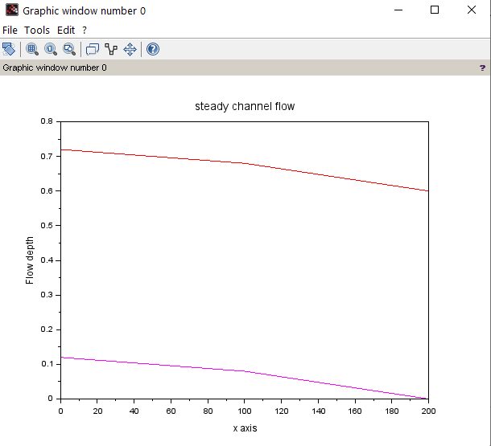

**(27) Steady_1D_channel_network_Without_reverse**

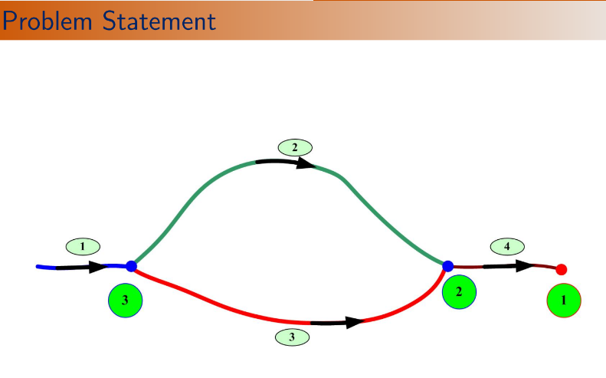

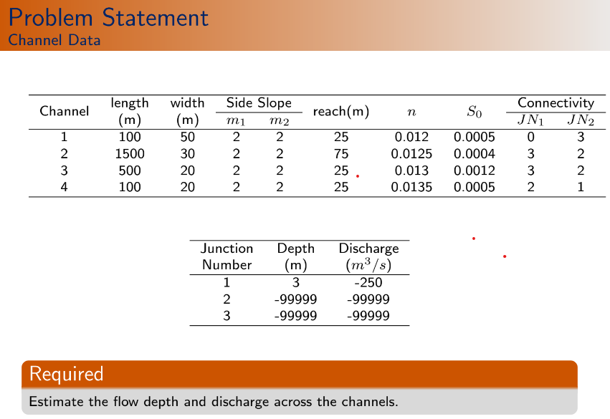

clc

clear

function **Av**=areav(**y**, **B**, **m1**, **m2**)

**Av**=**B**\***y**+(1/2)*(**m1**+**m2**)\***y**^2;

endfunction

function **dAv**=dareav(**y**, **B**, **m1**, **m2**)

**dAv**=**B**+(**m1**+**m2**)\***y**;

*//dAv means dA/dy. See (157.1).*

endfunction

function **Rv**=HRv(**y**, **B**, **m1**, **m2**)

**Rv**=(**B**\***y**+(1/2)*(**m1**+**m2**)\***y**^2)/(**B**+(sqrt(1+**m1**^2)+sqrt(1+**m2**^2))\***y**);

*// it is hydraulic radius. see equation (155)*

endfunction

function **dRv**=dHRv(**y**, **B**, **m1**, **m2**)

Tw=**B**+(**m1**+**m2**)\***y**;

*//Top width. See equation (155)*

Pm=(**B**+(sqrt(1+**m1**^2)+sqrt(1+**m2**^2))\***y**);

*//Wetted perimeter. See equation (155)*

Rh=HRv(**y**,**B**,**m1**,**m2**);

dPdy=(sqrt(1+**m1**^2)+sqrt(1+**m2**^2));

*//dP/dy. See equation (157.2).*

**dRv**=(Tw/Pm)-(Rh/Pm)*dPdy;

*//dRv means dR/dy. See equation (120)for its derrivation.*

endfunction

function **Mliv**=Mli(**y1**, **Q1**, **y2**, **Q2**, **S0**, **delta_x**, **D1**, **D2**, **B**, **m1**, **m2**)

**Mliv**=(**y2**-**y1**)-**S0**\***delta_x**+**D1**\*(**Q2**^2*areav(**y2**,**B**,**m1**,**m2**)^(-2)-**Q1**^2*areav(**y1**,**B**,**m1**,**m2**)^(-2))+**D2**\*(**Q2**\*abs(**Q2**)*HRv(**y2**,**B**,**m1**,**m2**)^(-4/3)*areav(**y2**,**B**,**m1**,**m2**)^(-2)+**Q1**\*abs(**Q1**)*HRv(**y1**,**B**,**m1**,**m2**)^(-4/3)*areav(**y1**,**B**,**m1**,**m2**)^(-2));

endfunction

function **dMdyiv**=dMdyi(**y**, **Q**, **D1**, **D2**, **B**, **m1**, **m2**)

term1=(2\***Q**^2/areav(**y**,**B**,**m1**,**m2**)^(3))*dareav(**y**,**B**,**m1**,**m2**);

term2=2\***Q**\*abs(**Q**)*areav(**y**,**B**,**m1**,**m2**)^(-3)*HRv(**y**,**B**,**m1**,**m2**)^(-4/3)*dareav(**y**,**B**,**m1**,**m2**);

term3=(4/3)\***Q**\*abs(**Q**)*areav(**y**,**B**,**m1**,**m2**)^(-2)*HRv(**y**,**B**,**m1**,**m2**)^(-7/3)*dHRv(**y**,**B**,**m1**,**m2**);

**dMdyiv**=-1+**D1**\*term1-**D2**\*(term2+term3);

*//From equation (147.1).Evaluates dM_{l,i}/dy_{l,i}.*

endfunction

function **dMdyip1v**=dMdyi(**y**, **Q**, **D1**, **D2**, **B**, **m1**, **m2**)

term1=(2\***Q**^2/area(**y**,**B**,**m1**,**m2**)^(3))*dareav(**y**,**B**,**m1**,**m2**);

term2=2\***Q**\*abs(**Q**)*areav(**y**,**B**,**m1**,**m2**)^(-3)*HRv(**y**,**B**,**m1**,**m2**)^(-4/3)*dareav(**y**,**B**,**m1**,**m2**);

term3=(4/3)\***Q**\*abs(**Q**)*areav(**y**,**B**,**m1**,**m2**)^(-2)*HRv(**y**,**B**,**m1**,**m2**)^(-7/3)*dHRv(**y**,**B**,**m1**,**m2**);

dMdyiv=-1-**D1**\*term1-**D2**\*(term2+term3);

*//From equation (147.3). Evaluates dM_{l,i}/dy_{l,i+1}.*

endfunction

function **dMdQip1v**=dMdQip1(**y**, **Q**, **D1**, **D2**, **B**, **m1**, **m2**)

term1=2\***Q**\*areav(**y**,**B**,**m1**,**m2**)^(-3);

term2=2*abs(**Q**)*areav(**y**,**B**,**m1**,**m2**)^(-2)*HRv(**y**,**B**,**m1**,**m2**)^(-4/3);

**dMdQip1v**=**D1**\*term1+**D2**\*term2;

*//From equation (147.4).*

endfunction

function **dMdQiv**=dMdQi(**y**, **Q**, **D1**, **D2**, **B**, **m1**, **m2**)

term1=2\***Q**\*areav(**y**,**B**,**m1**,**m2**)^(-3);

term2=2*abs(**Q**)*areav(**y**,**B**,**m1**,**m2**)^(-2)*HRv(**y**,**B**,**m1**,**m2**)^(-4/3);

dMdQip1v=-**D1**\*term1+**D2**\*term2;

*//From equation (147.2).*

endfunction

*//~~~~~~~~~~~~~~~~~~~~~~~~~~~~~~~~~~~~~~*

*//Channel reach: start + , end - .*

*//Flow depth condition: 1*

*//Flow rate (discharge) condition: 2*

*//~~~~~~~~~~~~~~~~~~~~~~~~~~~~~~~~~~~~~~*

*//~~~~~~~~~~Given Data~~~~~~~~~*

g=9.81; *//m/s^2*

global('g')

yd=3; *//m*

Qd=250; *//m^3/s*

eps_max=1e-6;

*//~~~~~~~~~~~~~~~~~~~~~~~~~~~~~~~~~~*

junn=3;*//number of junctions*

chln=4;*//number of channels*

*//~~~~Chl | Length | Width | m1 | m2 | Segment | n | S0 | JN1 | JN2 |*

chl_inf=[1 100 50 2 2 25 0.0120 0.0005 0 3

2 1500 30 2 2 75 0.0125 0.0004 3 2

3 500 20 2 2 25 0.0130 0.0012 3 2

4 100 40 2 2 25 0.0135 0.0005 2 1];

jun_inf=[yd -Qd

-99999 -99999

-99999 -99999];

jun_con= [1 -4 0 0

3 4 -3 -2

3 -1 2 3];

*//In 'jun_con' matrix, 1st column represents number of channels connected to that junction.*

*//Positive sign means 1st section of that channel is connected to that junction. Negative sign means (Nl+1)th section of that channel is connected to that junction.*

alpha=[1 1 1 1];

*//~~~~~~~Derived informations from 'chl_inf' matrix~~~~~~~~~~*

Lx=chl_inf(1:chln,2);

*//We know, 'chln' means channel number=4.*

B=chl_inf(1:chln,3);

m1=chl_inf(1:chln,4);

m2=chl_inf(1:chln,5);

delta_x=chl_inf(1:chln,6);

n=chl_inf(1:chln,7);

S0=chl_inf(1:chln,8);

mnode=Lx./delta_x+1;

*//Here, mnode is calculated at point by point basis. Here, Lx=[100; 1500; 500; 100], delta_x=[25;75; 25; 25] results mnode=[5; 21; 21; 5].*

*//~~~~~~~Problem Dependent Parameters~~~~~~~*

yv=yd*ones(sum(mnode),1);

Qv=Qd*ones(sum(mnode),1);

*//Problem is initialized with downstream depth and discharge values.*

gv=zeros(2*sum(mnode),1);

*//'gv' will store the general variable with y and Q.*

*//~~~General identification matrix~~~*

idv=0;

for l=1:chln

for i=1:mnode(l)

idv=idv+1;

gid(l,i)=idv;

*//Number of rows in 'gid' matrix= no. of channels=4 and number of columns= maximum no. of sections in a channel reach=max(5,21,21,5)=21. So, 'gid' is a 4*21 matrix.*

end

end

for l=1:chln

for i=1:mnode(l)

gv(2*gid(l,i)-1)=yv(gid(l,i))

gv(2*gid(l,i))=Qv(gid(l,i))

*//Initial Values of 'yv' and 'Qv' matries are stored in 'gv' or general variable matrix togetherly.*

end

end

for l=1:chln

D1(l)=alpha(l)/(2*g);

D2(l)=(1/2)*n(l)^2*delta_x(l);

end

A=zeros(2*sum(mnode),2*sum(mnode));

*//'A' will store coff(s) of jacobian matrix.*

r=zeros(2*sum(mnode),1);

Count=0;

rmse=1;

*//~~~~~~~~~~~~Space loop~~~~~~~~~~~~~~~~~~~*

while rmse>eps_max

rmse=0;

eqn=0;*//Equation number*

*//~~~~~Equations corresponding to segments(2N1+2N2+2N3+2N4)~~~~~~*

for l=1:chln

for i=1:mnode(l)-1

*//~~~~~~Jacobians for Continuity eqn~~~~~~~*

eqn=eqn+1;

A(eqn,2*gid(l,i)-1)=0;

*//del(C_{l,i})/del(y_{l,i}).See equation (156).*

A(eqn,2*gid(l,i))=-1;

*//del(C_{l,i})/del(Q_{l,i}).*

A(eqn,2*gid(l,i+1)-1)=0;

*//del(C_{l,i})/del(y_{l,i+1}).*

A(eqn,2*gid(l,i+1))=1;

*//del(C_{l,i})/del(Q_{l,i+1}).*

r(eqn)=0;

*//~~~~~~~Jacobians for Momentum eqn~~~~~~~~*

eqn=eqn+1;

A(eqn,2*gid(l,i)-1)=dMdyi(yv(gid(l,i)),Qv(gid(l,i)),D1(l),D2(l),B(l),m1(l),m2(l));

*//del(M_{l,i})/del(y_{l,i}).See page 37 & equation (147.1).*

A(eqn,2*gid(l,i))=dMdQi(yv(gid(l,i)),Qv(gid(l,i)),D1(l),D2(l),B(l),m1(l),m2(l));

*//del(M_{l,i})/del(Q_{l,i}).See equation (147.2).*

A(eqn,2*gid(l,i+1)-1)=dMdyip1(yv(gid(l,i+1)),Qv(gid(l,i+1)),D1(l),D2(l),B(l),m1(l),m2(l));

*//del(M_{l,i})/del(y_{l,i+1}).See equation (147.3).*

A(eqn,2*gid(l,i+1))=dMdQip1(yv(gid(l,i+1)),Qv(gid(l,i+1)),D1(l),D2(l),B(l),m1(l),m2(l));

*//del(M_{l,i})/del(Q_{l,i+1}).See equation (147.4).*

r(eqn)=-Mli(yv(gid(l,i)),Qv(gid(l,i)),yv(gid(l,i+1)),Qv(gid(l,i+1)),S0(l),delta_x(l),D1(l),D2(l),B(l),m1(l),m2(l));

end

end

*//~~~~~~~Junction Continuity Conditions~~~~~~~*

for j=1:junn

eqn=eqn+1;

if(jun_inf(j,2)<>-99999) then

r(eqn)=-jun_inf(j,2);

*//////How??????????? I.T--> r=-DB=-(Q_{4,N4+1}+Q_d)...See Equation(159). But here, r=-(-Q_d)=Q_d....*

else

r(eqn)=0;

*//'r(eqn)=0' -->it means, no quantity is added there.*

end

*// jun_con= [1 -4 0 0*

*// 3 4 -3 -2*

*// 3 -1 2 3];*

for l=1:jun_con(j,1)

*//1st column gives the information about number of channel connected to particular junction.*

if (abs(jun_con(j,l+1))>eps_max) then

*//Checks whether a non-zero value is there or not?!zero value means that, no channel is connected.*

if (jun_con(j,l+1)>0) then

*//Checks whether the value is positive or negative. If positive, then the 1st section of the channel is connected to that junction. If negative, then the end section of the channel is connected to that junction.*

jn_node=1;

A(eqn,2*gid(abs(jun_con(j,l+1)),jn_node))=-1;

r(eqn)=r(eqn)-Qv(gid(abs(jun_con(j,l+1)),jn_node));

end

if (jun_con(j,l+1)<0) then

jn_node=mnode(abs(jun_con(j,l+1)));

A(eqn,2*gid(abs(jun_con(j,l+1)),jn_node))=1;

r(eqn)=r(eqn)+Qv(gid(abs(jun_con(j,l+1)),jn_node));

end

end

end

r(eqn)=-r(eqn);

end

*//Explanation of the junction continuity condition:*

*/////For 1st iteration: for j=1;*

*// eqn=eqn+1;*

*//jun_inf(j,2)=jun_inf(1,2)=-250<>-99999;*

*// r(eqn)=-jun_inf(j,2)=-jun_inf(1,2)=-(-250)=250;*

*// l=1(i.e. for j=1 & l=1),*

*//if abs(jun_con(j,l+1))=abs(jun_con(1,2))=abs(-4)=4 > eps_max;*

*// if (jun_con(j,l+1)=jun_con(1,2)=-4<0)*

*// then jn_node=mnode(abs(jun_con(j,l+1)))=mnode(abs(jun_con(1,2)))=mnode(4)=5;*

*//A(eqn,2*gid(abs(jun_con(j,l+1)),jn_node))=A(eqn,2*gid(4,5))=A(eqn,2*52)=A(eqn,104)=1;*

*//r(eqn)=r(eqn)+Qv(gid(abs(jun_con(j,l+1)),jn_node))=250+Qv(52);*

*//??????????????///Therefore, equation becomes, 1*del_Qv(52)=250+Qv(52). But in my opinion, from equation 159 and 160, DBQ=Qv(52)+250 & d(DBQ)/d(Qv(52))=1. Using the relation, J*phi=-F(phi)(See 164 and 165), 1*del_Qv(52)=-(250+Qv(52))*

*/////For 2nd iteration: for j=2;*

*// eqn=eqn+1;*

*//jun_inf(j,2)=jun_inf(1,2)=-99999;*

*// r(eqn)=0;*

*// l=1(i.e. for j=2 & l=1),*

*//if (abs(jun_con(j,l+1)))=abs(jun_con(2,2))=abs(4)=4 > eps_max;*

*// if (jun_con(j,l+1)=jun_con(2,2)=4>0)*

*// then jn_node=1;*

*//A(eqn,2*gid(abs(jun_con(j,l+1)),jn_node))=A(eqn,2*gid(4,1))=A(eqn,2*48)=A(eqn,96)=-1;*

*//r(eqn)=r(eqn)+Qv(gid(abs(jun_con(j,l+1)),jn_node))=250+Qv(gid(abs(jun_con(2,2)),1))=250+Qv(gid(4,1))=250-Qv(48);*

*//~~~~~~~~~~~Junction Energy condition~~~~~~~~*

*// jun_con= [1 -4 0 0*

*// 3 4 -3 -2*

*// 3 -1 2 3];*

for j=1:junn

if(jun_inf(j,1)<>-99999) then

eqn=eqn+1;

if(jun_con(j,2)>0)then jn_nodel=1; end

if(jun_con(j,2)<0)then jn_nodel=mnode(abs(jun_con(j,2))); end

A(eqn, 2*gid(abs(jun_con(j,2)),jn_nodel)-1)=1;

r(eqn)=yv(gid(abs(jun_con(j,2)),jn_nodel))-jun_inf(j,1);

r(eqn)=-r(eqn);

end

if(jun_con(j,2)>1) then

for l=1:jun_con(j,1)-1

eqn=eqn+1;

if(jun_con(j,2)>0)then jn_nodel=1; end

if(jun_con(j,2)<0)then jn_nodel=mnode(abs(jun_con(j,2))); end

A(eqn, 2*gid(abs(jun_con(j,2)),jn_nodel)-1)=1;

r(eqn)=yv(gid(abs(jun_con(j,2)),jn_nodel));

if(jun_con(j,l+2)>0)then jn_node2=1; end

if(jun_con(j,l+2)<0)then jn_node2=mnode(abs(jun_con(j,l+2))); end

A(eqn, 2*gid(abs(jun_con(j,l+2)),jn_nodel)-1)=-1;

r(eqn)=r(eqn)-yv(gid(abs(jun_con(j,l+2)),jn_node2));

r(eqn)=-r(eqn);

end

end

end

*//~~~~~~~~~Delta gv~~~~~~~*

delyQ=A\r;

for i=1:2*sum(mnode)

gv(i)=gv(i)+delyQ(i);

rmse=rmse+delyQ(i)^2;

end

*//~~~~~Update Value~~~~~*

for l=1:chln

for i=1:mnode(l)

yv(gid(l,i))=gv(2*gid(l,i)-1);

Qv(gid(l,i))=gv(2*gid(l,i));

end

end

rmse=sqrt(rmse/sum(mnode));

count=count+1;

disp([count rmse])

end

*//Print output*

for l=1:chln

disp(['channel number:' string(l)])

disp('Section Distance(m) Depth(m) Discharge(m^3/s)')

for i=1:mnode(l)

disp([i (i-1)*delta_x(l) yv(gid(l,i)) Qv(gid(l,i))])

end

end

*////Wrong output!!!!!!!!!!!*

**!**

"channel number:" "1"

"Section Distance(m) Depth(m) Discharge(m^3/s)"

1. 0. 3. 250.

2. 25. 3. 250.

3. 50. 3. 250.

4. 75. 3. 250.

5. 100. 3. 250

.. . . . . . . . . . . . . . .

. . . . . . . . . . . . . . .

"channel number:" "4"

"Section Distance(m) Depth(m) Discharge(m^3/s)"

1. 0. 3. 250.

2. 25. 3. 250.

3. 50. 3. 250.

4. 75. 3. 250.

5. 100. 3. 250.

"channel number:" "1"

"Section Distance(m) Depth(m) Discharge(m^3/s)"

1. 0. 3. 250.

2. 25. 3. 250.

3. 50. 3. 250.

4. 75. 3. 250.

5. 100. 3. 250

.. . . . . . . . . . . . . . .

. . . . . . . . . . . . . . .

"channel number:" "4"

"Section Distance(m) Depth(m) Discharge(m^3/s)"

1. 0. 3. 250.

2. 25. 3. 250.

3. 50. 3. 250.

4. 75. 3. 250.

5. 100. 3. 250.

**(28) Steady_1D_channel_network_With_reverse**

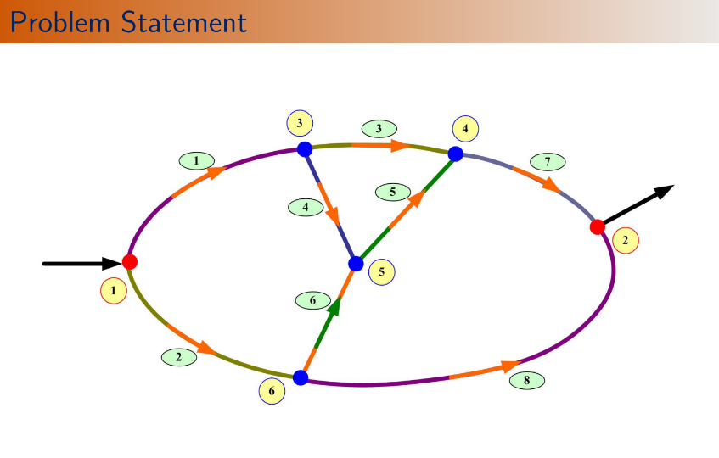

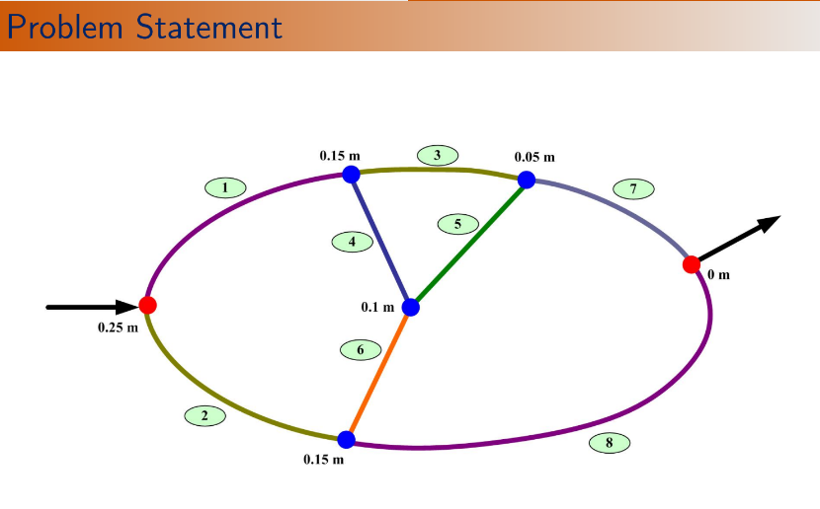

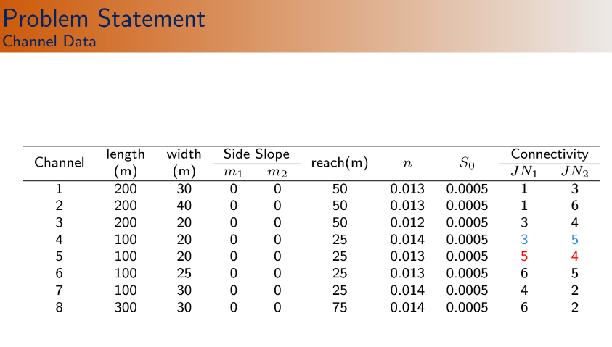

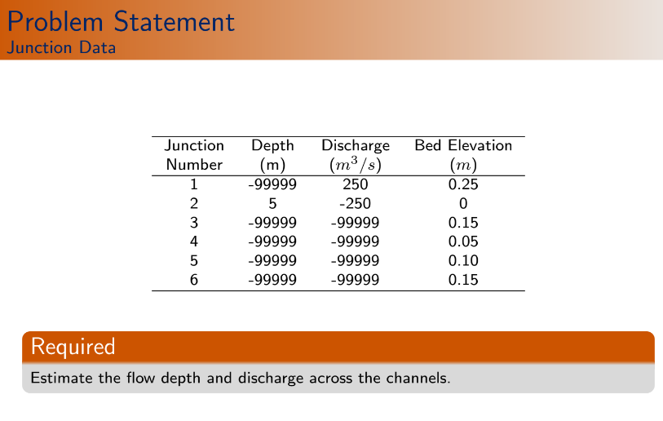

clc

clear

function **Av**=areav(**y**, **B**, **m1**, **m2**)

**Av**=**B**\***y**+(1/2)*(**m1**+**m2**)\***y**^2;

endfunction

function **dAv**=dareav(**y**, **B**, **m1**, **m2**)

**dAv**=**B**+(**m1**+**m2**)\***y**;

*//dAv means dA/dy. See (157.1).*

endfunction

function **Rv**=HRv(**y**, **B**, **m1**, **m2**)

**Rv**=(**B**\***y**+(1/2)*(**m1**+**m2**)\***y**^2)/(**B**+(sqrt(1+**m1**^2)+sqrt(1+**m2**^2))\***y**);

*// it is hydraulic radius. see equation (155)*

endfunction

function **dRv**=dHRv(**y**, **B**, **m1**, **m2**)

Tw=**B**+(**m1**+**m2**)\***y**;

*//Top width. See equation (155)*

Pm=(**B**+(sqrt(1+**m1**^2)+sqrt(1+**m2**^2))\***y**);

*//Wetted perimeter. See equation (155)*

Rh=HRv(**y**,**B**,**m1**,**m2**);

dPdy=(sqrt(1+**m1**^2)+sqrt(1+**m2**^2));

*//dP/dy. See equation (157.2).*

**dRv**=(Tw/Pm)-(Rh/Pm)*dPdy;

*//dRv means dR/dy. See equation (120)for its derrivation.*

endfunction

function **Mliv**=Mli(**y1**, **Q1**, **y2**, **Q2**, **S0**, **delta_x**, **D1**, **D2**, **B**, **m1**, **m2**)

**Mliv**=(**y2**-**y1**)-**S0**\***delta_x**+**D1**\*(**Q2**^2*areav(**y2**,**B**,**m1**,**m2**)^(-2)-**Q1**^2*areav(**y1**,**B**,**m1**,**m2**)^(-2))+**D2**\*(**Q2**\*abs(**Q2**)*HRv(**y2**,**B**,**m1**,**m2**)^(-4/3)*areav(**y2**,**B**,**m1**,**m2**)^(-2)+**Q1**\*abs(**Q1**)*HRv(**y1**,**B**,**m1**,**m2**)^(-4/3)*areav(**y1**,**B**,**m1**,**m2**)^(-2));

endfunction

function **dMdyiv**=dMdyi(**y**, **Q**, **D1**, **D2**, **B**, **m1**, **m2**)

term1=(2\***Q**^2/areav(**y**,**B**,**m1**,**m2**)^(3))*dareav(**y**,**B**,**m1**,**m2**);

term2=2\***Q**\*abs(**Q**)*areav(**y**,**B**,**m1**,**m2**)^(-3)*HRv(**y**,**B**,**m1**,**m2**)^(-4/3)*dareav(**y**,**B**,**m1**,**m2**);

term3=(4/3)\***Q**\*abs(**Q**)*areav(**y**,**B**,**m1**,**m2**)^(-2)*HRv(**y**,**B**,**m1**,**m2**)^(-7/3)*dHRv(**y**,**B**,**m1**,**m2**);

**dMdyiv**=-1+**D1**\*term1-**D2**\*(term2+term3);

*//From equation (147.1).Evaluates dM_{l,i}/dy_{l,i}.*

endfunction

function **dMdyip1v**=dMdyi(**y**, **Q**, **D1**, **D2**, **B**, **m1**, **m2**)

term1=(2\***Q**^2/area(**y**,**B**,**m1**,**m2**)^(3))*dareav(**y**,**B**,**m1**,**m2**);

term2=2\***Q**\*abs(**Q**)*areav(**y**,**B**,**m1**,**m2**)^(-3)*HRv(**y**,**B**,**m1**,**m2**)^(-4/3)*dareav(**y**,**B**,**m1**,**m2**);

term3=(4/3)\***Q**\*abs(**Q**)*areav(**y**,**B**,**m1**,**m2**)^(-2)*HRv(**y**,**B**,**m1**,**m2**)^(-7/3)*dHRv(**y**,**B**,**m1**,**m2**);

dMdyiv=-1-**D1**\*term1-**D2**\*(term2+term3);

*//From equation (147.3). Evaluates dM_{l,i}/dy_{l,i+1}.*

endfunction

function **dMdQip1v**=dMdQip1(**y**, **Q**, **D1**, **D2**, **B**, **m1**, **m2**)

term1=2\***Q**\*areav(**y**,**B**,**m1**,**m2**)^(-3);

term2=2*abs(**Q**)*areav(**y**,**B**,**m1**,**m2**)^(-2)*HRv(**y**,**B**,**m1**,**m2**)^(-4/3);

**dMdQip1v**=**D1**\*term1+**D2**\*term2;

*//From equation (147.4).*

endfunction

function **dMdQiv**=dMdQi(**y**, **Q**, **D1**, **D2**, **B**, **m1**, **m2**)

term1=2\***Q**\*areav(**y**,**B**,**m1**,**m2**)^(-3);

term2=2*abs(**Q**)*areav(**y**,**B**,**m1**,**m2**)^(-2)*HRv(**y**,**B**,**m1**,**m2**)^(-4/3);

dMdQip1v=-**D1**\*term1+**D2**\*term2;

*//From equation (147.2).*

endfunction

*//~~~~~~~~~~~~~~~~~~~~~~~~~~~~~~~~~~~~~~*

*//Channel reach: start + , end - .*

*//Flow depth condition: 1*

*//Flow rate (discharge) condition: 2*

*//~~~~~~~~~~~~~~~~~~~~~~~~~~~~~~~~~~~~~~*

*//~~~~~~~~~~Given Data~~~~~~~~~*

g=9.81; *//m/s^2*

global('g')

yd=5; *//m*

Qd=250; *//m^3/s*

Qu=250; *//m^3/s*

eps_max=1e-6;

*//~~~~~~~~~~~~~~~~~~~~~~~~~~~~~~~~~~*

junn=6;*//number of junctions*

bjn=2;*//Out of 6 junctions, 2 are boundary junctions.*

chln=8;*//number of channels*

*//~~~~Chl | Length | Width | m1 | m2 | Segment | n | S0 | JN1 | JN2 |~~~~~~~~*

chl_inf=[1 200 30 0 0 50 0.0130 0.0005 1 3

2 200 40 0 0 50 0.0130 0.0005 1 6

3 200 20 0 0 50 0.0120 0.0005 3 4

4 100 20 0 0 25 0.0140 0.0005 3 5

5 100 20 0 0 25 0.0130 0.0005 5 4

6 100 25 0 0 25 0.0130 0.0005 6 5

7 100 30 0 0 25 0.0140 0.0005 4 2

8 300 50 0 0 75 0.0140 0.0005 6 2];

*//~~~~~~Specified flow depth | Specified Discharge | Bed elevation~~~~~~*

jun_inf=[-99999 Qu 0.25

yd -Qd 0

-99999 -99999 0.15

-99999 -99999 0.05

-99999 -99999 0.1

-99999 -99999 0.15];

*//Upstream junction is numbered as 1 & downstream junction as 2.*

jun_con= [2 1 2 0

2 -7 -8 0

3 -1 3 4

3 -3 -5 7

3 -4 -6 5

3 -2 6 8];

alpha=ones(chln,1);

*//~~~~~~~Derived informations from 'chl_inf' matrix~~~~~~~~~~*

Lx=chl_inf(1:chln,2);

*//We know, 'chln' means channel number=8.*

B=chl_inf(1:chln,3);

m1=chl_inf(1:chln,4);

m2=chl_inf(1:chln,5);

delta_x=chl_inf(1:chln,6);

n=chl_inf(1:chln,7);

S0=chl_inf(1:chln,8);

mnode=Lx./delta_x+1;

*//Here, mnode is calculated at point by point basis.*

*//~~~~~~~~~~~z values~~~~~~~~~~~~~*

for l=1:chln

if (jun_inf(chl_inf(l,9),3)>jun_inf(chl_inf(l,10),3)) then

fact=-1;

*// 9th column of 'chl_inf' matrix represents the junction connected to the 1st section of that particular channel. 10th column represents the 'junction' connected to the last section of that particular channel. It checks, which junction is at higher elevation between this two...*

else

fact=+1;

end

zv(l,1)=jun_inf(chl_inf(l,9),3);

for i=2:mnode(l)

zv(l,i)=zv(l,i-1)+fact*S0(l)*delta_x(l);

*//Determines the elevations of the intermediate sections of l-th channel.*

end

end

*///Explanation of the 'z values' loop:*

*//1st iteration:*

*//for l=1:chln=1:8=> Take,l=1*

*// if (jun_inf(chl_inf(1,9),3)=(jun_inf(1,3))=0.25 > jun_inf(chl_inf(1,10),3))=(jun_inf(3,3))=0.15 then*

*// fact=-1;*

*//end*

*//zv(1,1)=jun_inf(chl_inf(1,9),3)=jun_inf(1,3)=0.25;*

*//for i=2:mnode(1)=2:5 (take i=2)*

*// zv(1,2)=zv(1,i-1)+fact*S0(1)*delta_x(1)=zv(1,1)+(-1)*S0(1)*delta_x(1)=0.25-0.0005*50=0.225;*

*// end*

*//end*

*//......and so on.....*

*//~~~~~~~Problem Dependent Parameters~~~~~~~*

yv=yd*ones(sum(mnode),1);

Qv=Qd*ones(sum(mnode),1);

*//Problem is initialized with downstream depth and discharge values.*

gv=zeros(2*sum(mnode),1);

*//'gv' will store the general variable with y and Q.*

*//~~~General identification matrix~~~*

idv=0;

for l=1:chln

for i=1:mnode(l)

idv=idv+1;

gid(l,i)=idv;

*//Number of rows in 'gid' matrix= no. of channels=8 and number of columns= maximum no. of sections in a channel reach=max(5,5,5,5,5,5,5,5)=5. So, 'gid' is a 8*5 matrix. Unlike the previous code (Steady_1D_channel_network_Without_reverse), we have no 'zero" entry in 'gid' matrix. So, we have total 40 sections.*

end

end

for l=1:chln

for i=1:mnode(l)

gv(2*gid(l,i)-1)=yv(gid(l,i))

gv(2*gid(l,i))=Qv(gid(l,i))

*//Initial Values of 'yv' and 'Qv' matries are stored in 'gv' or general variable matrix togetherly.*

end

end

for l=1:chln

D1(l)=alpha(l)/(2*g);

D2(l)=(1/2)*n(l)^2*delta_x(l);

end

A=zeros(2*sum(mnode),2*sum(mnode));

*//'A' will store coff(s) of jacobian matrix.*

r=zeros(2*sum(mnode),1);

Count=0;

rmse=1;

*//~~~~~~~~~~~~Space loop~~~~~~~~~~~~~~~~~~~*

while rmse>eps_max

rmse=0;

eqn=0;*//Equation number*

*//~~~~~Equations corresponding to segments(2N1+2N2+2N3+2N4+2N5+2N6+2N7+2N8)~~~~~~*

for l=1:chln

for i=1:mnode(l)-1

*//~~~~~~Jacobians for Continuity eqn~~~~~~~*

eqn=eqn+1;

A(eqn,2*gid(l,i)-1)=0;

*//del(C_{l,i})/del(y_{l,i}).See equation (156).*

A(eqn,2*gid(l,i))=-1;

*//del(C_{l,i})/del(Q_{l,i}).*

A(eqn,2*gid(l,i+1)-1)=0;

*//del(C_{l,i})/del(y_{l,i+1}).*

A(eqn,2*gid(l,i+1))=1;

*//del(C_{l,i})/del(Q_{l,i+1}).*

r(eqn)=0;

*//~~~~~~~Jacobians for Momentum eqn~~~~~~~~*

eqn=eqn+1;

A(eqn,2*gid(l,i)-1)=dMdyi(yv(gid(l,i)),Qv(gid(l,i)),D1(l),D2(l),B(l),m1(l),m2(l));

*//del(M_{l,i})/del(y_{l,i}).See page 37 & equation (147.1).*

A(eqn,2*gid(l,i))=dMdQi(yv(gid(l,i)),Qv(gid(l,i)),D1(l),D2(l),B(l),m1(l),m2(l));

*//del(M_{l,i})/del(Q_{l,i}).See equation (147.2).*

A(eqn,2*gid(l,i+1)-1)=dMdyip1(yv(gid(l,i+1)),Qv(gid(l,i+1)),D1(l),D2(l),B(l),m1(l),m2(l));

*//del(M_{l,i})/del(y_{l,i+1}).See equation (147.3).*

A(eqn,2*gid(l,i+1))=dMdQip1(yv(gid(l,i+1)),Qv(gid(l,i+1)),D1(l),D2(l),B(l),m1(l),m2(l));

*//del(M_{l,i})/del(Q_{l,i+1}).See equation (147.4).*

r(eqn)=-Mli(yv(gid(l,i)),Qv(gid(l,i)),yv(gid(l,i+1)),Qv(gid(l,i+1)),S0(l),delta_x(l),D1(l),D2(l),B(l),m1(l),m2(l));

end

end

jeqn=0;

*//~~~~~~Junction Continuity Condition~~~~~~~*

for j=1:junn

if (jun_inf(j,2)~=-99999) then

*//Checks whether the junction has specified didschsrge value or not.then r(eqn)=That specified discharge value.*

eqn=eqn+1;

jeqn=jeqn+1;

r(eqn)=jun_inf(j,2);

else

if(j>bjn) then

*//'bjn' means number of boundary junction and j>bjn means it is applicable for internal junctions where no specified depth or discharge condition exists.*

eqn=eqn+1;

jeqn=jeqn+1;

r(eqn)=0;

end

end

for l=1:jun_con(j,1)

*//1st column gives the information about number of channel connected to particular junction.*

if (abs(jun_con(j,l+1))>eps_max) then

*//Checks whether a non-zero value is there or not?!zero value means that, no channel is connected.*

if (jun_con(j,l+1)>0) then

*//Checks whether the value is positive or negative. If positive, then the 1st section of the channel is connected to that junction. If negative, then the end section of the channel is connected to that junction.*

jn_node=1;

A(eqn,2*gid(abs(jun_con(j,l+1)),jn_node))=-1;

r(eqn)=r(eqn)-Qv(gid(abs(jun_con(j,l+1)),jn_node));

end

if (jun_con(j,l+1)<0) then

jn_node=mnode(abs(jun_con(j,l+1)));

A(eqn,2*gid(abs(jun_con(j,l+1)),jn_node))=1;

r(eqn)=r(eqn)+Qv(gid(abs(jun_con(j,l+1)),jn_node));

end

end

end

r(eqn)=-r(eqn);

end

*//~~~~~~~~~~~Junction Energy condition~~~~~~~~*

*// jun_con= [1 -4 0 0*

*// 3 4 -3 -2*

*// 3 -1 2 3];*

for j=1:junn

if(jun_inf(j,1)<>-99999) then

*//1st column of "jun_inf" matrix represents the specified depth at boundary junctions (if unspecified, represented as -99999).*

eqn=eqn+1;

if(jun_con(j,2)>0)then jn_nodel=1; end

if(jun_con(j,2)<0)then jn_nodel=mnode(abs(jun_con(j,2))); end

A(eqn, 2*gid(abs(jun_con(j,2)),jn_nodel)-1)=1;

r(eqn)=yv(gid(abs(jun_con(j,2)),jn_nodel))-jun_inf(j,1);

r(eqn)=-r(eqn);

end

if(jun_con(j,1)>1) then

*//It means, if more than one channel is connected to that junction.*

for l=1:jun_con(j,1)-1

*//It runs for (number of channels connected to that junction-1) times. Because, one channel is already calculated for the channel represented by "jun_con(j,2)" elements in previous loop.*

eqn=eqn+1;

*//"*

if(jun_con(j,2)>0)then jn_nodel=1; end

if(jun_con(j,2)<0)then jn_nodel=mnode(abs(jun_con(j,2))); end

A(eqn, 2*gid(abs(jun_con(j,2)),jn_nodel)-1)=1;

r(eqn)=yv(gid(abs(jun_con(j,2)),jn_nodel));

*//"*

*//?????????Why " " part is required? I think, it has been already calculated.*

if(jun_con(j,l+2)>0)then jn_node2=1; end

*// Minimum and maximum values of l are:(1 & jun_con(j,1)-1). So, it will run for 1+2=3rd column to last non-zero column (depends on how many channels are connected to that particular junction) of "jun_con" matrix.*

if(jun_con(j,l+2)<0)then jn_node2=mnode(abs(jun_con(j,l+2))); end

A(eqn, 2*gid(abs(jun_con(j,l+2)),jn_node2)-1)=-1;

r(eqn)=r(eqn)-yv(gid(abs(jun_con(j,l+2)),jn_node2));

r(eqn)=-r(eqn);

end

end

end

*//~~~~Del y Q~~~*

delyQ=inv(A'*A)*(A'*r);

*// Here, we have 80 unknowns. But we get 81 equations. (See '5no-P-43' to know why). So we get,*

*// [A]_(81*80) * [delyQ]_(80*1)=[r]_(81*1)*

*// But, this matrix operation is not possible.So, multiplying both side of the equation with 'transpose of A',*

*// [A']_(80*81) * [A]_(81*80) * [delyQ]_(80*1)=[A']_(80*81) * [r]_(81*1)*

*// [A'A]_(80*80) * [delyQ]_(80*1)=[A'r]_(80*1)*

*// [delyQ]_(80*1)= inv([A'A]_(80*80)) * [A'r]_(80*1)*

for i=1:2*sum(mnode)

gv(i)=gv(i)+delyQ(i);

rmse=rmse+delyQ(i)^2;

end

*//~~~~~Update Value~~~~~*

for l=1:chln

for i=1:mnode(l)

yv(gid(l,i))=gv(2*gid(l,i)-1);

Qv(gid(l,i))=gv(2*gid(l,i));

end

end

rmse=sqrt(rmse/sum(mnode));

count=count+1;

disp([count rmse])

end

disp(eqn)

*//Print output*

for l=1:chln

disp(['channel number:' string(l)])

disp('Section Distance(m) Depth(m) Discharge(m^3/s)')

for i=1:mnode(l)

disp([i (i-1)*delta_x(l) yv(gid(l,i)) Qv(gid(l,i))])

end

end

*//Wrong Output!!!!!!!!!!!!!!!*

"channel number:" "1"

"Section Distance(m) Depth(m) Discharge(m^3/s)"

1. 0. 3. 250.

2. 25. 3. 250.

3. 50. 3. 250.

4. 75. 3. 250.

5. 100. 3. 250

.. . . . . . . . . . . . . . .

. . . . . . . . . . . . . . .

"channel number:" "4"

"Section Distance(m) Depth(m) Discharge(m^3/s)"

1. 0. 3. 250.

2. 25. 3. 250.

3. 50. 3. 250.

4. 75. 3. 250.

5. 100. 3. 250.

**!**

**(29) Unsteady_1D_channel_network_With_reverse**

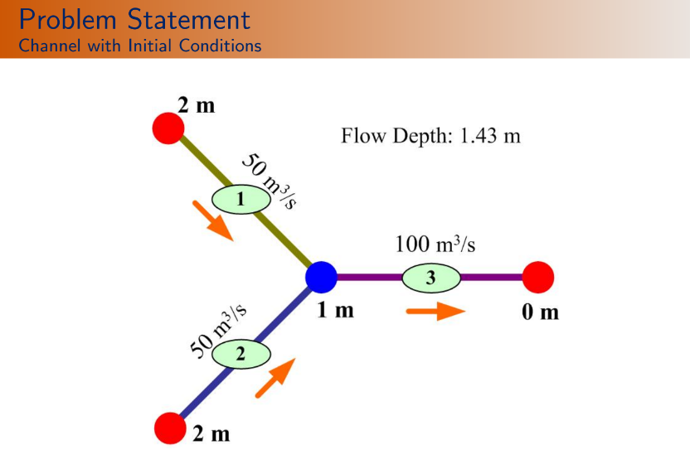

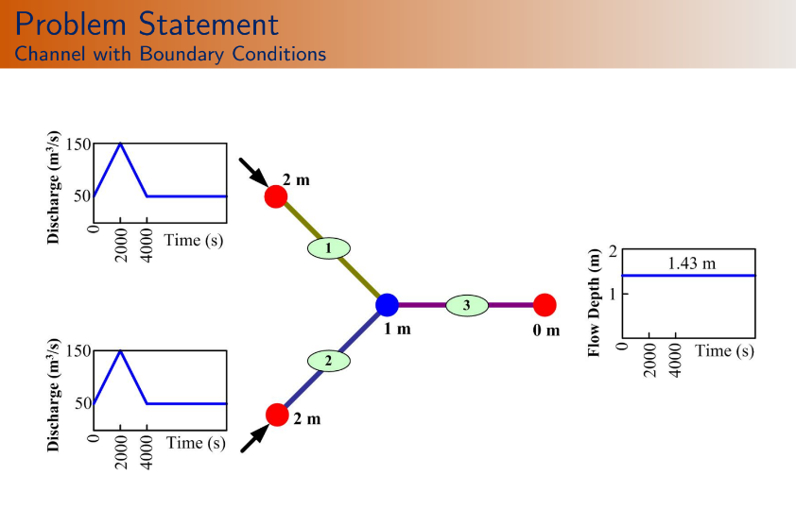

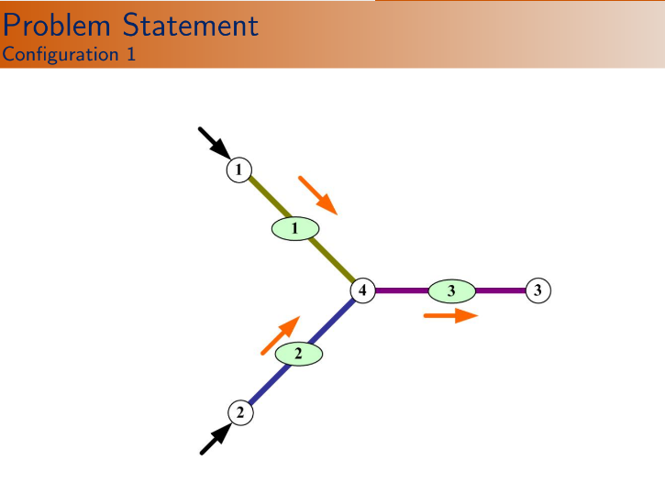

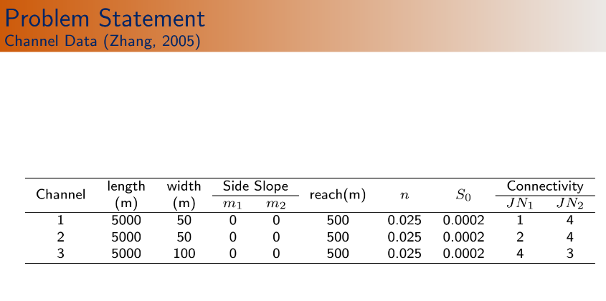

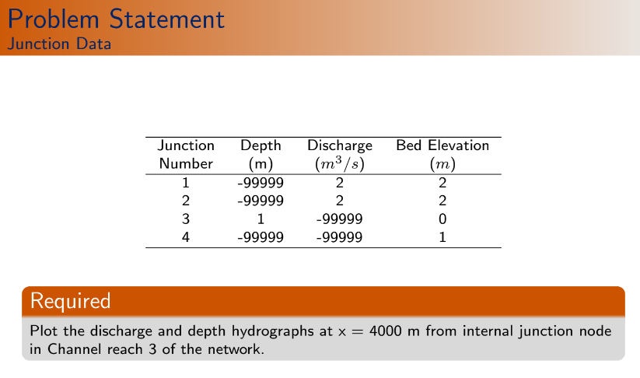

clc

clear

function **Av**=areav(**y**, **B**, **m1**, **m2**)

**Av**=**B**\***y**+(1/2)*(**m1**+**m2**)\***y**^2;

endfunction

function **dAv**=dareav(**y**, **B**, **m1**, **m2**)

**dAv**=**B**+(**m1**+**m2**)\***y**;

*//dAv means dA/dy. See (157.1).*

endfunction

function **Rv**=HRv(**y**, **B**, **m1**, **m2**)

**Rv**=(**B**\***y**+(1/2)*(**m1**+**m2**)\***y**^2)/(**B**+(sqrt(1+**m1**^2)+sqrt(1+**m2**^2))\***y**);

*// it is hydraulic radius. see equation (155)*

endfunction

function **dRv**=dHRv(**y**, **B**, **m1**, **m2**)

Tw=**B**+(**m1**+**m2**)\***y**;

*//Top width. See equation (155)*

Pm=(**B**+(sqrt(1+**m1**^2)+sqrt(1+**m2**^2))\***y**);

*//Wetted perimeter. See equation (155)*

Rh=HRv(**y**,**B**,**m1**,**m2**);

dPdy=(sqrt(1+**m1**^2)+sqrt(1+**m2**^2));

*//dP/dy. See equation (157.2).*

**dRv**=(Tw/Pm)-(Rh/Pm)*dPdy;

*//dRv means dR/dy. See equation (120)for its derrivation.*

endfunction

function **Cliv**=Cli(**y1**, **Q1**, **y2**, **Q2**, **y1o**, **Q1o**, **y2o**, **Q2o**, **zv1**, **zv2**, **theta**, **psi**, **delta_t**, **delta_x**, **alpha1**, **alpha2**, **B**, **m1**, **m2**, **nm**)

*//"y1o,Q1o,y2o,Q2o" repesents previous time level values.*

term1=areav(**y2**,**B**,**m1**,**m2**)-areav(**y2o**,**B**,**m1**,**m2**);

term2=areav(**y1**,**B**,**m1**,**m2**)-areav(**y1o**,**B**,**m1**,**m2**);

term3=**Q2**-**Q1**;

term4=**Q2o**-**Q1o**;

**Cliv**=(**psi**/**delta_t**)*term1+((1-**psi**)/**delta_t**)*term2+(**theta**/**delta_x**)*term3+((1-**theta**)/**delta_x**)*term4;

*//See equation (194). As there is no extraction or injection at any junction; so "q" term in equation (194) was taken as zero.*

endfunction

*//~~~~~~~~~~Continuity Functions~~~~~~~~~~~~~~~~~~~*

function **dCdyiv**=dCdyi(**y1**, **Q1**, **y2**, **Q2**, **y1o**, **Q1o**, **y2o**, **Q2o**, **zv1**, **zv2**, **theta**, **psi**, **delta_t**, **delta_x**, **alpha1**, **alpha2**, **B**, **m1**, **m2**, **nm**)

**dCdyiv**=((1-**psi**)/**delta_t**)*dareav(**y1**,**B**,**m1**,**m2**);

*//See equation 195(.1)*

endfunction

function **dCdyip1v**=dCdyip1(**y1**, **Q1**, **y2**, **Q2**, **y1o**, **Q1o**, **y2o**, **Q2o**, **zv1**, **zv2**, **theta**, **psi**, **delta_t**, **delta_x**, **alpha1**, **alpha2**, **B**, **m1**, **m2**, **nm**)

**dCdyip1v**=((**psi**)/**delta_t**)*dareav(**y2**,**B**,**m1**,**m2**);

*//See equation 195(.3)*

endfunction

function **dCdQiv**=dCdQi(**y1**, **Q1**, **y2**, **Q2**, **y1o**, **Q1o**, **y2o**, **Q2o**, **zv1**, **zv2**, **theta**, **psi**, **delta_t**, **delta_x**, **alpha1**, **alpha2**, **B**, **m1**, **m2**, **nm**)

**dCdQiv**=-**theta**/**delta_x**;

*//See equation 195(.2)*

endfunction

function **dCdQip1v**=dCdQip1(**y1**, **Q1**, **y2**, **Q2**, **y1o**, **Q1o**, **y2o**, **Q2o**, **zv1**, **zv2**, **theta**, **psi**, **delta_t**, **delta_x**, **alpha1**, **alpha2**, **B**, **m1**, **m2**, **nm**)

**dCdQip1v**=**theta**/**delta_x**;

*//See equation 195(.4)*

endfunction

*//~~~~~~~~~~~~~~Momentum Functions~~~~~~~~~~~~~~~~~~~~~~~~~~~~~~~~~~~~*

function **Mliv**=Mli(**y1**, **Q1**, **y2**, **Q2**, **y1o**, **Q1o**, **y2o**, **Q2o**, **zv1**, **zv2**, **theta**, **psi**, **delta_t**, **delta_x**, **alpha1**, **alpha2**, **B**, **m1**, **m2**, **nm**)

Av1=areav(**y1**,**B**,**m1**,**m2**);

Av2=areav(**y2**,**B**,**m1**,**m2**);

Av1o=areav(**y1o**,**B**,**m1**,**m2**);

Av2o=areav(**y2o**,**B**,**m1**,**m2**);

*//Av1,Av2 are corresponding to higher time level and Av1o,Av2o are corresponding to Previous time level.*

Rh1=HRv(**y1**,**B**,**m1**,**m2**);

Rh2=HRv(**y2**,**B**,**m1**,**m2**);

Rh1o=HRv(**y1o**,**B**,**m1**,**m2**);

Rh2o=HRv(**y2o**,**B**,**m1**,**m2**);

term11=(**Q2**/Av2-**Q2o**/Av2o);

term11=(**Q1**/Av1-**Q1o**/Av1o);

term21=((**alpha2**/2)\***Q2**^2*Av2^(-2))-((**alpha1**/2)\***Q1**^2*Av1^(-2));

term22=((**alpha2**/2)\***Q2o**^2*Av2o^(-2))-((**alpha1**/2)\***Q1o**^2*Av1o^(-2));

term31=(**y2**+**zv2**)-(**y1**+**zv1**);

term32=(**y2o**+**zv2**)-(**y1o**+**zv1**);

term41=**nm**^2\***Q2**\*abs(**Q2**)*Rh2^(-4/3)*Av2^(-2);

term42=**nm**^2\***Q1**\*abs(**Q1**)*Rh1^(-4/3)*Av1^(-2);

term43=**nm**^2\***Q2o**\*abs(**Q2o**)*Rh2o^(-4/3)*Av2o^(-2);

term44=**nm**^2\***Q1o**\*abs(**Q1o**)*Rh1o^(-4/3)*Av1o^(-2);

**Mliv**=(**psi**/**delta_t**)*term11+((1-**psi**)/**delta_t**)*term12+(**theta**/**delta_x**)*term21+((1-**theta**)/**delta_x**)*term22+(**theta**\*g/**delta_x**)*term31+((1-**theta**)*g/**delta_x**)*term32+**theta**\***psi**\*g*term41+**theta**\*(1-**psi**)*g*term42+(1-**theta**)\***psi**\*g*term43+(1-**theta**)*(1-**psi**)*g*term44;

*//See equation 196.*

endfunction

function **dMdyiv**=dMdyi(**y1**, **Q1**, **y2**, **Q2**, **y1o**, **Q1o**, **y2o**, **Q2o**, **zv1**, **zv2**, **theta**, **psi**, **delta_t**, **delta_x**, **alpha1**, **alpha2**, **B**, **m1**, **m2**, **nm**)

Av1=areav(**y1**,**B**,**m1**,**m2**);

Rh1=HRv(**y1**,**B**,**m1**,**m2**);

dAv1=dareav(**y1**,**B**,**m1**,**m2**);

dRh1=dHRv(**y1**,**B**,**m1**,**m2**);

term1=(**Q1**/Av1^2)*dAv1;

term2=(**Q1**^2/Av1^3)*dAv1;

term3=**theta**\*g/**delta_x**;

term41=2\***Q1**\*abs(**Q1**)*dAv1*Rh1^(-4/3)*Av1^(-3);

term42=(4/3)\***Q1**\*abs(**Q1**)*dRh1*Rh1^(-7/3)*Av1^(-2);

**dMdyiv**=-((1-**psi**)/**delta_t**)*term1+(**theta**\***alpha1**/**delta_x**)*term2-term3-**theta**\*(1-**psi**)*g\***nm**^2*(term41+term42);

*//See equation 197(.1)*

endfunction

function **dMdyip1v**=dMdyip1(**y1**, **Q1**, **y2**, **Q2**, **y1o**, **Q1o**, **y2o**, **Q2o**, **zv1**, **zv2**, **theta**, **psi**, **delta_t**, **delta_x**, **alpha1**, **alpha2**, **B**, **m1**, **m2**, **nm**)

Av2=areav(**y2**,**B**,**m1**,**m2**);

Rh2=HRv(**y2**,**B**,**m1**,**m2**);

dAv2=dareav(**y2**,**B**,**m1**,**m2**);

dRh2=dHRv(**y2**,**B**,**m1**,**m2**);

term1=(**Q2**/Av2^2)*dAv2;

term2=(**Q2**^2/Av2^3)*dAv2;

term3=**theta**\*g/**delta_x**;

term41=2\***Q2**\*abs(**Q2**)*dAv2*Rh2^(-4/3)*Av2^(-3);

term42=(4/3)\***Q2**\*abs(**Q2**)*dRh2*Rh2^(-7/3)*Av2^(-2);

**dMdyip1v**=-(**psi**/**delta_t**)*term1-(**theta**\***alpha2**/**delta_x**)*term2+term3-**theta**\***psi**\*g\***nm**^2*(term41+term42);

*//See equation 197(.3)*

endfunction

function **dMdQiv**=dMdQi(**y1**, **Q1**, **y2**, **Q2**, **y1o**, **Q1o**, **y2o**, **Q2o**, **zv1**, **zv2**, **theta**, **psi**, **delta_t**, **delta_x**, **alpha1**, **alpha2**, **B**, **m1**, **m2**, **nm**)

Av1=areav(**y1**,**B**,**m1**,**m2**);

Rh1=HRv(**y1**,**B**,**m1**,**m2**);

term1=Av1^(-1);

term2=**Q1**/Av1^2;

term3=abs(**Q1**)*Rh1^(-4/3)*Av1^(-2);

**dMdQiv**=((1-**psi**)/**delta_t**)*term1-(**theta**\***alpha1**/**delta_x**)*term2+2\***theta**\*(1-**psi**)*g\***nm**^2*term3;

*//See equation 197(.2)*

endfunction

function **dMdQip1v**=dMdQip1(**y1**, **Q1**, **y2**, **Q2**, **y1o**, **Q1o**, **y2o**, **Q2o**, **zv1**, **zv2**, **theta**, **psi**, **delta_t**, **delta_x**, **alpha1**, **alpha2**, **B**, **m1**, **m2**, **nm**)

Av2=areav(**y2**,**B**,**m1**,**m2**);

Rh2=HRv(**y2**,**B**,**m1**,**m2**);

term1=Av2^(-1);

term2=**Q2**/Av2^2;

term3=abs(**Q2**)*Rh2^(-4/3)*Av2^(-2);

**dMdQip1v**=(**psi**/**delta_t**)*term1+(**theta**\***alpha2**/**delta_x**)*term2+2\***theta**\***psi**\*g\***nm**^2*term3;

*//See equation 197(.4)*

endfunction

*//~~~~~~~~Boundary values Functions~~~~~~~~~~~~~~~~~~~~~~~~~~~~~~~~~~~~~~~~~~~~~~~~~~~~~*

function **bndv**=bndcon(**typ**, **jnum**, **tv**)

*//'typ' means type. if typ=1, means we specify depth. If typ=2, we specify the discharge value. "jnum" specify the junction number(See 5 no-page-49)."tv" means time value.*

if (**typ**==1 & **jnum**==3) then

**bndv**=1.43;

*// Depth at downstream has a fixed value.*

end

if (typ==2 & jnum==1) then

if (tv<2000) then

bndv=50+100/2000*tv;

end

if (tv>=2000) then

bndv=150-(100/2000)*(tv-2000);

end

if (tv>4000) then

bndv=50;

end

end

if (typ==2 & jnum==2) then

if (tv<2000) then

bndv=50+100/2000*tv;

end

if (tv>=2000) then

bndv=150-(100/2000)*(tv-2000);

end

if (tv>4000) then

bndv=50;

end

end

*// At junction number 1 and 2, there are varying discharge boundary conditions with time.*

endfunction

*// Channel reach: Start + End -*

*//~~~~~~~~~~~~~~Given Data~~~~~~~~~*

g=9.81;*//m.s^(-2)*

global('g')

eps_max=1e-6;

t_max=25001;*//s*

delta_t=250;*//s*

theta=0.5;

*// To get Intermediate value between 'n' and 'n+1'th time level.*

psi=0.5;

*// To get Intermediate value between 'i' and 'i+1'th node*

junnn=4;

bjn=3;

chln=3;

*//~~~~Chl | Length | Width | m1 | m2 | Segment | n | S0 | JN1 | JN2 |*

chl_inf=[1 5000 50 0 0 500 0.025 0.0002 1 4

2 5000 50 0 0 500 0.025 0.0002 2 4

3 5000 100 0 0 500 0.025 0.0002 4 3];

*//~~~~~~Specified flow depth | Specified Discharge | Bed elevation~~~~~~*

jun_inf=[-99999 2 2

-99999 2 2

1 -99999 0

-99999 -99999 1];

*//"1" is symbolized as specified depth."2" is symbolized as specified discharge."-99999" means no value specified.*

jun_con=[1 1 0 0

1 2 0 0

1 -3 0 0

3 3 -1 -2];

*//In 'jun_con' matrix, 1st column represents number of channels connected to that junction.*

*//Positive sign means 1st section of that channel is connected to that junction. Negative sign means (Nl+1)th section of that channel is connected to that junction.*

alpha=ones(chln,1);

*//Derived informations*

Lx=chl_inf(1:chln,2);

*//We know, 'chln' means channel number=4.*

B=chl_inf(1:chln,3);

m1=chl_inf(1:chln,4);

m2=chl_inf(1:chln,5);

delta_x=chl_inf(1:chln,6);

nm=chl_inf(1:chln,7);

S0=chl_inf(1:chln,8);

mnode=Lx./delta_x+1;

*//mnode is total number of sections for a particular channel. Here, mnode is calculated at point by point basis.*

*//~~~~~~~~z values~~~~~~~~~~*

for l=1:chln

if (jun_inf(chl_inf(l,9),3)>jun_inf(chl_inf(l,10),3)) then

fact=-1;

*// 9th column of 'chl_inf' matrix represents the junction connected to the 1st section of that particular channel. 10th column represents the 'junction' connected to the last section of that particular channel. It checks, which junction is at higher elevation between this two...*

else

fact=+1;

end

zv(l,1)=jun_inf(chl_inf(l,9),3);

for i=2:mnode(l)

zv(l,i)=zv(l,i-1)+fact*S0(l)*delta_x(l);

*//Determines the elevations of the intermediate sections of l-th channel.*

end

end

*//~~~~~~~Problem Dependent Parameters~~~~~~~*

yv=zeros(sum(mnode),1);

Qv=zeros(sum(mnode),1);

yo=zeros(sum(mnode),1);

Qo=zeros(sum(mnode),1);

*// yv, Qv are values corresponding to future time level and yo, Qo are values corresponding to old time level.*

*//~~~General identification matrix~~~*

idv=0;

for l=1:chln

for i=1:mnode(l)

idv=idv+1;

gid(l,i)=idv;

*//Number of rows in 'gid' matrix= no. of channels=4 and number of columns= maximum no. of sections in a channel reach=max(11,11,11)=11. So, 'gid' is a 3*11 matrix.*

end

end

*//~~~~~~~Initial values~~~~~~~~~*

for l=1:chln

for i=mnode(l)

if (l==1 & l==2) then

yo(gid(l,i))=1.4300;

Qo(gid(l,i))=50.00;

*// Initial depth and discharge values for channel 1 and 2.*

else

yo(gid(l,i))=1.4300;

Qo(gid(l,i))=100.00;

*// Initial depth and discharge values for channel 3.*

end

end

end

yv=yo;

Qv=Qo;

*//At first, yv and Qv vector stores initial values.*

gv=zeros(2*sum(mnode),1);

for l=1:chln

for i=1:mnode(l)

gv(2*gid(l,i)-1)=yv(gid(l,i));

gv(2*gid(l,i))=Qv(gid(l,i));

*//Initial Values of 'yv' and 'Qv' matries are stored in 'gv' or general variable matrix togetherly.*

end

end

*//~~~~~~~~~~~~~~~~~~ Time loop~~~~~~~~~~~~~~~~~~~~~~~~~~~~~*

tv=0;*//zero time level.*

tcount=0;

while tv<t_max

tv=tv+delta_t;

A=zeros(2*sum(mnode),2*sum(mnode));

*//Specifying the size of the jacobian matrix.*

r=zeros(2*sum(mnode),1);

disp(['Time in seconds:' string(tv)])

count=0;

rmse=1;

*//~~~~~~~~Space Loop~~~~~~~~~~*

while rmse>eps_max

rmse=0;

*//????? In line 286, rmse=1 and here rmse=0. What does it mean???*

eqn=0;

*//Equation number.*

*//~~~~Equations corresponding to segments (2N1+2N2+2N3)~~~~*

for l=1:chln

for i=1:mnode(l)-1

*//~~~~~~~Continuity~~~~~~~*

eqn=eqn+1;

A(eqn,2*gid(l,i)-1)=dCdyi(yv(gid(l,i)),Qv(gid(l,i)),yv(gid(l,i+1)),Qv(gid(l,i+1)),yo(gid(l,i)),Qo(gid(l,i)),yo(gid(l,i+1)),Qo(gid(l,i+1)),zv(l,i),zv(l,i+1),theta,psi,delta_t,delta_x(l),alpha(l),B(l),m1(l),m2(l),nm(l));

*//del(C_{l,i})/del(y_{l,i}).See page 52 & equation 195(.1). Everything written within the brackets are variables corresponding to i-th segment of l-th channel (i.e.(l,i)).*

A(eqn,2*gid(l,i))=dCdQi(yv(gid(l,i)),Qv(gid(l,i)),yv(gid(l,i+1)),Qv(gid(l,i+1)),yo(gid(l,i)),Qo(gid(l,i)),yo(gid(l,i+1)),Qo(gid(l,i+1)),zv(l,i),zv(l,i+1),theta,psi,delta_t,delta_x(l),alpha(l),B(l),m1(l),m2(l),nm(l));

*//del(C_{l,i})/del(Q_{l,i}).See equation 195(.2).*

A(eqn,2*gid(l,i+1)-1)=dCdyip1(yv(gid(l,i)),Qv(gid(l,i)),yv(gid(l,i+1)),Qv(gid(l,i+1)),yo(gid(l,i)),Qo(gid(l,i)),yo(gid(l,i+1)),Qo(gid(l,i+1)),zv(l,i),zv(l,i+1),theta,psi,delta_t,delta_x(l),alpha(l),B(l),m1(l),m2(l),nm(l));

*//del(C_{l,i})/del(y_{l,i+1}).See equation 195(.3).*

A(eqn,2*gid(l,i+1))=dCdQip1(yv(gid(l,i)),Qv(gid(l,i)),yv(gid(l,i+1)),Qv(gid(l,i+1)),yo(gid(l,i)),Qo(gid(l,i)),yo(gid(l,i+1)),Qo(gid(l,i+1)),zv(l,i),zv(l,i+1),theta,psi,delta_t,delta_x(l),alpha(l),B(l),m1(l),m2(l),nm(l));

*//del(C_{l,i})/del(Q_{l,i+1}).See equation 195(.4).*

r(eqn)=-Cli(yv(gid(l,i)),Qv(gid(l,i)),yv(gid(l,i+1)),Qv(gid(l,i+1)),yo(gid(l,i)),Qo(gid(l,i)),yo(gid(l,i+1)),Qo(gid(l,i+1)),zv(l,i),zv(l,i+1),theta,psi,delta_t,delta_x(l),alpha(l),B(l),m1(l),m2(l),nm(l));

*//~~~~~~~Momentum~~~~~~~*

eqn=eqn+1;

A(eqn,2*gid(l,i)-1)=dMdyi(yv(gid(l,i)),Qv(gid(l,i)),yv(gid(l,i+1)),Qv(gid(l,i+1)),yo(gid(l,i)),Qo(gid(l,i)),yo(gid(l,i+1)),Qo(gid(l,i+1)),zv(l,i),zv(l,i+1),theta,psi,delta_t,delta_x(l),alpha(l),B(l),m1(l),m2(l),nm(l));

*//del(M_{l,i})/del(y_{l,i}).See page 52 & equation 197(.1). Everything written within the brackets are variables corresponding to i-th segment of l-th channel (i.e.(l,i)).*

A(eqn,2*gid(l,i))=dMdQi(yv(gid(l,i)),Qv(gid(l,i)),yv(gid(l,i+1)),Qv(gid(l,i+1)),yo(gid(l,i)),Qo(gid(l,i)),yo(gid(l,i+1)),Qo(gid(l,i+1)),zv(l,i),zv(l,i+1),theta,psi,delta_t,delta_x(l),alpha(l),B(l),m1(l),m2(l),nm(l));

*//del(M_{l,i})/del(Q_{l,i}).See equation 197(.2).*

A(eqn,2*gid(l,i+1)-1)=dMdyip1(yv(gid(l,i)),Qv(gid(l,i)),yv(gid(l,i+1)),Qv(gid(l,i+1)),yo(gid(l,i)),Qo(gid(l,i)),yo(gid(l,i+1)),Qo(gid(l,i+1)),zv(l,i),zv(l,i+1),theta,psi,delta_t,delta_x(l),alpha(l),B(l),m1(l),m2(l),nm(l));

*//del(M_{l,i})/del(y_{l,i+1}).See equation 197(.3).*

A(eqn,2*gid(l,i+1))=dMdQip1(yv(gid(l,i)),Qv(gid(l,i)),yv(gid(l,i+1)),Qv(gid(l,i+1)),yo(gid(l,i)),Qo(gid(l,i)),yo(gid(l,i+1)),Qo(gid(l,i+1)),zv(l,i),zv(l,i+1),theta,psi,delta_t,delta_x(l),alpha(l),B(l),m1(l),m2(l),nm(l));

*//del(M_{l,i})/del(Q_{l,i+1}).See equation 197(.4).*

r(eqn)=-Mli(yv(gid(l,i)),Qv(gid(l,i)),yv(gid(l,i+1)),Qv(gid(l,i+1)),yo(gid(l,i)),Qo(gid(l,i)),yo(gid(l,i+1)),Qo(gid(l,i+1)),zv(l,i),zv(l,i+1),theta,psi,delta_t,delta_x(l),alpha(l),B(l),m1(l),m2(l),nm(l));

end

end

*//~~~~~~Junction Continuity condition~~~~~~~*

for j=1:junn

dcond=0; *//Initially zero,=1 if discharge condition is there.*

if (jun_inf(j,2)==2) then

*// At the 2nd column of jun_inf matrix, discharge values of the junctions are shown. "2" number symbolizes discharge and -99999 represents no specified value.*

eqn=eqn+1;

r(eqn)=bndcon(2,j,tv);

*//We know "bndv=bndcon(typ,jnum,tv)". For example bndcon(2,1,0) means discharge boundary condition of 1st junction at time=0s.*

dcond=1;

else

if(j>bjn) then

*//"bjn" means number of boundary junctions(i.e=3). Those are numbered as 1,2 and 3. So, this condition implies the internal junctions.*

eqn=eqn+1;

r(eqn)=0;

dcond=1;

end

end

if (dcond==1) then

for l=1:jun_con(j,1)

if(abs(jun_con(j,l+1))>eps_max) then

if (jun_con(j,l+1)>0) then

jun_node=1;

A(eqn,2*gid(abs(jun_con(j,l+1)),jn_node))=-1;

r(eqn)=r(eqn)-Qv(gid(abs(jun_con(j,l+1)),jn_node));

end

if (jun_con(j,l+1)<0) then

jn_node=mnode(abs(jun_con(j,l+1)));

A(eqn,2*gid(abs(jun_con(j,l+1)),jn_node))=1;

r(eqn)=r(eqn)+Qv(gid(abs(jun_con(j,l+1)),jn_node));

end

end

end

r(eqn)=-r(eqn);

end

end

*//~~~~~~~~~Junction Energy Condition~~~~~~~~~~*

for j=1:junn

if(jun_inf(j,1)==1) then

*//1st column of "jun_inf" matrix represents the specified depth at boundary junctions (if specified,represented as 1. If unspecified, represented as -99999).*

eqn=eqn+1;

if(jun_con(j,2)>0)then jn_nodel=1; end

if(jun_con(j,2)<0)then jn_nodel=mnode(abs(jun_con(j,2))); end

*//Above two 'if' statements check whether the junction is connected to 1st section or the last section of the channel.*

A(eqn, 2*gid(abs(jun_con(j,2)),jn_nodel)-1)=1;

r(eqn)=yv(gid(abs(jun_con(j,2)),jn_nodel))-bndcon(1,j,tv);

r(eqn)=-r(eqn);

end

*//Explanation of the above loop:*

*//Let us start with j=3. Because Only for that We have specified depth condition.*

*//for j=3;*

*//if(jun_inf(j,1)== jun_inf(3,1)==1) then*

*// eqn=eqn+1;*

*// if(jun_con(j,2)=jun_con(3,2)=-3<0)*

*// then jn_nodel=mnode(abs(jun_con(j,2)))=mnode(abs(jun_con(3,2)))=mnode(abs(-3))=mnode(3)=11;*

*// end*

*// A(eqn, 2*gid(abs(jun_con(j,2)),jn_nodel)-1)=A(eqn, 2*gid(abs(jun_con(3,2)),jn_nodel)-1)=A(eqn, 2*gid(3,11)-1)=A(eqn,2*33-1)=A(eqn,65)=1;*

*// r(eqn)=yv(gid(abs(jun_con(j,2)),jn_nodel))-bndcon(1,j,tv)=yv(gid(abs(jun_con(3,2)),jn_nodel))-bndcon(1,j,tv)=yv(gid(3,11))-bnd(1,3,0)=yv(33)-1.43;*

*// r(eqn)=-r(eqn)=1.43-yv(33)*

*//So, as per this loop, d/s equation becomes, 1.delta_y(33)=1.43-yv(33).*

*//?????????? But in my opinion,Mli=yd-y(33), dMdyi=-1. So, acoording to the rule dMdyi*delta_y(33)=-Mli => (-1).delta_y(33)=-(yd-y(33)) => "delta_y(33)=y(33)-yd". this is different!*

if(jun_con(j,1)>1) then

*//It means, if more than one channel is connected to that junction.*

for l=1:jun_con(j,1)-1

*//It runs for (number of channels connected to that junction-1) times. Because, one channel is already calculated for the channel represented by "jun_con(j,2)" elements in previous loop.*

eqn=eqn+1;

*//"*

if(jun_con(j,2)>0)then jn_nodel=1; end

if(jun_con(j,2)<0)then jn_nodel=mnode(abs(jun_con(j,2))); end

A(eqn, 2*gid(abs(jun_con(j,2)),jn_nodel) -1)=1;

r(eqn)=yv(gid(abs(jun_con(j,2)),jn_nodel));

*//"*

*//?????????Why " " part is required? I think, it has been already calculated. Ans: No, junction with multiple channel is seperately calculated. This part is exclusively for junction 4.*

if(jun_con(j,l+2)>0)then jn_node2=1; end

*// Minimum and maximum values of l are:(1 & jun_con(j,1)-1). So, it will run for 1+2=3rd column to last non-zero column (depends on how many channels are connected to that particular junction) of "jun_con" matrix.*

if(jun_con(j,l+2)<0)then jn_node2=mnode(abs(jun_con(j,l+2))); end

A(eqn, 2*gid(abs(jun_con(j,l+2)),jn_node2)-1)=-1;

r(eqn)=r(eqn)-yv(gid(abs(jun_con(j,l+2)),jn_node2));

r(eqn)=-r(eqn);

end

end

end

*//~~~~~del y Q~~~~~~~~*

delyQ=A\r;

for i=1:2*sum(mnode)

gv(i)=gv(i)+delyQ(i);

rmse=rmse+delyQ(i)^2;

end

*//~~~~~Update Value~~~~~*

for l=1:chln

for i=1:mnode(l)

yv(gid(l,i))=gv(2*gid(l,i)-1);

Qv(gid(l,i))=gv(2*gid(l,i));

*//We should update those values so that we can use those values for the next iteration.*

end

end

rmse=sqrt(rmse/sum(mnode));

count=count+1;

*//disp([count rmse])*

end

tcount=tcount+1;

*//~~~~~~Update values for time n<--n+1~~~~~~*

for l=1:chln

for i=1:mnode(l)

yo(gid(l,i))=yv(gid(l,i));

Qo(gid(l,i))=Qv(gid(l,i));

end

end

timev(tcount)=tv;

ysim(tcount)=yv(31);

Qsim(tcount)=Qv(31);

end

*//Print output*

plot(timev,ysim)

xtitle('Flow depth at 4000 m in channel 3','Time(s)', 'Flow Depth(m)');

figure

plot(timev,Qsim)

xtitle('Discharge at 4000 m in channel 3','Time(s)', 'Discharge(m^3/s)');

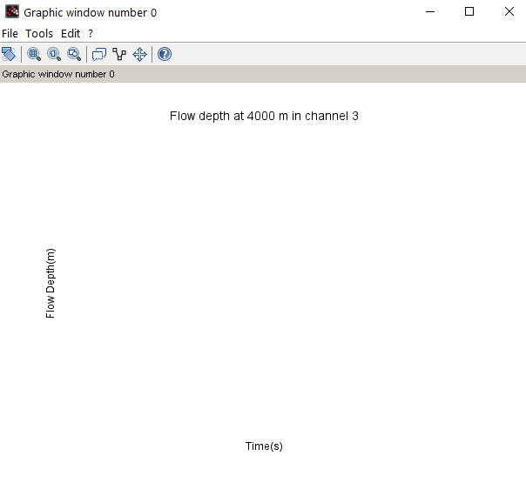

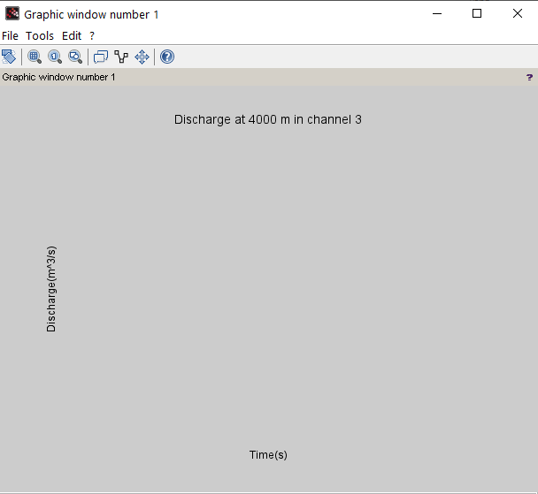

**!**

**(30) Steady_1D_pipe_network**

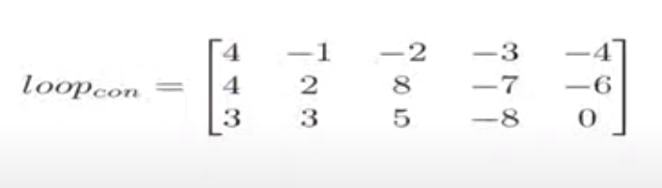

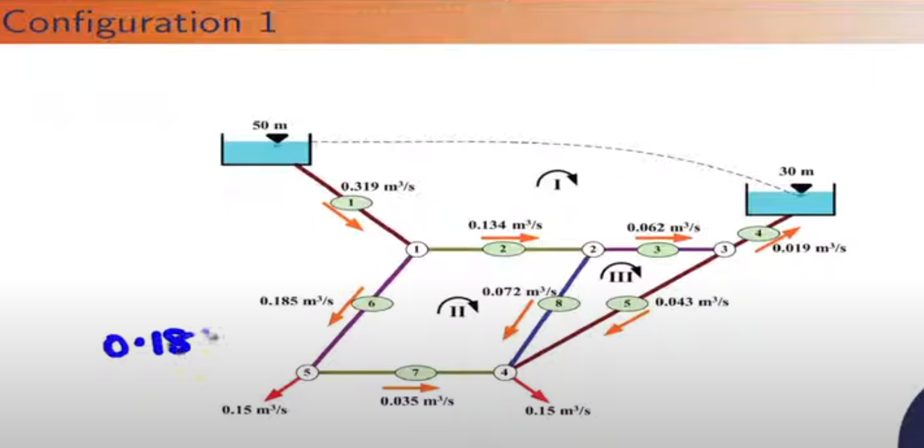

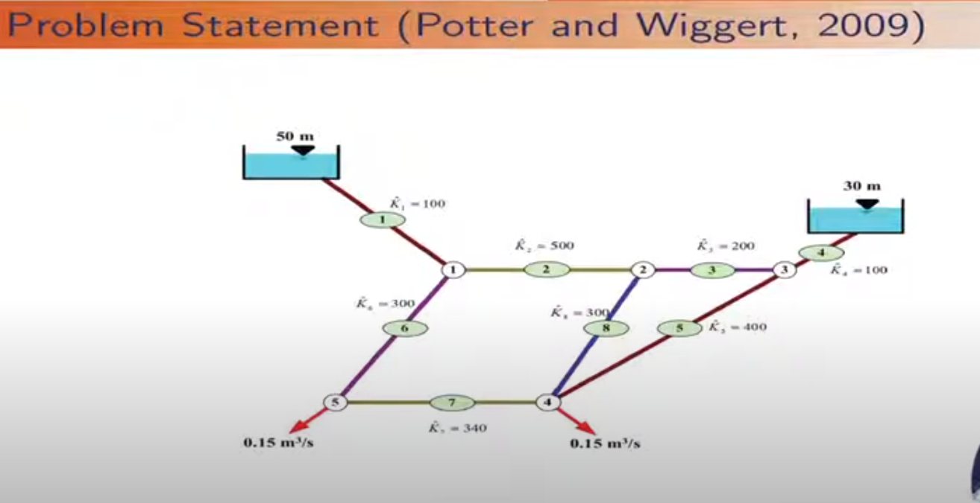

clc

clear

*//~~~Given Data~~~`*

g=9.81; *//m/s^(-2)*

global('g')

eps_max=1e-6;

betav=2; *//exponent of discharge.*

pipen=8; *//Number of pipes.*

nmaxpl=4;*//Maximum number of pipes connected to a particular loop.*

junn=5; *//Number of junctions.*

ploop=1; *//Number of pseudo loop.*

iloop=2; *//Number of interior loop.*

loopn=ploop+iloop; *//Total number of loops.*

Qi=[0.319 0.134 0.062 0.019 0.043 0.185 0.035 0.072]; *//initial discharge*

head_diff=[20]; *//m , in pseudo loop*

loop_con=[4 -1 -2 -3 -4

4 2 8 -7 -6

3 3 5 -8 0];

*//In 'loop_con' marix, 1st column represents the number of pipes connected to that loop. Other shows the pipes connected to that. + sign means flow in clockwise direction.*

pipe_con=zeros(pipen,loopn);

*//'pipe_con' should be a 8*3 matrix.*

for l=1:loopn

*//'l' stands for loop numbering.(i.e, l=1:3).*

for i=1:loop_con(l,1)

*//"loop_con(l,1)" represents the number of pipes connected to l-th loop.*

pipe_con(abs(loop_con(l,i+1)),l)=l;

*//"for i=1:loop_con(l,1), abs(loop_con(l,i+1))" covers all the 'pipe nos' connected to lth loop. We can see, each row of "loop_con" matrix is dedicated to a particular pipe no. It shows, in which loop a particular pipe is connected. Output: pipe_con=*

*// 1. 0. 0.*

*// 1. 2. 0.*

*// 1. 0. 3.*

*// 1. 0. 0.*

*// 0. 0. 3.*

*// 0. 2. 0.*

*// 0. 2. 0.*

*// 0. 2. 3.*

end

end

Kv=[100 500 200 100 400 300 400 300];

*//'Kv' means "Ki(cap)", which considers the total loss thing.*

*//~~~~~~Problem dependent parameters~~~~~~~~*

Qv=zeros(loopn,nmaxpl);

*//'Qv' is a (3*4) matrix.*

*//~~~~~General Identification Matrix~~~~*

for l=1:loopn

for i=1:loop_con(l,1)

Qv(l,i)=sign(loop_con(l,i+1))*Qi(abs(loop_con(l,i+1)));

*//'loop_con(l,i+1)' because channel numbering starts from 2nd column. For each 'pipe loop(l)', i runs for 'loop_con(l,1)' times. Because, 'loop_con(l,1)' is the number of pipes connected to l-th loop. Here, Qv considers the sign of discharge also. Because, in loop_con matrix we considered the pipe numberings with appropriate sign (Clockwise + ,Anticlockwise -)*

end

end

count=0;

rmse=1;

*//~~~~~~~~Space Loop~~~~~~~~~~~~*

while rmse>eps_max

rmse=0;

delQ=zeros(loopn,1);

*//We are considering a particular delQ value for all pipes in each loop.*

for l=1:loopn

nr=0;

dr=0;

*//numerator and denominator initialized as zero values.*

if (l<=ploop)then

*//Because, we have assigned the pseudo loop as loop no 1. As ploop=1, therefore, l<=1 implies the pseudo loop , where a particular head difference is present between two reservoirs.*

nr=nr+head_diff(l);

end

for i=1:loop_con(l,1)

*//"loop_con(l,1)" represents number of pipes connected to l-th loop.*

nr=nr+Kv(abs(loop_con(l,i+1)))*Qv(l,i)*abs(Qv(l,i))^(betav-1);

*// In "Kv(abs(loop_con(l,i+1)))" i+1 is taken because,numbering of connected pipes are started from 2nd column of 'loop_con' matrix.*

dr=dr+betav*Kv(abs(loop_con(l,i+1)))*abs(Qv(l,i))^(betav-1);

*//See equation (412) for "nr" and "dr" calculation.*

end

delQ(l)=-(nr/dr);

end

*//From output, delQ= [0.0000010; 0.0000007; 0.0000009]*

*//~~~~~~~~~~~~~~~~~~~~~~~~~~~~~~~~~~~~~~*

for l=1:loopn

*//Considers loops*

for j=1:loop_con(l,1)

*//Considers all pipes connected to that loop.*

for k=1:loopn

*//Related to 'pipe_con' matrix. Considers a pipe connected to how many loops.*

if (pipe_con(abs(loop_con(l,j+1)),k)<>0)then

if (pipe_con(abs(loop_con(l,j+1)),k)==l)then *//this condition is important.*

Qv(l,j)=Qv(l,j)+delQ(pipe_con(abs(loop_con(l,j+1)),k));

else

Qv(l,j)=Qv(l,j)-delQ(pipe_con(abs(loop_con(l,j+1)),k));

end

end

end

end

end

*//~~~~~~~~~~~~~~~~~~~~~~~~~~~~~~~~~~~~~*

*//Explanation of the above loop:*

*//when l=1,j=1,k=1, pipe_con(abs(loop_con(1,2)),1)=pipe_con(1,1)=1; Qv(1,1)=Qv(1,1)+delQ(pipe_con(abs(loop_con(1,2)),1))=Qv(1,1)+delQ(1);*

*//when l=1,j=1,k=2, pipe_con(abs(loop_con(1,2)),2)=pipe_con(1,2)=0; -->stop*

*//when l=1,j=1,k=3, pipe_con(abs(loop_con(1,2)),3)=pipe_con(1,3)=0; -->stop*

*//when l=1,j=2,k=1, pipe_con(abs(loop_con(1,3)),1)=pipe_con(2,1)=1; Qv(1,2)=Qv(1,2)+delQ(pipe_con(abs(loop_con(1,3)),1))=Qv(1,2)+delQ(1);*

*//when l=1,j=2,k=2, pipe_con(abs(loop_con(1,3)),2)=pipe_con(2,2)=2; Qv(1,2)=Qv(1,2)+delQ(pipe_con(abs(loop_con(1,3)),2))=Qv(1,2)-delQ(2);*

*//when l=1,j=2,k=3, pipe_con(abs(loop_con(1,3)),3)=pipe_con(2,2)=0;--->stop*

*//when l=1,j=3,k=1, pipe_con(abs(loop_con(1,4)),1)=pipe_con(3,1)=1; Qv(1,3)=Qv(1,3)+delQ(pipe_con(abs(loop_con(1,4)),1))=Qv(1,3)+delQ(1);*

*//when l=1,j=3,k=2, pipe_con(abs(loop_con(1,4)),2)=pipe_con(3,2)=0; --> stop*

*//when l=1,j=3,k=3, pipe_con(abs(loop_con(1,4)),3)=pipe_con(3,3)=3; Qv(1,3)=Qv(1,3)+delQ(pipe_con(abs(loop_con(1,4)),3))=Qv(1,3)-delQ(3);*

*////when l=2,j=1,k=1, pipe_con(abs(loop_con(2,2)),1)=pipe_con(2,1)=1; Qv(2,1)=Qv(2,1)+delQ(pipe_con(abs(loop_con(2,2)),1))=Qv(2,1)-delQ(1);*

*//Similarly other iterations will be there. I.T ---> (As 'l' stands for loop and 'j' stands for pipe, so from "loop_con" matrix, we can say that Qv(1,2)*,Qv(2,1)** both gives discharge of pipe 2. Similarly Qv(1,3),Qv(3,1) both gives discharge of pipe 3. Qv(2,2),Qv(2,3) both gives discharge of pipe 8. Those pairs should be added together to get the discharges of pipe no 2,3 & 8.)🡪Wrong Idea,Discharge value of a pipe for any loop has same value. Because, for any loop it considers all effects.*

*// * In loop_con matrix, row 1,2 ,3 stands foe loop 1, loop2, loop3 respectively. So, Qv(1,2) means 2nd pipe of row 1 (i.e, pipe represented by (1,3)th element. As pipes are started from 2nd column, 1st column represents the total number of pipes connected to that particular loop).*

*// ** Similarly, Qv(2,1) means 1st pipe of row 2 (i.e, pipe represented by (2,2)th element.*

for l=1:loopn

rmse=rmse+delQ(l)^2;

end

rmse=sqrt(rmse/loopn);

count=count+1;

disp([count rmse])

end

*//Print output*

for l=1:loopn

disp(['Loop Number:' string(l)])

disp('Pipe Number Discharge(m^3/s)')

for i=1:loop_con(l,1)

disp([abs(loop_con(l,i+1)) Qv(l,i)])

end

end

Output: 1. 0.0004983

2. 0.0003078

3. 0.0001496

4. 0.0001064

5. 0.0000546

6. 0.0000386

7. 0.0000212

8. 0.0000146

9. 0.0000084

10. 0.0000057

11. 0.0000034

12. 0.0000022

13. 0.0000013

14. 0.0000009

"Loop Number:" "1"

"Pipe Number Discharge(m^3/s)"

1. -0.3184094

2. -0.1345158

3. -0.0624709

4. -0.0184094

"Loop Number:" "2"

"Pipe Number Discharge(m^3/s)"

2. 0.1345158

8. 0.072045

7. -0.0338936

6. -0.1838936

"Loop Number:" "3"

"Pipe Number Discharge(m^3/s)"

3. 0.0624709

5. 0.0440615

8. -0.072045